

Project Fini

Production Requirements Document

Version : 0.1

Created by : Hong Kong Exchanges and Clearing Limited

Date : 4 March 2020

**Document History**

|  |  |  |  |
| --- | --- | --- | --- |
| Version | Date | Author | Description of Change |
| V0.1 | 4 March 2020 | Raymond Lee | Initial skeleton outline |
|  |  |  |  |

**Distribution list**

|  |  |  |  |
| --- | --- | --- | --- |
| Name | Division | Department | Responsibility |
| Raymond Lee | GSP | Innovation Lab | Document owner |
| Gordon Tam | GSP | Innovation Lab | Input/ Review |
| Victor Wong | ITD | Platform Development | Input/ Review |
| Maria Chan | LD | IPO Vetting | Input |
| Geoffrey Tong | LD | IPO Vetting | Input |
| Erin Chung | LD | IPO Vetting | Input |
| City Chan | PT | IPO management | Input |
| Stanley Ng | PT | Stock Admission | Input |
| Mandy Tong | PT | Stock Admission | Input |
| Pinky Ko | PT | Stock Admission | Input |
| Derek Ng | ITD | Clearing System | Input |
| Amy Yip | ITD | Clearing System | Input |
| Karina Chan | ITD | Clearing System | Input / Review |
| Richard Lai | ITD | System Architecture | Input / Review |
| Lukas Petrikas | GSP | Co-Head of Innovation Lab | Sign off |
| Grace Kan | LD | Head of IPO Advisory and Projects | Sign off |
| Daniel Poon | PT | Head of On-Exchange and OTC Clearing | Sign off |

Table of Contents

Table of Contents 2

1 Background 4

1.1 Current settlement process 4

1.2 Target operating model 5

1.3 Expected users of the system 9

2 Functional requirements 11

2.1 Delivery channel 11

2.1.1 Support on browser type 11

2.1.2 Support on mobile devices 11

2.2 Instant notification 12

2.2.1 Website message 12

2.2.2 Email 17

2.3 External integration layer 18

2.3.1 API gateway 18

2.3.2 EMFT integration (external) 18

2.3.3 Data exchange with SWIFT 18

2.3.4 Data Exchange with SR 27

2.4 Core processing engine – Shared services 30

2.4.1 Participant management 30

2.4.2 User management and authentication / authorisation management 31

2.4.2.1 User Structure Requirements 31

2.4.2.2 Identity and Function setup requirement 34

2.4.2.3 User Management Requirements 34

2.4.2.4 User Data synchronization 35

2.4.3 IPO reference data and information management 35

2.4.4 Preferential offers and public offer upsize option 43

2.4.5 IPO closing and reporting 46

2.5 Core processing engine – Public offer 48

2.5.1 EIPO application 48

2.5.2 Application data management: real-time check and statistics 52

2.5.3 Application data management: cleansing and verification 53

2.5.4 Application data management: consolidation and allotment 53

2.5.5 EIPO funding calculator 53

2.5.6 Payment instruction 54

2.5.7 Share posting 57

2.6 Core processing engine – Institutional offer 58

2.6.1 IPO pricing 58

2.6.2 Sub-placing arrangement 58

2.6.3 Placee allocation 61

2.6.4 Application data management: real-time check and statistics 66

2.6.5 Application data management: cleansing and verification 67

2.6.6 Application data management: consolidation 67

2.6.7 Regulatory submission 68

2.6.8 Document services 74

2.7 Controls & monitoring 78

2.7.1 Exceptions handling for dynamic IPOs 78

2.7.2 Contingency planning 79

2.7.3 Data access rights 80

2.7.4 Audit log (internal & external) 80

2.8 Internal integration layer & HKEX existing systems 81

2.8.1 Data exchange with CCASS 81

2.8.2 FINI -> Electronic Case Management (ECM) 82

2.8.3 FINI -> Sanctum 83

# Background

The time gap between the pricing and trading of HK IPOs currently takes a minimum of five business days (called T+5), which reflects an ageing settlement process that is difficult to materially accelerate in its current form.

HKEX proposes to rationalise and modernise Hong Kong’s IPO settlement process, so that the market can start trading newly listed shares much faster and more efficiently.

The purpose of the project is to design a new software platform to transform how Hong Kong market participants and authorities interact to settle IPOs, using modern workflow, collaboration and data tools.

## Current settlement process

The flowchart below is a high-level summary of summarises the current settlement process:

**Before T-4**

**T-4 to T-2**

**T-1**

**T:**

**pricing day**

**T+1**

**T+2**

**T+3**

**T+5:**

**First trading day**

Consolidate & validate

Pre-fund

Deposit global offer shares

Global offer roadshow

Public offer subscriptions

Placee lists / documents

Regulatory approvals

Start of trading

Balloting and public offer allocations

Refund

Deposit public offer shares

Post-Hearing Letter

Final IPO details

Allotment results

**T+4**

Final Clawback

Pricing

The following table summarises the key actions of each market participant during the IPO settlement process:

|  |  |  |  |  |  |  |  |  |  |  |  |  |  |  |  |  |
| --- | --- | --- | --- | --- | --- | --- | --- | --- | --- | --- | --- | --- | --- | --- | --- | --- |
| **Day** | **#** | **Activity** | **ISS** | **SPO** | **SPC** | **LBK** | **DIST** | **INV** | **CP** | **SR** | **ICL** | **SB** | **RB** | **LD** | **SFC** | **HKX** |
| T-X | **1** | Issue Post-Hearing Letter | ⚫ | **⚫** | **⚫** |  |  |  |  |  |  |  |  | ⚫ |  |  |
| T-X | **2** | Pass board resolutions | ⚫ |  | **⚫** |  |  |  |  | ⚫ |  |  |  |  |  | ⚫ |
| T-X | **3** | Allocate stock code | **⚫** | **⚫** | **⚫** |  |  |  |  |  |  |  |  |  |  | ⚫ |
| T-X | **4** | Sign IPO agreements | ⚫ | ⚫ | ⚫ |  |  |  |  | ⚫ |  |  | ⚫ |  |  | ⚫ |
| T-6 | **5** | Register prospectus for bulk printing | ⚫ | ⚫ | ⚫ |  |  |  |  | ⚫ |  |  |  | ⚫ | ⚫ | ⚫ |
| T-6 | **6** | Finalise and submit IPO details to HKEX | ⚫ | ⚫ | ⚫ | ⚫ | ⚫ | ⚫ | ⚫ | ⚫ |  | ⚫ | ⚫ | ⚫ | ⚫ | ⚫ |
| T-5 | **7** | Set up IPO on systems / bank branches | ⚫ | ⚫ | ⚫ |  |  |  | ⚫ | ⚫ |  |  | ⚫ |  |  | ⚫ |
| T-5 | **8** | Start global roadshow / bookbuild | ⚫ | ⚫ | ⚫ | ⚫ | ⚫ | ⚫ | ⚫ | ⚫ |  | ⚫ | ⚫ | ⚫ | ⚫ | ⚫ |
| T-4 | **9** | Open public offer |  | ⚫ | ⚫ | ⚫ | ⚫ | ⚫ | ⚫ | ⚫ |  | ⚫ | ⚫ | ⚫ | ⚫ | ⚫ |
| T-2 | **10** | Submit public offer subscriptions | ⚫ | ⚫ | ⚫ | ⚫ | ⚫ | ⚫ | ⚫ | ⚫ |  | ⚫ | ⚫ | ⚫ | ⚫ | ⚫ |
| T-2 | **11** | Consolidate public offer subscriptions |  |  |  |  |  |  |  | ⚫ |  |  | ⚫ |  |  | ⚫ |
| T-1 | **12** | Pre-fund EIPO channel subscriptions |  |  |  |  |  | ⚫ |  |  | ⚫ | ⚫ | ⚫ |  |  | ⚫ |
| T-1 | **13** | Remove invalid subscriptions |  |  |  |  |  |  |  | ⚫ | ⚫ | ⚫ |  |  |  |  |
| T-1 | **14** | Finalise clawback | ⚫ | ⚫ | ⚫ | ⚫ | ⚫ |  |  | ⚫ |  |  |  | ⚫ | ⚫ | ⚫ |
| T | **15** | Price IPO / allocate shares to institutional offer | ⚫ | ⚫ | ⚫ | ⚫ | ⚫ | ⚫ |  |  |  |  |  |  |  |  |
| T | **16** | Sign underwriting agreement | ⚫ | ⚫ | ⚫ | ⚫ | ⚫ |  |  |  |  |  |  |  |  |  |
| T+1 | **17** | Ballot public offer subscriptions | ⚫ |  |  |  |  |  |  | ⚫ |  |  |  |  |  |  |
| T+1 | **18** | Submit placee lists |  | ⚫ |  | ⚫ | ⚫ |  |  |  |  |  |  | ⚫ | ⚫ |  |
| T+1 | **19** | Submit forms and supporting documents | ⚫ | ⚫ | ⚫ | ⚫ | ⚫ |  |  | ⚫ |  |  |  | ⚫ | ⚫ | ⚫ |
| T+2 | **20** | Allot public offer shares |  |  |  |  |  | ⚫ |  | ⚫ |  |  |  |  |  | ⚫ |
| T+3 | **21** | Deposit public offer shares into CCASS |  |  |  |  |  |  |  | ⚫ |  |  |  |  |  | ⚫ |
| T+3 | **22** | Refund unsuccessful public offer subscriptions |  |  |  |  |  | ⚫ |  | ⚫ | ⚫ | ⚫ | ⚫ |  |  | ⚫ |
| T+3 | **23** | Submit draft allotment results announcement | ⚫ | ⚫ | ⚫ |  |  |  |  | ⚫ |  |  |  | ⚫ | ⚫ | ⚫ |
| T+4 | **24** | Approve to commence trading | ⚫ | ⚫ | ⚫ | ⚫ | ⚫ |  |  |  |  |  |  | ⚫ | ⚫ |  |
| T+4 | **25** | Input settlement instructions for institutional offer |  | ⚫ |  | ⚫ | ⚫ | ⚫ |  |  |  |  |  |  |  | ⚫ |
| T+5 | **26** | Deposit institutional offer shares into CCASS |  |  |  |  |  |  |  | ⚫ |  |  |  |  |  | ⚫ |
| T+5 | **27** | Listing ceremony: commencement of trading | ⚫ | ⚫ | ⚫ | ⚫ | ⚫ |  |  | ⚫ |  |  | ⚫ | ⚫ |  |  |

|  |  |  |
| --- | --- | --- |
| **ISS** = Issuer  **SPO** = Sponsor  **SPC** = Sponsor’s counsel  **LBK** = Lead Broker  **DIST**= Sub-distributors  **INV** = Investors  **CP** = Clearing Participants (retail brokers) | **SR** = Share registrar  **ICL** = Hong Kong Interbank Clearing Limited  **SB** = Settlement banks  **RB** = Issuer’s receiving bank  **LD** = SEHK Listing Department  **SFC** = Securities and Futures Commission  **HKX** = HKEX Post-Trade / Markets teams | ⚫ = collecting or providing information  ⚫ = receiving or processing information  ⚫ = issuing an approval or confirmation  ⚫ = participation or attendance |

The main challenges to this existing system are three-folded:

1. **Lack of enforced data standards**Both the public and institutional offers lack common data standards for expedient processing. The public offer involves three different channel operators who only exchange information after the closing of the public offer for data cleaning and aggregation. Placing allocations for the institutional offer are consolidated manually via a combination of spreadsheets and printouts.
2. **Inefficient communication**Most communications and submissions are made through email or fax, which creates a lot of inefficient workflows and data reconciliation between participants and regulators.
3. **Use of paper**Use of physical application forms, cheque payments and fax printouts creates a lot manual data entry into different systems.

## Target operating model

The target is to shorten the IPO settlement is to build a platform that consolidates the workflows of the public offer and institutional offer and achieve a T+1 settlement timetable.

The platform incorporates three main design principles:

1. **Digital application capture**Applicants’ information is digitised, standardised and verified at the point of collection, making subsequent aggregation, verification and analysis of IPO demand more time-efficient.
2. **Streamlined and automated workflows**New software facilitates real-time communication between the involved market participants, with e-forms, data transformation, analytics, review and populating of standard documents on a secure shared ledger.
3. **Net settlement of funds for the Public Offer**Retail investors only pay for the shares they actually receive, resulting in more equitable treatment versus institutional investors and lowering the burden on the markets.

The expected workflow of the system:

**Online = direct communication with the Fini system**

**Offline = communication outside the Fini system**

|  |  |  |  |  |  |  |
| --- | --- | --- | --- | --- | --- | --- |
| **Day** | **#** | **IPO syndicate** | **[FINI] system** | | | **Listing regulators / market operators** |
| T-X | 1 |  |  | **Online** | ◀ | **LD / SFC:** Create IPO |
| T-X | 2 |  |  | **Online** | **▶** | **LD / SFC:** Generate unique key |
| T-X | 3 | **SPC:** Start IPO setup (unique key to unlock e-form) | ◀ | **Offline** | ◀ | **LD:** Issue Post-Hearing letter |
| T-5 | 4 | **SPO / SPC:** Submit IPO e-form (1) | **▶** | **Online** | **▶** | **LD / SFC / HKX:** For reference |
| T-(4-1) | 5 | **CP / SR:** Start public offer subscriptions | ◀ | **Online** |  |  |
| T-(4-1) | 6 | **CP / SR:** Submit public offer subscriptions (2) | **▶** | **Online** |  |  |
| T-1 | 7 | **SR:** Consolidated EIPO application list (3) | ◀ | **Online** |  |  |
| T-1 | 8 | **ISS / SPO / LBK / SR:** Finalise clawback | ◀ | **Online** | **▶** | **LD / SFC / HKX:** For reference |
| T-1 | 7 | **SR:** Allot public offer shares | **▶** | **Online** | **▶** | **LD / SFC / HKX:** For reference |
| T-1 | 9 | **ICL / SB / RB:** Fund public offer allotment (4) | ◀ | **Online** |  |  |
| T | 10 | **ISS / SPO:** Price IPO / allocate shares to institutional offer |  | **Offline** |  |  |
| T | 11 | **ISS / SPO / SPC:** Sign underwriting agreement |  | **Offline** |  |  |
| T | 12 | **SPC:** Input IPO price | **▶** | **Online** | **▶** | **LD / SFC / HKX:** For reference |
| T | 13 | **LBK / DIST:** Input sub-placing allocations | **▶** | **Online** | **▶** | **SFC / HKX:** View control list |
| T | 14 | **LBK / DIST:** Submit placee lists | **▶** | **Online** | **▶** | **LD / SFC:** Review consolidated list |
| T | 15 | **ISS:** Submit issuer’s declaration form (Form F or 5E) | **▶** | **Online** |  |  |
| T | 16 | **SPO:** Submit sponsor’s declaration form (Form E or 7I) | **▶** | **Online** |  |  |
| T | 17 | **LBK / DIST:** Submit **l**etters of independence | **▶** | **Online** |  |  |
| T | 18 | **LBK / DIST:** Submit supporting documents | **▶** | **Online** | **▶** | **LD / SFC:** Review information |
| T | 19 | **SPO:** Submit company information sheet | **▶** | **Online** |  |  |
| T | 20 | **LBK:** Submit placement form | **▶** | **Online** | **▶** | **HKX:** Prepare for institutional offer settlement |
| T | 21 | **SR:** Dispatch public offer share certificates | **▶** | **Offline** | **▶** | **HKX:** Reconciliation |
| T | 22 |  |  | **Online** | **▶** | **HKX:** Post public offer shares into CCASS |
| T | 23 | **SPC:** Submit draft allotment results announcement | **▶** | **Online** | **▶** | **[LD / SFC:** Review system analytics] |
| T | 24 |  | ◀ | **Online** | ◀ | **LD / SFC:** Approve to commence trading |
| T | 25 | **LBK / DIST:** Input settlement instructions for institutional offer | **▶** | **Offline** |  | (CCASS operations) |
| T+1 | 26 | **SR:** Dispatch institutional offer share certificates | **▶** | **Offline** | **▶** | **HKX:** Reconciliation |
| T+1 | 27 | Listing ceremony: commence of trading |  | **Offline** |  |  |
| T | 28 | **ICL / SB / RB:** Refund IPO price differential | ◀ | **Online** |  |  |

1. Include IPO details + uploading with direction debit authorization form, company registration document(s) and company constitutional document(s).
2. Aggregation, de-duplication and data cleansing performed at application capture.
3. Perform final data cleansing checks and pass the
4. Pay at max offer price using SWIFT.

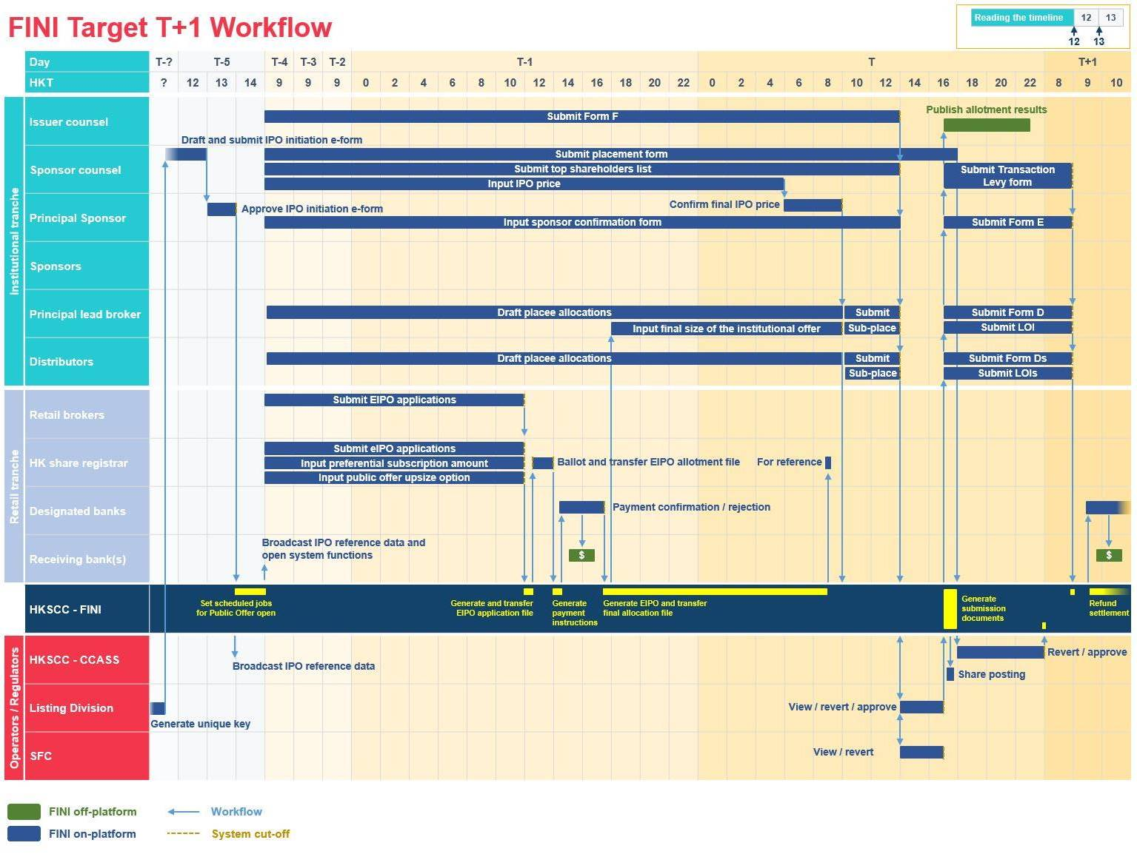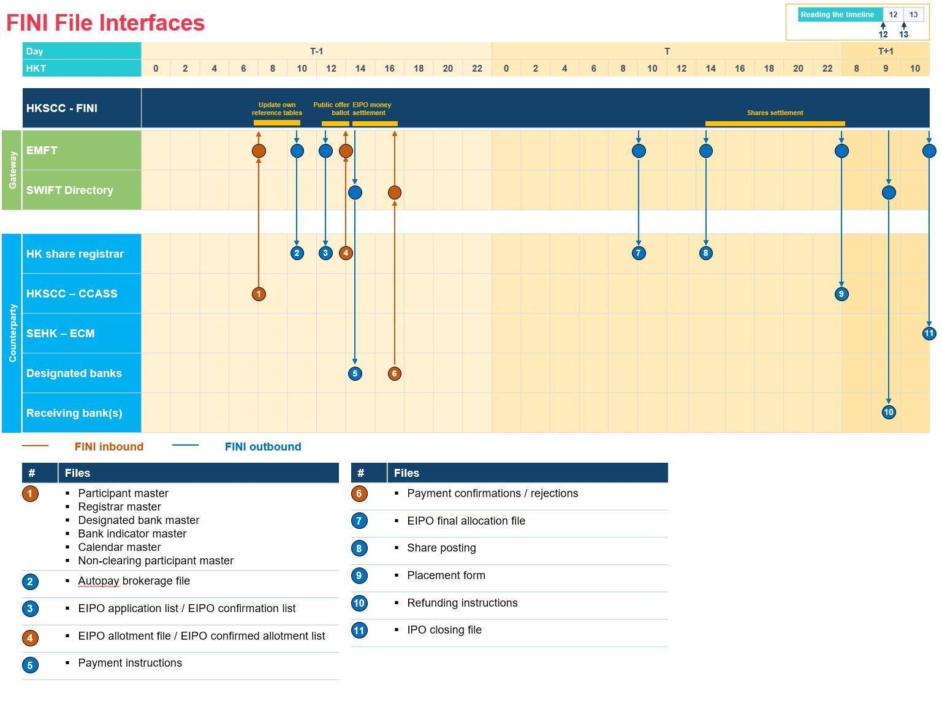

## Expected users of the system

The table below summarises the different types of users expected to on-boarded onto the system:

|  |  |  |  |  |  |
| --- | --- | --- | --- | --- | --- |
| **User** | **Roles / responsibilities** | **Communication channel** | | **Fini system user?** | **Maker / checker?** |
| **Current** | **Future** |
| Issuer | * Files application for its shares to be listed on the exchange for trading | Email | Represented by issuer’s counsel on-platform | **X** | **N/A** |
| Issuer’s counsel | * Represents the issuer on various listing matters and regulatory submissions | Email | On-platform | **✓** | **X** |
| Sponsor | * Underwrites the IPO for the issuer | Email | On-platform | **✓** | **X** |
| Sponsor’s counsel | * Represents the sponsor on various listing matters and regulatory submissions | Email | On-platform | **✓** | **X** |
| Lead Brokers | * Manages institutional offer allocations for high net worth clients and subplacing to distributors | Email / CCASS | On-platform / CCASS | **✓** | **✓** |
| Distributors | * Manages institutional offer allocations for high net worth clients | Email / CCASS | On-platform / CCASS | **✓** | **✓** |
| HKICL | * Manages settlement of public offer subscription funding | File exchange | File exchange | **X** | **N/A** |
| Settlement banks | * Manages public offer payments and refunds for Clearing Participants | File exchange | File exchange | **X** | **N/A** |
| Receiving bank | * Manages public offer payments and refunds for the issuer | File exchange | File exchange | **X** | **N/A** |
| Clearing Participants | * Manages public offer subscriptions and allotments for brokerage investors | CCASS | On-platform | **✓** | **✓** |
| Share Registrar | * Manages public offer subscriptions and allotments | Email + file exchange | On-platform + file exchange | **✓** | **✓** |
| HKEX Post Trade | * Manages the stock exchange’s settlement systems | Email / CCASS | On-platform | **✓** | **X** |
| HKEX Markets | * Manages the stock exchange’s trading systems | Email | Receive reports downstream | **X** | **N/A** |
| Regulators (HKEX) | * Reviews regulatory submissions from issuer’s counsel / sponsor / sponsor’s counsel / lead brokers / distributors | Email | On-platform | **✓** | **X** |
| Regulators (SFC) | * Reviews regulatory submissions from issuer’s counsel / sponsor / sponsor’s counsel / lead brokers / distributors | Email | On-platform | **✓** | **X** |

While all the on-boarded system users should have access to the system at all times, their user permissions and visibility are based on their assigned roles on an IPO-by-IPO basis.

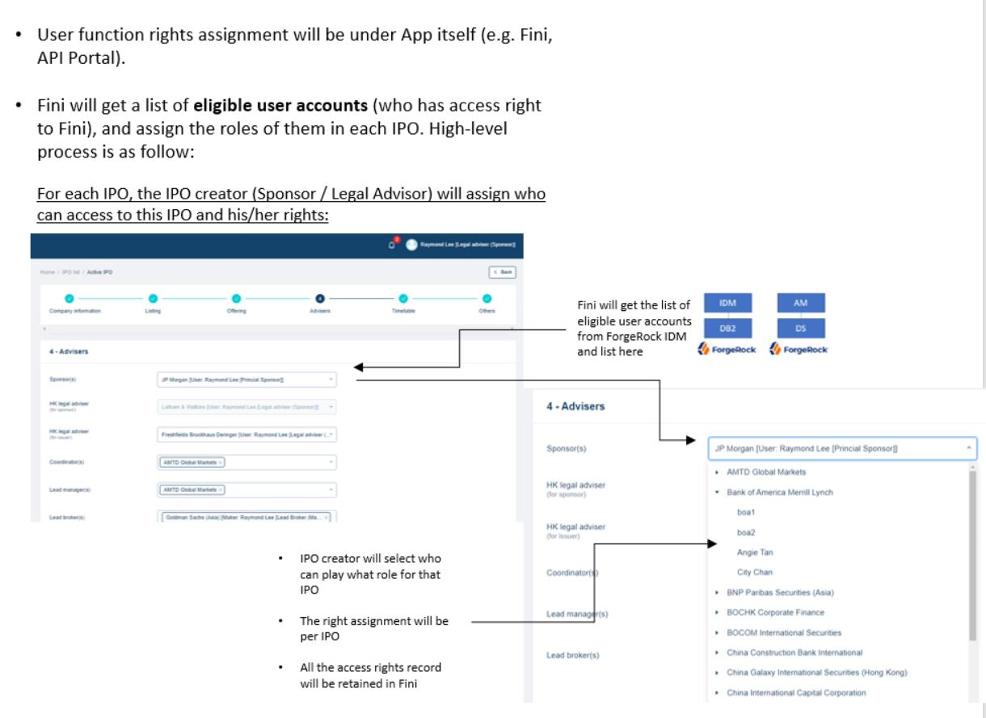

# Functional requirements

The diagram below summarises the list of functional modules. Functions that were implemented in the prototype under the agreed scope are marked under a red tag **[Implemented in prototype] or [IIP]**. Otherwise additional functions and requirements will be marked in black.

## Delivery channel

### Support on browser type

This system should be accessible from the following browser running on Windows 10 / OS X 10.11 El Capitan or above:

* Internet Explorer 11.0
* Google Chrome 72.0.3626 or above **[IIP]**
* Microsoft Edge 42.17134 or above
* Firefox 68.0 or above
* Safari 11.1.2 or above

For users using browsers not listed above, the system should display the following warning statement on the login page:

* **Header:** “BROWSER COMPATIBILITY”
* **Message:** “Please note the system has detected that you are using an unsupported browser. Please consider using the latest versions of Internet Explorer, Google Chrome, Microsoft Edge, Firefox or Safari for the best user experience on this site.”

### Support on mobile devices

FINI should be accessible by the browsers listed in 2.1.1 Support on browser type for Apple iOS 12 and Android 9 Pie or above.

Users operating FINI via mobile devices should have access to all navigation and online input functions, but not file download / upload functions.

## Instant notification

### Website message

Format guide:

* All notifications should only be sent to relevant party involved in the submission / revert / approval.
* All user name inputs should be based on “full name [firm name]”, e.g. John Lee [Goldman Sachs (Asia)].
* Underlined text should include hyperlinks to the relevant interface for further user action.

**IPO initiation**

|  |  |  |  |  |  |  |
| --- | --- | --- | --- | --- | --- | --- |
| **#** | **Action** | **Sponsor counsel** | **Principal Sponsor** | **HKSCC / Regulator (SFC)** | **Regulator (HKEX)** | **Clearing Participant (maker + checker)** |
| 1 | Regulator (HKEX) generates unique FINI case #  “[Regulator (HKEX)] has generated a new FINI case number for [IPO initiation Field #2].” |  |  |  | ✓ |  |
| 2 | Sponsor counsel inputs unique FINI case # to activate IPO initiation e-form  “[Sponsor counsel] has activated the IPO initiation e-form for [IPO initiation Field #2].” | ✓ |  | ✓ | ✓ |  |
| 3 | Sponsor counsel submits IPO initiation e-form to Principal Sponsor  “[Sponsor counsel] has submitted the IPO initiation e-form of [IPO initiation Field #2] for confirmation.” | ✓ | ✓ |  |  |  |
| 4 | Principal Sponsor reverts IPO initiation e-form to Sponsor counsel  “[Sponsor] has reverted the IPO initiation e-form of [IPO initiation Field #2] for amendment.” | ✓ | ✓ |  |  |  |
| 5 | Principal Sponsor approves IPO initiation e-form  “[Sponsor] has approved the IPO initiation e-form of [IPO initiation Field #2].” | ✓ | ✓ | ✓ | ✓ |  |
| 6 | Commencement of Public Offer  “The public offer of [IPO initiation Field #2] has opened for EIPO applications.” |  |  |  |  |  |

**Preferential Offer**

|  |  |  |  |
| --- | --- | --- | --- |
| **#** | **Action** | **Share Registrar (Maker + checker)** | **HKSCC / Regulator(SFC)/ Regulator(HKEX)/ Sponsor Counsel / Principal Sponsor** |
| 1 | Share Registrar (maker) inputs the settlement details for the preferential offers  [Temporary -> Pending]  “[Share Registrar (maker)] has inputted the settlement details for the [IPO initiation Field #58] - [IPO initiation Field #10] [IPO initiation Field #2]‘s [IPO initiation Field #59].” | ✓ |  |
| 2 | Share Registrar (checker) reverts entries to Share Registrar (maker)  [Pending -> Temporary]  “[Share Registrar (checker)] has reverted the settlement details for the [IPO initiation Field #58] - [IPO initiation Field #10] [IPO initiation Field #2]‘s [IPO initiation Field #59] for amendment.” | ✓ |  |
| 3 | Share Registrar (checker) authorizes entries from Share Registrar (maker)  [Pending -> Authorized]  “[Share Registrar (checker)] has authorized the settlement details for the [IPO initiation Field #58] - [IPO initiation Field #10] [IPO initiation Field #2]’s [IPO initiation Field #59].” | ✓ | ✓ |

**EIPO application**

|  |  |  |  |  |
| --- | --- | --- | --- | --- |
| **#** | **Action** | **Clearing Participant (maker + checker) / Share Registrar (maker + checker)** | **HKSCC** | **Principal Sponsor / Sponsor Counsel / Regulator(SFC)** |
| 1 | Clearing Participant / Share Registrar (Maker) submits public offer subscription to Clearing Participant / Share Registrar(Checker)  [Temporary -> Pending]  "[Clearing Participant maker] / [Share Registrar maker] has submitted [#] EIPO Applications for [IPO initiation Field #10] [IPO initiation Field #2].” | ✓ |  |  |
| 2 | Clearing Participant / Share Registrar(Checker) reverts EIPO Applications’ entries to Clearing Participant / Share Registrar(Maker)  [Pending -> Temporary]  "[Clearing Participant checker] / [Share Registrar checker]has reverted [#] EIPO Applications for [IPO initiation Field #10] [IPO initiation Field #2] for amendment.” | ✓ |  |  |
| 3 | Clearing Participant / Share Registrar(Checker) authorizes EIPO Applications’ entries  [Pending -> Authorized]  "[Clearing Participant checker] / [Share Registrar checker] has authorized [#] EIPO Applications for [IPO initiation Field #10] [IPO initiation Field #2].” | ✓ |  |  |
| 4 | Cross public offer application list duplication after authorisation of entries  “Duplicated EIPO Application is being detected for [IPO initiation Field #10] [IPO initiation Field #2] [Application No] across public offer tranches” | ✓ |  |  |
| 5 | Cross public offer application list deduplication after Public Offer close  “EIPO Application for [IPO initiation Field #10] [IPO initiation Field #2] [Application No] is duplicated across public offer tranches and being invalidated from the EIPO Application List" | ✓ | ✓ |  |
| 6 | After Public Offer close  “The accumulated total number of shares being applied for [IPO initiation Field #10] [IPO initiation Field #2] are [#] [shares / units], with an oversubscription ratio of [0.0x].” |  | ✓ | ✓ |

**EIPO Allotment**

|  |  |  |  |
| --- | --- | --- | --- |
| **#** | **Action** | **Clearing Participant (maker + checker) / Share Registrar (maker + checker)** | **HKSCC** |
| 1 | The validation of the allotment file has completed successfully  “The validation of the allotment file completed successfully for [IPO initiation Field #10] [IPO initiation Field #2].” |  | ✓ |
| 2 | The validation of the allotment file has failed  “The validation of the allotment file failed for [IPO initiation Field #10] [IPO initiation Field #2].” |  | ✓ |
| 3 | No allotment file received after cut-off  “No allotment file received for [IPO initiation Field #10] [IPO initiation Field #2].” |  | ✓ |
| 4 | After successful validation of the allotment file  "[#] of shares allotted for the Public Offer of [IPO initiation Field #10] [IPO initiation Field #2].” |  | ✓ |
| 5 | Share Registrar allotment file have successfully allotted # of shares to particular CP / Share Registrar.  "[#] of shares allotted for [IPO initiation Field #10] [IPO initiation Field #2].” | ✓ |  |

**Sub-placing arrangement**

| **#** | **Action** | **Principal lead broker (Maker)** | **Principal lead broker (Checker)** | **Distributor (Maker)** | **Distributor (Checker)** | **Regulator (HKEX)/**  **(SFC)** |
| --- | --- | --- | --- | --- | --- | --- |
| 1 | Principal lead broker (maker) inputs the final size of the institutional offer  “[Principal lead broker (maker)] has submitted [IPO initiation Field #2]’s final offer size of the institutional offer to be [final # of placing shares] shares for confirmation.” | ✓ | ✓ |  |  |  |
| 2 | Principal lead broker (checker) reverts the final size of the institutional offer  “[Principal lead broker (checker)] has reverted [IPO initiation Field #2]’s final offer size of the institutional offer for amendment.” | ✓ | ✓ |  |  |  |
| 3 | Principal lead broker (checker) approves the final size of the institutional offer  “[Principal lead broker (checker)] has confirmed [IPO initiation Field #2]’s final offer size of the institutional offer to be [final # of placing shares] shares.” | ✓ | ✓ |  |  | ✓ |
| 4.1 | Principal lead broker/distributor sub-places shares to distributors  “[Principal lead broker/Distributor] has allocated [# of shares] shares to [Distributor] [IPO initiation Field #2].”  **Note:** The party allocating the shares should only receive one notification summarizing the allocation per action. For example, the principal lead broker allocates shares to 3 distributors and the notification should be:  [Principal lead broker] has allocated [# of shares] shares to [Distributor 1], [# of shares] shares to [Distributor 2] and [# of shares] shares to [Distributor 3] for [IPO initiation Field #2].  The party receiving the allocated shares should only receive the notification relating to itself. For example, Distributor 2 above will only know the # of shares allocated to itself:  [Principal lead broker] has allocated [# of shares] shares to [Distributor 2] for [IPO initiation Field #2]. | ✓ | ✓ | ✓ | ✓ |  |
| 4.2 | Principal lead broker/distributor amends the # of shares allocated to distributors  ““[Principal lead broker/Distributor] has revised the allocation of shares to [Distributor] for [IPO initiation Field #2] from [previous # of shares] shares to [revised # of shares] shares.”  If the # of shares allocated is reduced, add the following message for the distributor:  “Placee lists previously submitted to Regulators will need to be re-submitted for approval.” | ✓ | ✓ | ✓ | ✓ |  |
| 5 | Principal lead broker amends the final size of the institutional offer (after maker-checker workflow, please see items 1 and 2 above)  “[Principal lead broker (checker)] has revised and confirmed [IPO initiation Field #2]’s final offer size of the institutional offer from [previous final # of placing shares] shares to [amended final # of placing shares] shares.” | ✓ | ✓ |  |  | ✓ |
| 5.1 | The amended final size of institutional offer is decreased and the entire sub-placing arrangement is reset with all shares “reallocated” to the principal lead broker  “[Principal lead broker] has downsized [IPO initiation Field #2]’s final offer size of the institutional offer and the sub-placing arrangement has been reset. Placee lists previously submitted to Regulators will need to be re-submitted for approval.” | ✓ | ✓ | ✓ | ✓ | ✓ |

**IPO pricing**

|  |  |  |  |  |
| --- | --- | --- | --- | --- |
| **#** | **Action** | **Sponsor counsel (maker)** | **Principal Sponsor (checker)** | **HKSCC / Regulator (HKEX) / Regulator (SFC) / Sponsors / Principal lead broker / Distributors** |
| 1 | Sponsor counsel inputs IPO price  “[Sponsor counsel] has submitted [IPO initiation Field #2]’s final offer price ([IPO initiation Field #23][final IPO price]) for confirmation.” | ✓ | ✓ |  |
| 2 | Principal sponsor reverts IPO price to Sponsor counsel  “[Principal sponsor] has reverted [IPO initiation Field #2]’s final offer price for amendment.” | ✓ | ✓ |  |
| 3 | Principal sponsor approves IPO price  “[Principal sponsor] has confirmed [IPO initiation Field #2]’s final offer price at [IPO initiation Field #23][final IPO price].” | ✓ | ✓ | ✓ |

**Placee allocation**

| **#** | **Action** | **Principal lead broker / Distributor (Maker)** | **Principal lead broker / Distributor (Checker)** | **Regulator (HKEX)** | **Regulator (SFC)** |
| --- | --- | --- | --- | --- | --- |
| 1 | Distributor (Maker) initiates the first temporary entry  [-> Temporary]  Header: “WARNING”  Message: “No amendments to the placee list can be made after 14:00 [Listing date – 1] except for addressing regulators’ comments.” | ✓ |  |  |  |
| 2 | Distributor (Maker) submits placees to Distributor (Checker)  [Temporary -> Pending]  "[Distributor maker] has submitted [#] placee(s) for [IPO initiation Field #2] for approval.” | ✓ | ✓ |  |  |
| 3 | Distributor (Checker) reverts entries to Distributor (Maker)  [Pending -> Temporary]  “[Distributor checker] has commented on and reverted [#] placee(s) of [IPO initiation Field #2] for amendment.” | ✓ | ✓ |  |  |
| 4 | Distributor (Checker) authorizes placees to Regulator (HKEX) / (SFC)  [Pending -> Authorized]  “[Distributor checker] has submitted [#] placee(s) for [IPO initiation Field #2] for approval.” |  | ✓ | ✓ | ✓ |
| 5 | Regulator (HKEX/SFC) reverts entries to Distributor (Maker)  [Authorized -> Temporary]  “The Regulators have commented on and reverted [#] placee(s) of [IPO initiation Field #2] for amendment.” | ✓ | ✓ | ✓ | ✓ |
| 6 | Regulator (HKEX) approves consolidated placee list and documents  [Authorized -> Approved]  “The consolidated placee list of [IPO initiation Field #2] has been approved.” | ✓ | ✓ | ✓ | ✓ |

**Regulatory submission**

**Document services**

Placement form / pre-deposit form:

|  |  |  |  |  |  |
| --- | --- | --- | --- | --- | --- |
| **#** | **Action** | **Sponsor Counsel / Principal Sponsor** | **Principal Lead Broker/ Distributor \*\*\*** | **Share Registrar** | **HKSCC**  **(maker + checker)** |
| 1 | Sponsor Counsel (Maker) submits the online e-form specifying the settlement arrangements of the institutional offer to Principal Sponsor (Checker)  [Temporary ->Pending]  “[Sponsor Counsel] has submitted the online e-form specifying the settlement arrangements of the International Offer for [IPO initiation Field #10] [IPO initiation Field #2]” | ✓ |  |  |  |
| 2 | Principal Sponsor (Checker) reverts the online e-form to Sponsor Counsel (Maker)  [Pending -> Temporary]  “[Principal Sponsor] has reverted the online e-form specifying the settlement arrangements of the International Offer for [IPO initiation Field #10] [IPO initiation Field #2] for amendment” | ✓ |  |  |  |
| 3 | Principal Sponsor (Checker) authorizes the online e-form  [Pending ->Authorized]  “[Principal Sponsor] has authorized the online e-form specifying the settlement arrangements of the International Offer for [IPO initiation Field #10] [IPO initiation Field #2]” | ✓ |  |  | ✓ |
| 4 | HKSCC reverts the online e-form to Sponsor Counsel (Maker)  [Authorized -> Temporary]  “[HKSCC (Maker / Checker)] has reverted the online e-form specifying the settlement arrangements of the International Offer for [IPO initiation Field #10] [IPO initiation Field #2] for amendment” | ✓ |  |  | ✓ |
| 5 | HKSCC approves the online e-form and generates Placement form / Pre-deposit form  “[HKSCC Checker] has approved the online e-form specifying the settlement arrangements of the institutional offer and generated the [Placement form / Pre-deposit form Field #1] for [IPO initiation Field #10] [IPO initiation Field #2].” | ✓ | ✓ | ✓ | ✓ |

*** Selected in [Placement form / pre-deposit form Field #9].

Formal Admission Letter

|  |  |  |
| --- | --- | --- |
| **#** | **Action** | **Sponsor counsel (maker + checker) / HKSCC** |
| 1 | Regulator (HKEX) approves the placee allocation list  “[HKSCC] has generated the Formal Admission Letter for [IPO initiation Field #10] [IPO initiation Field #2].” | ✓ |

**Exceptions handling for dynamic IPOs**

### Email

[Input]

## External integration layer

### API gateway

FINI should provide the API functions for the following functions.

|  |  |  |  |  |
| --- | --- | --- | --- | --- |
| **#** | **API function** | **Users** | **HTTP method** | **Idempotent** |
| 1 | Enquire IPO reference data | All FINI users | GET | Yes |
| 2 | Add, edit and delete EIPO application entries | Clearing Participant, Share Registrar (if assigned to an IPO) | POST / PATCH / DELETE | No |
| 3 | Enquire EIPO application entries | Clearing Participant, Share Registrar (if assigned to an IPO) | GET | Yes |

Every firm with access to FINI should have permission operate up to two API accounts.

The data field requirements are attached within the .xlsx file below:



### EMFT integration (external)

EMFT is the dedicated file server through which FINI communicates with non-FINI users.

|  |  |  |  |  |  |
| --- | --- | --- | --- | --- | --- |
| **Timing** | **Condition** | **File** | **FINI in(out)bound** | **EMFT folder** | **Reference section** |
| 08:00 | None, daily drop | * Participant master * Registrar master * Designated bank master * Bank indicator master * Calendar master * Non-clearing participant master * ICL Member Information File | **Inbound** | FINI/INBOX/from_prod_CCASS | 2.8.1 Data Exchange with CCASS |
| 09:30 | IPO reaches commencement of trading | All international offer-related reports and documents | **Outbound** | FINI/OUTBOX/to_prod_SDFSR | 2.8.2 FINI -> Electronic Case Management (ECM) |
| 10:00 | IPO received listing approval -1 day | Placement / pre-deposit form | **Outbound** | FINI/OUTBOX/to_prod_SDFSR | 2.6.7 Document services |
| 10:00 | IPO allotment completed -1 day | EIPO final allocation file | **Outbound** | FINI/OUTBOX/to_prod_SDFSR | 2.3.4 Data Exchange with SR |
| 11:00 | IPO reaches Public Offer close date | Autopay brokerage file | **Outbound** | FINI/OUTBOX/to_prod_SDFSR | 2.3.4 Data Exchange with SR |
| 12:30 | IPO reaches Public Offer close | EIPO application list / EIPO confirmation list | **Outbound** | FINI/OUTBOX/to_prod_SDFSR | 2.3.4 Data Exchange with SR |
| 14:00 | EIPO application list / EIPO confirmation list sent | EIPO allotment file / EIPO confirmed allotment list | **Inbound** | FINI/INBOX/from_prod_SDFSR | 2.3.4 Data Exchange with SR |
| 14:30 | IPO pricing completed at 10:00 | Share Posting | **Outbound** | FINI/OUTBOX/to_prod_SDFSR | 2.8.1 Data Exchange with CCASS |

### Data exchange with SWIFT

**Receiving bank BIC / branch codes list**

The list of BIC codes should be based on the ICL Member Information File, mapped to the bank codes in IPO initiation Field #49 / #50, Participant Master Field #6 or Designated Bank Master Field #8.

The table below summarises the list of payment messages expected to be generated, sent or processed by FINI. For each message type, there will be a slight difference between the pre-funding and refunding specifications.

|  |  |  |
| --- | --- | --- |
| **Message type** | **Use case** | **Direction** |
| MT 101 | Payment instruction | FINI ▶ SWIFT |
| MT 900 | Confirmation | SWIFT ▶ FINI |
| MT 195 | Rejection | SWIFT ▶ FINI |

**Format**

All SWIFT MT messages are in .txt format and comprise of five blocks, of which FINI will generate or validate 3:

* {1:} Basic header block
* {2:} Application header
* {4:} Text block

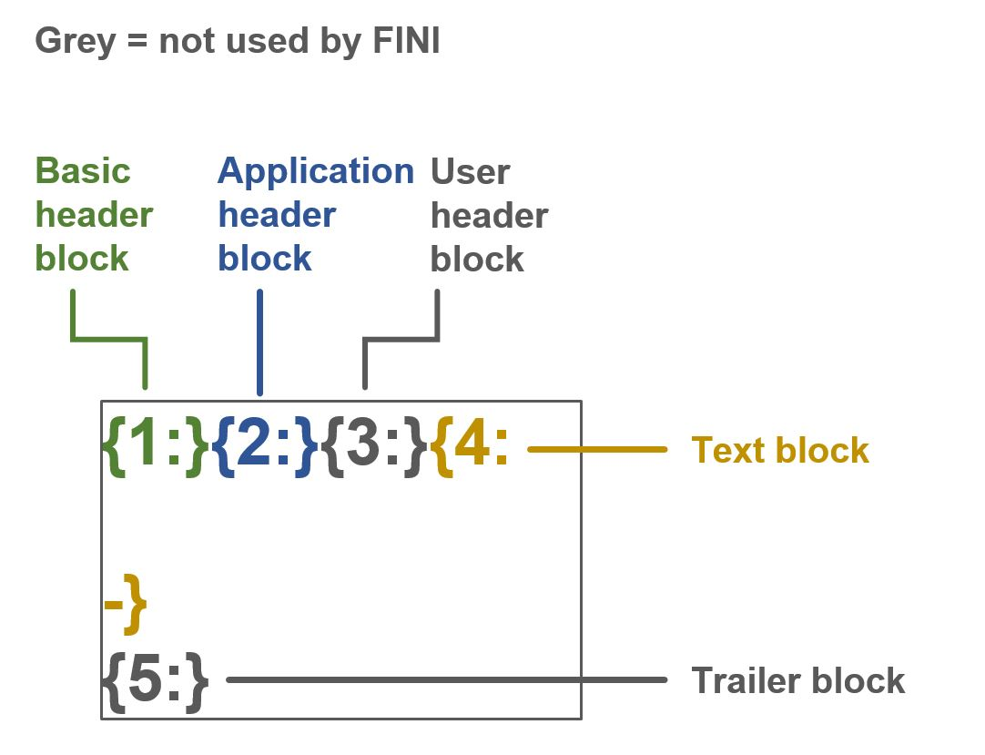

All SWIFT message data fields also operate a unique set of specifications, which differ to other FINI data exchange specifications (SR, CCASS):

|  |  |  |
| --- | --- | --- |
| **Length restrictions** | nn | Maximum length |
| nn! | Fixed length |
| nn-nn | Minimum and maximum length |
| nn * nn | Maximum number of lines times maximum line length |
| **Types of character** | n | Digits |
| d | Digits with a decimal comma |
| h | Uppercase hexadecimals |
| a | Uppercase letters |
| c | Uppercase alphanumeric |
| e | Space |
| x | SWIFT character set |
| y | Upper case level A ISO 9735 characters |
| z | SWIFT extended character set |
| /, word | Character as-is, or, word as-is |
| **Optional element identifier** | […] | Where … represents any of the allowed combinations of length or character |

Below are some examples to illustrate how SWIFT data fields formats function:

|  |  |  |
| --- | --- | --- |
| **Data field format** | **Definition** | **Example(s)** |
| 16x | Up to SWIFT character sets | 3NJBK4L3L5SY2IY9  3NJBK4L <- can be shorter than 16  3NJ <- can be shorter than 16 |
| 3!a15d | **3!a** = 3 fixed length uppercase letters  **15d** = up to 15 digits with a decimal comma. The decimal limit for SWIFT is always two digits, and the decimal comma counts as a 1 character.  Therefore, the integer before the decimal may only go to up 12 digits | HKD12345678,99  HKD999999999999,99 <- max amount possible, as it has twelve 9s. |
| 4!a2!a2!c[3!c] | **4!a** = 4 fixed length uppercase letters  **2!a** = 4 fixed length uppercase letters  **2!c** = 4 fixed length uppercase alphanumeric  **[3!c]** = optional to add 3 uppercase alphanumeric | HSBCHKHH <- can choose not to use the optional field  HSBCHKHHXXX  HKSCHKHHIPO |

**MT 101 HKD pre-funding instructions (FINI ▶ SWIFT)**

**Basic header block:**

|  |  |  |  |  |
| --- | --- | --- | --- | --- |
| **Field** | **Field Name** | **Format** | **FINI implementation guidelines** | **Example** |
| 1 | AppID | 1a | Always “**F”** | F |
| 2 | ServiceID | 2n | Always **“01”** | 01 |
| 3 | LTAddress | 12x | Always **“HKSCHKHHAIPO”** | HKSCHKHHAIPO |
| 4 | SessionNumber | 4n | Always **“0000”** | 0000 |
| 5 | SequenceNumber | 6n | Always **“000000”** | 000000 |

**Application header block:**

|  |  |  |  |  |
| --- | --- | --- | --- | --- |
| **Field** | **Field Name** | **Format** | **FINI implementation guidelines** | **Example** |
| 1 | Input / Output ID | 1a | Always **“I”** | I |
| 2 | SWIFT Message type | 3n | **“101”** to indicate MT 101 message | 101 |
| 3 | Destination Address | 12x | Designated Bank’s BIC code, with an **“A”** between the BIC and branch code [SWIFT BIC codes list] | BKCHHKHHAXXX  (In this example:  BKCHHKHH = BIC code  XXX = branch code) |
| 4 | Priority | 1a | Always **“N”** | N |
| 5 | Delivery Monitoring | 1x | Always **“2”** | 2 |
| 6 | Obsolescence Period | 3n | Always **“020”** | 020 |

**Text block:**

|  |  |  |  |  |
| --- | --- | --- | --- | --- |
| **Field** | **Field Name** | **Format** | **FINI implementation guidelines** | **Example** |
| 20 | Sender’s reference | 16x | Globally unique reference:   * Stock code (5!n) [IPO initiation Field #10] * CCASS participant ID (1!a5!n) [Participant Master Field #4] * Reference number (3!a2!n) [description below]   The reference number is comprised of an instruction code, with the 2 integers indicating sequence:  **PAI = payment instruction**  **RPI = resent payment instruction due to previous rejection**  **REF** = refund instruction  **RRF** = resent refund instruction due to previous rejection | :20:09988B01130PAI01 |
| 28D | Message Index / Total | 5n/5n | Always 1/1. | :28D:1/1 |
| 50C | Instructing Party | 4!a2!a2!c[3!c] | Always **“50C”**, marked with HKSCHKHHIPO for IPO payments | :50C:HKSCHKHHIPO |
| 30 | Requested Execution Date | 6!n | Message generation date, in YYMMDD format | :30:200610 |
| 21 | Transaction Reference | 16x | Repetition of **:20: Sender’s Reference** | :21:09988B01130PAI01 |
| 32B | Currency / Transaction Amount | 3!a15d | **Currency** = HKD  **Transaction Amount** = retail broker’s payment obligations (up to 12 digits + 2 decimal points, separated by a decimal comma) | :32B:HKD12345678,99 |
| 50G | Ordering Customer | [/1!a][/34x]  4!a2!a2!c[3!c] | Always **“50G”**, with the retail broker’s bank account details:-  **1st line** = “/” + “HK” [bank code, Participant Master Field #6]-[branch code, Participant Master Field #9]-[bank account #, Participant Master Field #7] (3!n-3!n-8!n)  **2nd line** = designated bank BIC code [SWIFT BIC codes list] | :50G:/HK000-000-00000000  BKCHHKHHXXX |
| 57A | Account with Institution | [/1!a][/34x]  4!a2!a2!c[3!c] | Always **“57A”**, with the receiving bank BIC code [SWIFT BIC codes list] | :57A:HSBCHKHHXXX |
| 59F | Beneficiary | [/34x]  4*(1!n/33x) | Always **“59F”**, with IPO issuer’s bank account information:  1st line = “/” + “HK” [bank code]-[branch code]-[bank account #] (3!n-3!n-8!n) [IPO initiation Field #49/ #50]  2nd to 5th lines = sequence number + “/” + name and address details [IPO initiation Field #49/ #50] | :59F:/HK999-999-99999999  1/ALIBABA GROUP HOLDING LIMITED  2/26F TOWER ONE TIMES SQUARE  2/1 MATHESON ROAD CAUSEWAY BAY  3/HKSAR CHINA |
| 71A | Details of Charges | 3!a | Always **“SHA”** | :71A:SHA |

**Example:**

* **MT 101** payment instruction for **Bank of China (as a designated bank)** to execute **BOCI Securities Limited’s payment** of **HK$12345678.99** for **Alibaba’s IPO shares** on **10 June 2020**

|  |
| --- |
| Message:  {1:F01HKSCHKHHAIPO0000000000}{2:I**101BKCHHKHHXXX**N2020}{4:  :20:**09988B01130PAI01**  :28D:1/1  :50C:HKSCHKHHIPO  :30:**200610**  :21:**09988B01130PAI01**  :32B:**HKD12345678,99**  :50G:/HK000-000-00000000  HHC00000  :57A:HSBCHKHH  :59F:/HK999-999-99999999  1/ALIBABA GROUP HOLDING LIMITED  2/26F TOWER ONE TIMES SQUARE  2/1 MATHESON ROAD CAUSEWAY BAY  3/HKSAR CHINA  :71A:SHA} |

**MT 101 HKD re-funding instructions (FINI ▶ SWIFT)**

**Basic header block:**

|  |  |  |  |  |
| --- | --- | --- | --- | --- |
| **Field** | **Field Name** | **Format** | **FINI implementation guidelines** | **Example** |
| 1 | AppID | 1a | Always “**F”** | F |
| 2 | ServiceID | 2n | Always **“01”** | 01 |
| 3 | LTAddress | 12x | Always **“HKSCHKHHAIPO”** | HKSCHKHHAIPO |
| 4 | SessionNumber | 4n | Always **“0000”** | 0000 |
| 5 | SequenceNumber | 6n | Always **“000000”** | 000000 |

**Application header block:**

|  |  |  |  |  |
| --- | --- | --- | --- | --- |
| **Field** | **Field Name** | **Format** | **FINI implementation guidelines** | **Example** |
| 1 | Input / Output ID | 1a | Always **“I”** | I |
| 2 | SWIFT Message type | 3n | **“101”** to indicate MT 101 message | 101 |
| 3 | Destination Address | 12x | Receiving Bank’s BIC code, with an **“A”** between the BIC and branch code [SWIFT BIC codes list] | HSBCHKHHAXXX  (In this example:  HSBCHKHH = BIC code  XXX = branch code) |
| 4 | Priority | 1a | Always **“N”** | N |
| 5 | Delivery Monitoring | 1x | Always **“2”** | 2 |
| 6 | Obsolescence Period | 3n | Always **“020”** | 020 |

**Text block:**

|  |  |  |  |  |
| --- | --- | --- | --- | --- |
| **Field** | **Field Name** | **Format** | **FINI implementation guidelines** | **Example** |
| 20 | Sender’s reference | 16x | Globally unique reference:   * Stock code (5!n) [IPO initiation Field #10] * CCASS participant ID (1!a5!n) [Participant Master Field #4] * Reference number (3!a2!n) [description below]   The reference number is comprised of an instruction code, with the 2 integers indicating sequence:  PAI = payment instruction  RPI = resent payment instruction due to previous rejection  **REF = refund instruction**  **RRF = resent refund instruction due to previous rejection** | :20:09988B01130REF01 |
| 28D | Message Index / Total | 5n/5n | Always 1/1. | :28D:1/1 |
| 50C | Instructing Party | 4!a2!a2!c[3!c] | Always **“50C”**, marked with HKSCHKHHIPO for IPO payments | :50C:HKSCHKHHIPO |
| 30 | Requested Execution Date | 6!n | Message generation date, in YYMMDD format | :30:200611 |
| 21 | Transaction Reference | 16x | Repetition of **:20: Sender’s Reference** | :21: 09988B01130REF01 |
| 32B | Currency / Transaction Amount | 3!a15d | **Currency** = HKD  **Transaction Amount** = receiving bank’s refunding obligations (up to 12 digits + 2 decimal points, separated by a decimal comma) | :32B:HKD2345678,99 |
| 50G | Ordering Customer | [/1!a][/34x]  4!a2!a2!c[3!c] | Always **“50G”**, with the receiving bank’s account details:  **1st line** = “/” + “HK” [bank code]-[branch code]-[bank account#] (3!n-3!n-8!n) [IPO initiation Field #49/ #50]  **2nd Line** = Receiving bank BIC code [SWIFT BIC codes list] | :50G:/HK999-999-99999999  HSBCHKHHXXX |
| 57A | Account with Institution | [/1!a][/34x]  4!a2!a2!c[3!c] | Always **“57A”**, with the designated bank BIC code [SWIFT BIC codes list] | :57A:BKCHHKHHXXX |
| 59F | Beneficiary | [/34x]  4*(1!n/33x) | Always **“59F”**, with IPO issuer’s bank account information:  1st line = “/” + “HK” [bank code, Participant Master Field #6]-[branch code, Participant Master Field #9]-[bank account #, Participant Master Field #7] (3!n-3!n-8!n)  2nd to 5th lines = sequence number + “/” + name and address details [Participant Master Fields #13-17] | :59F:/HK000-000-00000000  1/BOCI SEC LTD  2/22F GRAND MILLENIUM PLAZA  2/181 QUEEN’S ROAD CENTRAL  3/HONG KONG |
| 71A | Details of Charges | 3!a | Always **“SHA”** | :71A:SHA |

**Example:**

* **MT 101** payment instruction for **HSBC (as the receiving bank)** to execute **a refund of HK$235678.99** to **BOCI Securities Limited’s payment** for **Alibaba’s IPO** on **11 June 2020**

|  |
| --- |
| Message:  {1:F01HKSCHKHHAIPO0000000000}{2:I**101HSBCHHKHHXXX**N2020}{4:  :20:**09988B01130REF01**  :28D:1/1  :50C:HKSCHKHHIPO  :30:**200611**  :21:**09988B01130REF01**  :32B:**HKD2345678,99**  :50G:/HK999-999-99999999  HSBCHKHHXXX  :57A:BKCHHKHHXXX  :59F:/HK000-000-00000000  1/BOCI SEC LTD  2/22F GRAND MILLENIUM PLAZA  2/181 QUEEN’S ROAD CENTRAL  3/HONG KONG  :71A:SHA} |

**MT 101 CNY/USD pre-funding instructions (FINI ▶ SWIFT)**

**\* Variation from HKD version**

**Basic header block:**

|  |  |  |  |  |
| --- | --- | --- | --- | --- |
| **Field** | **Field Name** | **Format** | **FINI implementation guidelines** | **Example** |
| 1 | AppID | 1a | Always “**F”** | F |
| 2 | ServiceID | 2n | Always **“01”** | 01 |
| 3 | LTAddress | 12x | Always **“HKSCHKHHAIPO”** | HKSCHKHHAIPO |
| 4 | SessionNumber | 4n | Always **“0000”** | 0000 |
| 5 | SequenceNumber | 6n | Always **“000000”** | 000000 |

**Application header block:**

|  |  |  |  |  |
| --- | --- | --- | --- | --- |
| **Field** | **Field Name** | **Format** | **FINI implementation guidelines** | **Example** |
| 1 | Input / Output ID | 1a | Always **“I”** | I |
| 2 | SWIFT Message type | 3n | **“101”** to indicate MT 101 message | 101 |
| 3 | Destination Address | 12x | Designated Bank’s BIC code, with an **“A”** between the BIC and branch code [SWIFT BIC codes list] | BKCHHKHHAXXX  (In this example:  BKCHHKHH = BIC code  XXX = branch code) |
| 4 | Priority | 1a | Always **“N”** | N |
| 5 | Delivery Monitoring | 1x | Always **“2”** | 2 |
| 6 | Obsolescence Period | 3n | Always **“020”** | 020 |

**Text block:**

|  |  |  |  |  |
| --- | --- | --- | --- | --- |
| **Field** | **Field Name** | **Format** | **FINI implementation guidelines** | **Example** |
| 20 | Sender’s reference | 16x | Globally unique reference:   * Stock code (5!n) [IPO initiation Field #10] * **CCASS participant ID (1!a5!n) [Designated Bank Master Field #2]** * Reference number (3!a2!n) [description below]   The reference number is comprised of an instruction code, with the 2 integers indicating sequence:  **PAI = payment instruction**  **RPI = resent payment instruction due to previous rejection**  REF = refund instruction  RRF = resent refund instruction due to previous rejection | :20:09988**B01130**PAI01 |
| 28D | Message Index / Total | 5n/5n | Always 1/1. | :28D:1/1 |
| 50C | Instructing Party | 4!a2!a2!c[3!c] | Always **“50C”**, marked with HKSCHKHHIPO for IPO payments | :50C:HKSCHKHHIPO |
| 30 | Requested Execution Date | 6!n | Message generation date, in YYMMDD format | :30:200610 |
| 21 | Transaction Reference | 16x | Repetition of **:20: Sender’s Reference** | :21:09988B01130PAI01 |
| 32B | Currency / Transaction Amount | 3!a15d | **Currency** = **CNY / USD**  **Transaction Amount** = retail broker’s payment obligations (up to 12 digits + 2 decimal points, separated by a decimal comma) | :32B:**CNY**12345678,99 |
| 50G | Ordering Customer | [/1!a][/34x]  4!a2!a2!c[3!c] | Always **“50G”**, with the retail broker’s bank account details:-  **1st line** = “/” + “HK” **[bank code, Designated Bank Master Field #8]-[branch code, Designated Bank Master Field #9]-[bank account #, Participant Master Field #10] (3!n-3!n-8!n)**  **2nd line** = designated bank BIC code [SWIFT BIC codes list] | :50G:/HK**000-000-00000000**  BKCHHKHHXXX |
| 57A | Account with Institution | [/1!a][/34x]  4!a2!a2!c[3!c] | Always **“57A”**, with the receiving bank BIC code [SWIFT BIC codes list] | :57A:HSBCHKHHXXX |
| 59F | Beneficiary | [/34x]  4*(1!n/33x) | Always **“59F”**, with IPO issuer’s bank account information:  1st line = “/” + “HK” [bank code]-[branch code]-[bank account #] (3!n-3!n-8!n) [IPO initiation Field #49/ #50]  2nd to 5th lines = sequence number + “/” + name and address details [IPO initiation Field #49/ #50] | :59F:/HK999-999-99999999  1/ALIBABA GROUP HOLDING LIMITED  2/26F TOWER ONE TIMES SQUARE  2/1 MATHESON ROAD CAUSEWAY BAY  3/HKSAR CHINA |
| 71A | Details of Charges | 3!a | Always **“SHA”** | :71A:SHA |

**Example:**

* **MT 101** payment instruction for **Bank of China (as a designated bank)** to execute **BOCI Securities Limited’s payment** of **CNY$12345678.99** for **Alibaba’s IPO shares** on **10 June 2020**

|  |
| --- |
| Message:  {1:F01HKSCHKHHAIPO0000000000}{2:I**101BKCHHKHHXXX**N2020}{4:  :20:**09988B01130PAI01**  :28D:1/1  :50C:HKSCHKHHIPO  :30:**200610**  :21:**09988B01130PAI01**  :32B:**CNY12345678,99**  :50G:/HK000-000-00000000  HHC00000  :57A:HSBCHKHH  :59F:/HK999-999-99999999  1/ALIBABA GROUP HOLDING LIMITED  2/26F TOWER ONE TIMES SQUARE  2/1 MATHESON ROAD CAUSEWAY BAY  3/HKSAR CHINA  :71A:SHA} |

**MT 101 CNY/USD refunding instructions (FINI ▶ SWIFT)**

**Basic header block:**

|  |  |  |  |  |
| --- | --- | --- | --- | --- |
| **Field** | **Field Name** | **Format** | **FINI implementation guidelines** | **Example** |
| 1 | AppID | 1a | Always “**F”** | F |
| 2 | ServiceID | 2n | Always **“01”** | 01 |
| 3 | LTAddress | 12x | Always **“HKSCHKHHAIPO”** | HKSCHKHHAIPO |
| 4 | SessionNumber | 4n | Always **“0000”** | 0000 |
| 5 | SequenceNumber | 6n | Always **“000000”** | 000000 |

**Application header block:**

|  |  |  |  |  |
| --- | --- | --- | --- | --- |
| **Field** | **Field Name** | **Format** | **FINI implementation guidelines** | **Example** |
| 1 | Input / Output ID | 1a | Always **“I”** | I |
| 2 | SWIFT Message type | 3n | **“101”** to indicate MT 101 message | 101 |
| 3 | Destination Address | 12x | Receiving Bank’s BIC code, with an **“A”** between the BIC and branch code [SWIFT BIC codes list] | HSBCHKHHAXXX  (In this example:  HSBCHKHH = BIC code  XXX = branch code) |
| 4 | Priority | 1a | Always **“N”** | N |
| 5 | Delivery Monitoring | 1x | Always **“2”** | 2 |
| 6 | Obsolescence Period | 3n | Always **“020”** | 020 |

**Text block:**

|  |  |  |  |  |
| --- | --- | --- | --- | --- |
| **Field** | **Field Name** | **Format** | **FINI implementation guidelines** | **Example** |
| 20 | Sender’s reference | 16x | Globally unique reference:   * Stock code (5!n) [IPO initiation Field #10] * **CCASS participant ID (1!a5!n) [Designated Bank Master Field #2]** * Reference number (3!a2!n) [description below]   The reference number is comprised of an instruction code, with the 2 integers indicating sequence:  PAI = payment instruction  RPI = resent payment instruction due to previous rejection  **REF = refund instruction**  **RRF = resent refund instruction due to previous rejection** | :20:09988**B01130**REF01 |
| 28D | Message Index / Total | 5n/5n | Always 1/1. | :28D:1/1 |
| 50C | Instructing Party | 4!a2!a2!c[3!c] | Always **“50C”**, marked with HKSCHKHHIPO for IPO payments | :50C:HKSCHKHHIPO |
| 30 | Requested Execution Date | 6!n | Message generation date, in YYMMDD format | :30:200611 |
| 21 | Transaction Reference | 16x | Repetition of **:20: Sender’s Reference** | :21: 09988B01130REF01 |
| 32B | Currency / Transaction Amount | 3!a15d | **Currency** = **CNY / USD**  **Transaction Amount** = receiving bank’s refunding obligations (up to 12 digits + 2 decimal points, separated by a decimal comma) | :32B:**HKD**2345678,99 |
| 50G | Ordering Customer | [/1!a][/34x]  4!a2!a2!c[3!c] | Always **“50G”**, with the receiving bank’s account details:  **1st line** = “/” + “HK” [bank code]-[branch code]-[bank account#] (3!n-3!n-8!n) [IPO initiation Field #49/ #50]  **2nd Line** = Receiving bank BIC code [SWIFT BIC codes list] | :50G:/HK999-999-99999999  HSBCHKHHXXX |
| 57A | Account with Institution | [/1!a][/34x]  4!a2!a2!c[3!c] | Always **“57A”**, with the designated bank BIC code [SWIFT BIC codes list] | :57A:BKCHHKHHXXX |
| 59F | Beneficiary | [/34x]  4*(1!n/33x) | Always **“59F”**, with IPO issuer’s bank account information:  1st line = “/” + “HK” **[bank code, Designated Bank Master Field #8]-[branch code, Designated Bank Master Field #9]-[bank account #, Participant Master Field #10] (3!n-3!n-8!n)**  2nd to 5th lines = sequence number + “/” + name and address details [Participant Master Fields #13-17] | :59F:/HK**000-000-00000000**  1/BOCI SEC LTD  2/22F GRAND MILLENIUM PLAZA  2/181 QUEEN’S ROAD CENTRAL  3/HONG KONG |
| 71A | Details of Charges | 3!a | Always **“SHA”** | :71A:SHA |

**Example:**

* **MT 101** payment instruction for **HSBC (as the receiving bank)** to execute **a refund of HK$235678.99** to **BOCI Securities Limited’s payment** for **Alibaba’s IPO** on **11 June 2020**

|  |
| --- |
| Message:  {1:F01HKSCHKHHAIPO0000000000}{2:I**101HSBCHHKHHXXX**N2020}{4:  :20:**09988B01130REF01**  :28D:1/1  :50C:HKSCHKHHIPO  :30:**200611**  :21:**09988B01130REF01**  :32B:**HKD2345678,99**  :50G:/HK999-999-99999999  HSBCHKHHXXX  :57A:BKCHHKHHXXX  :59F:/HK000-000-00000000  1/BOCI SEC LTD  2/22F GRAND MILLENIUM PLAZA  2/181 QUEEN’S ROAD CENTRAL  3/HONG KONG  :71A:SHA} |

**MT 900 confirmation (SWIFT ▶ FINI)**

Since FINI is the recipient, the only validation required is for {4: text block}.

**Text block:**

|  |  |  |  |  |
| --- | --- | --- | --- | --- |
| **Field** | **Field Name** | **Format** | **FINI implementation guidelines** | **Example** |
| 20 | Sender’s reference | 16x | Bank’s own sender’s reference **[No FINI validation]** | :20:3NJBK4L3L5SY2IY9 |
| 21 | Related Reference | 16x | Must match :20:Sender’s Reference or :21:Related Reference data field from MT 101 payment instruction | :21:09988B01130PAI01 |
| 25 | Account Identification | 35x | Always “25”, includes bank account name of the debited bank account **[No FINI validation]** | :25: BOCI SECURITIES LIMITED |
| 32A | Value Date, Currency Code, Amount | 6!n3!a15d | Must match against “Requested Execution Date” + “Currency / Transaction Amount” from MT 101 payment instruction | :32A:200610HKD12345678,99 |
| 72 | Sender to Receiver Information | /8c/[additional information] | Always code “REC” and a full copy of the sender’s reference of the executing MT103 payment message **[No FINI validation]** | :72:/REC/D08JSAARZ0IN502P |

**Example:**

* **Bank of China (as a designated bank)** **confirms** the execution of **BOCI Securities Limited’s payment** of **HK$12345678.99** for **Alibaba’s IPO shares** on **10 June 2020**

|  |
| --- |
| Message:  {1:F01**BKCHHKHHAXXX**4321123456}{2:I**900**HKSCHKHHIPON2020}{4:  :20:3NJBK4L3L5SY2IY9  :21:**09988B01130PAI01**  :25: **BOCI SECURITIES LIMITED**  :32A:**200610HKD12345678,99**  :72:/REC/D08JSAARZ0IN502P} |

**MT 195 rejection (SWIFT ▶ FINI)**

Since FINI is the recipient, the only validation required is for {4: text block}.

**Text block:**

|  |  |  |  |  |
| --- | --- | --- | --- | --- |
| **Field** | **Field Name** | **Format** | **FINI implementation guidelines** | **Example** |
| 20 | Sender’s reference | 16x | Bank’s own sender’s reference **[No FINI validation]** | :20:3NJBK4L3L5SY2IY9 |
| 21 | Related Reference | 16x | Must match :20:Sender’s Reference or :21:Related Reference data field from MT 101 payment instruction | :21:09988B01130PAI01 |
| 75 | Queries | 6*35x | Based on the following format: /2n/[supplement 1][supplement 2]  FINI will support the following reason codes:  **5:** The beneficiary cannot be located at the address you supplied. Please provide further particulars.  **22:** This item appears to be a duplicate of your entry dated (1) … (YYYYMMDD) with reference (2) (16x). Please investigate and, in need, adjust with good value.  **47:** We appear to have been charged incorrectly for this transaction  Where supplement (2) is used, ie two different pieces of supplementary information are provided, the second piece of information should be preceded by a slash ‘/’ | :75:/22/20200610/09988B01130PAI01 |
| 11S | MT and Date of Original Message | 3!n  6!n | Always **“11S”** | :11S:101  200610 |
|  | Narrative Description of the Message to Which the Query Relates | 35*50x | Repetition of original MT 101 payment instruction | :20:09988B01130PAI01  :28D:1/1  :50C:HKSCHKHHIPO  :30:200610  :21:09988B01130PAI01  :32B:HKD12345678,99  :50G:/HK000-000-00000000  HHC00000  :57A:HSBCHKHH  :59F:/HK999-999-99999999  1/ALIBABA GROUP HOLDING LIMITED  2/LEVEL 25 HSBC MAIN BUILDING  3/1 QUEEN’S ROAD CENTRAL  4/HONG KONG  :71A:SHA |

**Example:**

* **Bank of China (as a designated bank)** responds that the **MT 101 message for BOCI Securities Limited’s payment of HK$12345678.99** has been **rejected** due to a **potential duplication** (between 09988B01130PAI01 and 09988B01130PAI02)

|  |
| --- |
| Message:  {1:F01**BKCHHKHHAXXX**4321123456}{2:I**195**HKSCHKHHIPON2020}{4:  :20:3NJBK4L3L5SY2IY9  :21:**09988B01130PAI02**  :75:**/22/20200610/09988B01130PAI01**  :11S:**101**  **200610**}  **:20:09988B01130PAI02**  **:28D:1/1**  **:50C:HKSCHKHHIPO**  **:30:200610**  **:21:09988B01130PAI02**  **:32B:HKD12345678,99**  **:50G:/HK000-000-00000000**  **HHC00000**  **:57A:HSBCHKHH**  **:59F:/HK999-999-99999999**  **1/ALIBABA GROUP HOLDING LIMITED**  **2/26F TOWER ONE TIMES SQUARE**  **3/1 MATHESON ROAD**  **4/CAUSEWAY BAY**  **5/HONG KONG**  **:71A:SHA** |

### Data Exchange with SR

The data exchange between FINI and Share Registars should be via EMFT. Every file to be sent to SRs should be placed in a compressed .zip file with (AES-256 encryption).

**Autopay brokerage file (FINI -> SR)**

Every day, FINI should generate an autopay brokerage file based on CCASS reference data to outline the bank account information of all Clearing Participants. The file should only be sent to SRs who have an IPO that is reaching the public offer book close.

**Technical specifications:**

|  |  |  |
| --- | --- | --- |
| **Field Name** | **Field Format** | **Description** |
| PC File Name | BANKACCINFO.txt |  |
| ZIP File Name | BANKACCINFO.zip |

**Header record:**

|  |  |  |
| --- | --- | --- |
| **Field Name** | **Field Format** | **Description** |
| Record Type | X(1) | Should always be 0 for header record |
| File Name | X(15) | ‘BANK ACC INFO ’ |
| File creation date | X(8) | In YYYYMMDD format |
| File creation time | X(6) | In HHMMSS format |

**Detailed record:**

|  |  |  |
| --- | --- | --- |
| **Field Name** | **Field Format** | **Description** |
| Record Type | X(1) | Should always be 1 for detailed record |
| Firm ID | 9(5) | Field #4 (Part Firm ID) from Participant Master |
| Broker Full Name 1 | X(40) | Field #11 (Full Name 1) from Participant Master |
| Broker Full Name 2 | X(40) | Field #12 (Full Name 2) from Participant Master |
| Broker Short Name | X(15) | Field #13 (Short Name) from Participant Master |
| Bank Account Currency | X(3) | HKD / CNY / USD |
| Bank Code | X(3) | For HKD:  Field #6 (Bank Code) from Participant Master  For CNY / USD:  Field #9 (Bank Account Number) from Designated Bank Master |
| Branch Code | X(3) | For HKD:  Field #9 (Branch Code) from Participant Master  For CNY / USD:  Field #10 (Bank Account Number) from Designated Bank Master |
| Bank Account Number | X(9) | For HKD:  Field #7 (Bank Code) from Participant Master  For CNY / USD:  Field #11 (Bank Account Number) from Designated Bank Master |
| Bank Account Name | X(40) | For HKD:  Field #8 (Bank Account Number) from Participant Master  For CNY / USD:  Field #12 (Bank Account Number) from Designated Bank Master |
| Broker Address 1 | X(40) | Field #14 (Address 1) from Participant Master |
| Broker Address 2 | X(40) | Field #15 (Address 2) from Participant Master |
| Broker Address 3 | X(40) | Field #16 (Address 3) from Participant Master |
| Broker Address 4 | X(40) | Field #17 (Address 4) from Participant Master |

**Control record:**

|  |  |  |
| --- | --- | --- |
| **Field Name** | **Field Format** | **Description** |
| Record Type | X(1) | Should always be 9 for control record |
| Number of detailed records | 9(5) |  |

**EIPO application file (FINI -> SR)**

Every day, FINI should generate an EIPO application list for each IPO that has passed the public offer book close and final data cleansing, including:

* All valid applications under authorised status (broker channel + share registrar channel)
* Duplicate applications under authorised status (share registrar channel)

The fixed-length .txt file should be placed in a compressed .zip file with (AES-256 encryption), and sent to the Share Registrar via EMFT immediately after EIPO de-duplication.

**Technical specifications:**

|  |  |  |
| --- | --- | --- |
| **Field Name** | **Field Format** | **Description** |
| PC File Name | EIPOAPPL_Rxx_STKyyyyy.txt | RXX = Registrar code (from Registrar Master)  yyyyy = Stock code, with leading zeroes (from IPO reference data) |
| ZIP File Name | EIPOAPPL_Rxx_STKyyyyy.zip |

**Header record:**

|  |  |  |
| --- | --- | --- |
| **Field Name** | **Field Format** | **Description** |
| Record Type | X(1) | Should always be 0 for header record |
| File Name | X(15) | ‘IPO APPLN FILE ’ |
| Registrar ID | X(2) | Registrar code (from Registrar Master Field #2), truncated after “R”  Based on HK share registrar (from IPO initiation Field #48) |
| Stock Code | X(5) | IPO stock code (from IPO initiation Field #10) |
| File creation date | X(8) | In YYYYMMDD format |
| File creation time | X(6) | In HHMMSS format |

**Detailed record:**

|  |  |  |
| --- | --- | --- |
| **Field Name** | **Field Format** | **Description** |
| Record Type | X(1) | Should always be 1 for detailed record |
| Firm ID | 9(5) |  |
| Application Instruction No. | X(9) | Unique # generated by FINI |
| Remarks (Share Registrar channel) | X(32) | Only show remarks of Share Registrar applications  Always blank for broker channel applications |
| Valid / invalid | X(1) | V = Valid, I = Invalid (duplicate applications) |
| Application Quantity | 9(11) | Right justify with leading zeroes |

**Control record:**

|  |  |  |
| --- | --- | --- |
| **Field Name** | **Field Format** | **Description** |
| Record Type | X(1) | Should always be 9 for control record |
| Total no. of applications | 9(9) |  |
| Application Quantity Total | 9(15) |  |

**EIPO Allotment file (SR -> FINI)**

Every day, the Share Registrar generates an EIPO allotment file for each IPO after balloting and before 2pm on the public offer book close date. The fixed-length .txt file should be placed in a compressed .zip file with (AES-256 encryption), and sent to FINI via EMFT.

**Technical specifications:**

|  |  |  |
| --- | --- | --- |
| **Field Name** | **Field Format** | **Description** |
| PC File Name | EIPOALLOTMENT_STKyyyyy.txt | yyyyy = Stock code, with leading zeroes (from IPO reference data) |
| ZIP File Name | EIPOALLOTMENT_STKyyyyy.zip |

**Header record:**

|  |  |  |
| --- | --- | --- |
| **Field Name** | **Field Format** | **Description** |
| Record Type | X(1) | Should always be 0 for header record |
| File Name | X(15) | ‘EIPO ALLOTMENT’ |
| Stock Code | X(5) | IPO stock code (from IPO initiation Field #10) |
| File creation date | X(8) | In YYYYMMDD format |
| File creation time | X(6) | In HHMMSS format |

**Detailed record:**

|  |  |  |
| --- | --- | --- |
| **Field Name** | **Field Format** | **Description** |
| Record Type | X(1) | Should always be 1 for detailed record |
| Firm ID | 9(5) | Applicant’s Firm ID |
| Application Instruction No. | X(9) | Unique # generated by FINI, per IPO |
| Successful Quantity | 9(11) | Zero indicates wholly unsuccessful application |
| Unsuccessful Quantity | 9(11) | Zero indicates wholly successful application |
| Unsuccessful Reason Code | X(2) | ‘01’ – not allotted  ‘02’ – failed payment  Must be blank if successful quantity >0 |
| Application Quantity | 9(11) | Applicant’s application of shares, with leading zeroes |

**Control record:**

|  |  |  |
| --- | --- | --- |
| **Field Name** | **Field Format** | **Description** |
| Record Type | X(1) | Should always be 9 for control record |
| Total no. of detailed records | 9(9) |  |
| Application Quantity Total | 9(15) |  |
| Total Successful Quantity | 9(15) |  |
| Total Unsuccessful Quantity | 9(15) |  |

**EIPO final allocation file (FINI -> SR)**

**EIPO confirmation file (FINI -> SR)**

**EIPO unconfirmed file (SR -> FINI)**

## Core processing engine – Shared services

### Participant management

FINI will leverage the current Company profile management functions in ForgeRock (the instance that Client Connect is using).

**Company Profile Management**

Internal Admin User will create new companies based on the FINI operation. Excluding HKEX, there are eight types of companies that will use FINI platform:

1. Legal Advisor (Sponsor)
2. Legal Advisor (Issuer)
3. Principal Sponsor
4. Lead Broker
5. Distributor
6. Clearing Participant
7. Share Registrar
8. Regulator (i.e. SFC)

For the companies already exist in the ForgeRock system (as they are also Client Connect users), such as Clearing Participants and Share Registrars. The existing company profile will be used for FINI.

The maintenance process of Company data will follow the existing procedure of Client Connect operations. However for new company setup, a bulk upload function is required in order onboard large number of new companies. The assumptions of the function are as followed

**Company Identity Management**

Company Identity defines the ‘relationship’ of the company with HKEX. For example, the Identity ‘HKSCCp’ means the company is a HKSCC participant.

In order to fufill the FINI operation requirements, a new set of Identity will be defined based on the types of companies identified above. Each company will be assigned with one or more Identity types, and a Company Identity code will be assigned (e.g. the Company Identity code for HKSCCp will be the HKSCC Part ID). However, one company cannot be assigned with the same Identity type for more than once.

The setup process of Company data will follow the existing procedure of Client Connect operations.

### User management and authentication / authorisation management

FINI will leverage the current ForgeRock platform for User management, Participant management, as well as Role management. ForgeRock is the Identity Access Management platform for Client Connect, and will be extended to be used by other internet facing application.

#### User Structure Requirements

**Current user structure**

The current user structure (currently used by Client Connect platform) consists of four key attributes (Company, Identity, Function, Role Type. The relationship can adopted in FINI, and the proposed usage is illustrated in the diagram below:

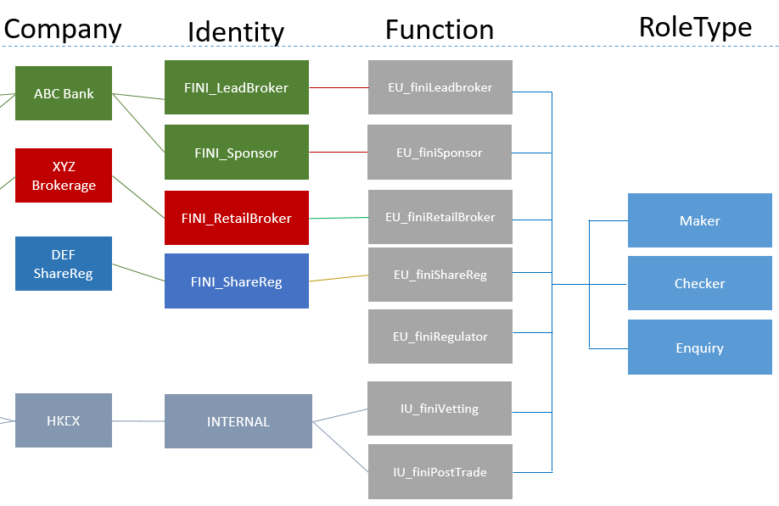

Each External user can be assigned with one to many companies, and each assigned company can have one to many Identities. Functions and Role Types are assigned based on the Company and Identity pairs.

**Proposed user structure**

In order to fulfill FINI operation requirement, a new attribute (‘Team’) will be added in order to segregate the IPO data access within a company. The new proposed user structure is shown below:

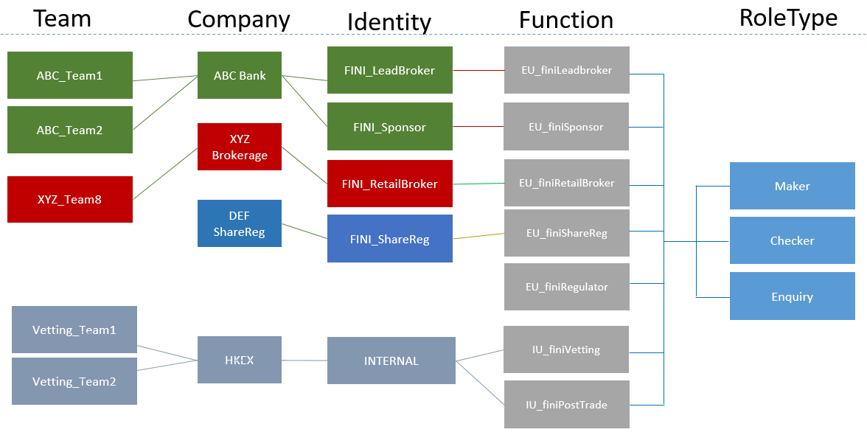

The Team is defined as the grouping of users within the same company. Multiple teams can be created for one company. It is used for the assignment of ‘advisors’ in the IPO setup, and it governs the IPO data access. For example, if ABC_Team1 of ABC Bank (in the above diagram) is assigned as the Sponsor advisor of a particular IPO, it means that only the user of the ABC_Team1 can access the data of that IPO, while the other users of ABC Bank will not have such access.

The ‘Team’ concept will be applied to functions which requires ‘Chinese Wall’ among the operation teams. For the functions such as EIPO application submission, the ‘Team’ assignment will not be required, and all the users (with the right function assigned) within the company will be able to access all IPOs.

Team concept also applies to ‘multiple companies’ scenario. For example, if a user can manage multiple companies. S/he can belong to the teams that created under all his/her managed companies. An example is illustrated below:

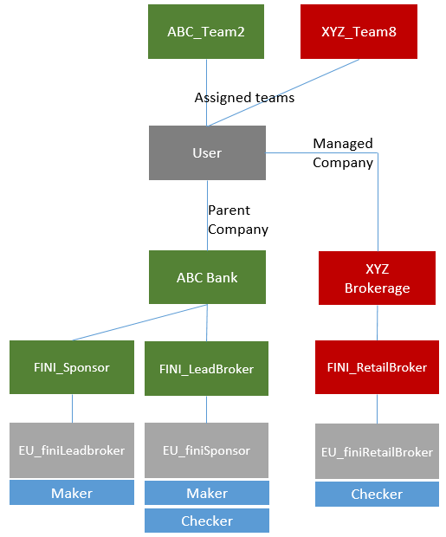

In the above example, the User can manage two companies (ABC Bank, XYZ Brokerage). This user can be assigned to the teams under the two managed companies.

It is required that once the user login to FINI system, s/he can ‘switch’ company and the functions and data access be changed accordingly.

**API user structure**

As FINI will provide API access, it is required that the EXTERNAL ADMIN users can manage their own API users (i.e. the user for ‘system to system’ communication). In order to align with the experience of existing user management, it is proposed that the API users be managed within ForgeRock platform.

API user structure will be relatively simpler than human user structure as there will NOT be API to perform maker/checker role. And the ‘Team’ concept does not apply to API users too. The user structure API users can be illustrated below:

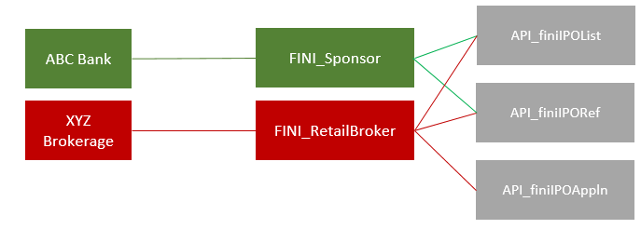

Simply, each API user will represent a company and the functions available will depend on the ‘identity’ of the company. For example (in the above diagram), ABC Bank is a Sponsor and there are two API available. When the Admin of ABC Bank creates the API user, there will be two APIs available.

#### Identity and Function setup requirement

**Company Identity**

A new set of Identity and a new set of Functions will be created for FINI platform.

In general, the ‘Identity’ set will follow the type of ‘participants’ in FINI. They are listed below:

1. Legal Advisor (Sponsor)
2. Legal Advisor (Issuer)
3. Principal Sponsor
4. Lead Broker
5. Distributor
6. Clearing Participant
7. Share Registrar
8. Regulator (i.e. SFC)

Internal teams are not included in the above as they belong to the existing identity for HKEX.

So there will be at least 8 different ‘Identities’ and they will be pre-fixed with specific tag (i.e. ‘FINI_’) in the identity name in order to be identified as ‘eligible for FINI system access’.

HKEX IT Admin users will set up the new Identities in ForgeRock.

**Functions**

The Functions available in ForgeRock will follow the functional groups in FINI platform. So the list of Functions on both system will be identical so as to simplify the setup process. However, within FINI, the grouping of individual functions should be configurable by system admin via script or configuration file.

HKEX IT Admin users will set up the new Functions in ForgeRock.

#### User Management Requirements

The operation of the user management functions for existing user structure will remain unchanged. So the new functions required include the ‘Team Management’ and ‘API User Management’.

**Team Management**

The proposed flow for External Users as follow:

1. IT team define new Functions (e.g. ‘EA_ManageTeam’) for the External Admin users to operate the team management function.
2. IT team assign the new Function to the FINI Identity (those with prefix ‘FINI’)
3. Internal Admin create Company, assign the FINI Identity.
4. Internal Admin create External Admin users and add the EA_ManageTeam function (at least one maker and one checker users)
5. External Admin creates the ‘Team’ (maker-checker required). The team name will consist of two part: a prefix (which is a predefined list, e.g.’ECM’, ‘IBD’, ‘SYN’. The exact listing will be defined in design phase) and the team name (a free text for user to input). The prefix will be used in FINI to prefiter the team availabel for selection in IPO creation.
6. External Admin assign External Business Users to the Team (maker-checker required).

The proposed flow for Internal Users as follow:

1. IT team define new Functions (e.g.‘IA_ManageTeam’) for Internal Admin users to operate the team management function.
2. IT team assign the new Function to the internal Identity
3. IT team create the Internal Admin users add the IA_ManageTeam function (one maker and one checker)
4. Internal Admin users create the ‘Team’ (maker-checker required)
5. Internal Admin users assign Internal Business Users to the Team (maker-checker required).

Team members can be changed anytime. However the team name cannot be changed once created.

Team can be deleted only if NO member assigned.

**API User Management**

The proposed flow for API Users as follow:

1. IT team define new Function (e.g. ‘EA_ManageAPIRoles’) for External Admin users to operate the API user management functions.
2. IT team define new Functions based on the list of API in FINI (e.g. ‘API_finiIPOList’).
3. IT team assign the new Functions to the FINI Identities.
4. Internal Admin users creates the External Admin users and assign the EA_ManageAPIRoles Function (at least one maker and one checker users)
5. External Admin users create an API user with self-defined username and password, assign the Identity and assign the API Functions (maker-checker required).

Other requirements on the API user management:

1. Control on the maximum number of API users per company
2. Reset password function for API user
3. Deletion of API users

#### User Data synchronization

As the Access Management function will reside on ForgeRock, it is required that the following data be synchronized to FINI for authorization purpose:

1. Company profile
2. User profiles including managed companies, assigned Identity, Functions and Role Type
3. API user profiles including assigned Identity and Functions

In addition to the above, Authorization information will be required to be sent to MuleSoft (the API gateway) for Authentication and authorization.

### IPO reference data and information management

The purpose for this module is to create IPOs to open the public offer and apply for listing. The IPO initiation e-form should cover 9 sections:

|  |  |  |
| --- | --- | --- |
| **#** | **Section name** | **Responsible party for input** |
| 1 | Initial information | Regulators |
| 2 | Company information | Sponsor counsel / Principal sponsor |
| 3 | Listing | Sponsor counsel / Principal sponsor |
| 4 | Offering | Sponsor counsel / Principal sponsor |
| 5 | Advisers | Sponsor counsel / Principal sponsor |
| 6 | Timetable | Sponsor counsel / Principal sponsor |
| 7 | Preferential offers | Sponsor counsel / Principal sponsor |
| 8 | Documents | Sponsor counsel / Principal sponsor |
| 9 | Transaction costs | Sponsor counsel / Principal sponsor |

The starting point for an IPO should be at the post-hearing stage of an IPO, when FINI generates a unique key for the Regulator (HKEX) user after inputting some basic information. A high-level workflow is summarised below.

The cut-off time for the responsible Principal Sponsor to approve the e-form should be 2 pm, the business day before the public offer book open, with no exceptions.

For text string data fields:

* Unless specified, Traditional and Simplified Chinese characters are not permitted
* With no exceptions, the characters “[“, “]” and “^” are not permitted

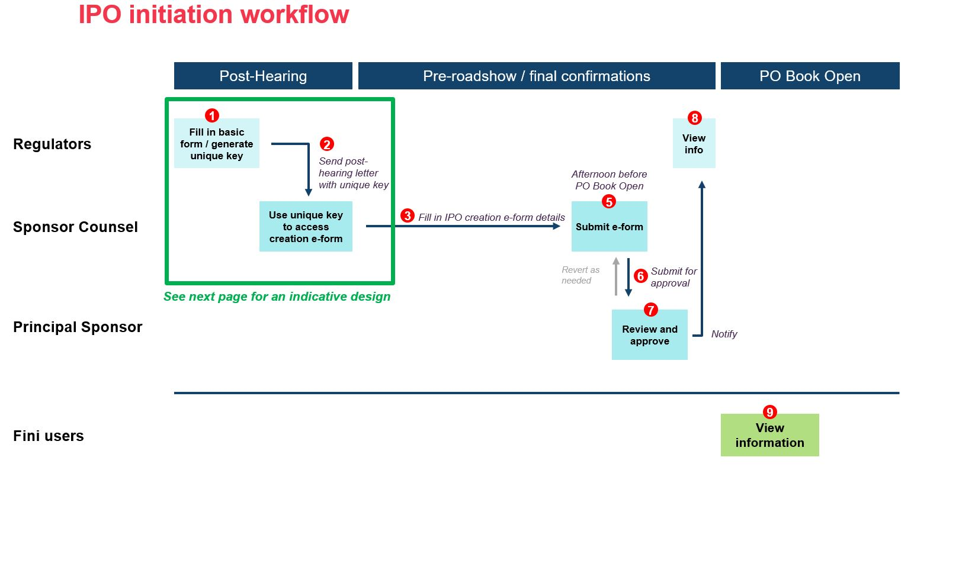



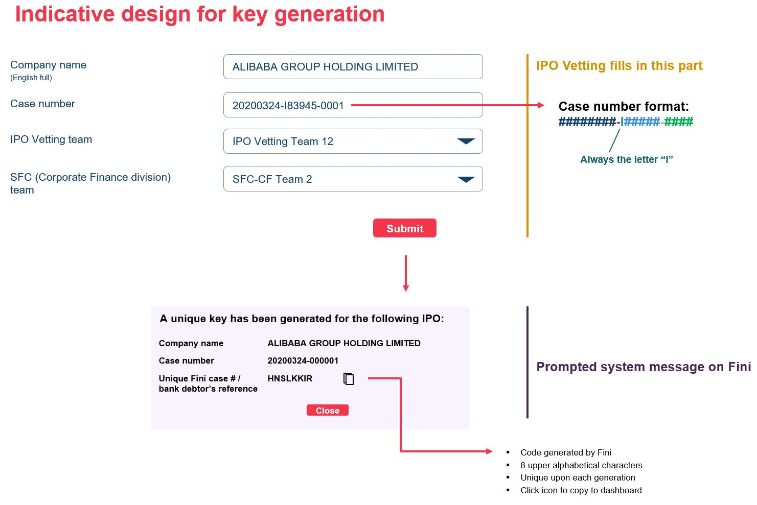

**Required data fields**

1. **Initial information**

|  |  |  |  |  |
| --- | --- | --- | --- | --- |
| # | Field name | Input method | Max field length | Notes |
| 1 | Case number | Text string  (00000000-I00000-0000) | 20 | IPO Vetting’s ECM case number. Used as reference to deposit files after the IPO close. |
| 2 | Company name (English full) | Text string | 80 |  |
| 3 | IPO Vetting team | Dropdown menu | 40 | Reflects list of active IPO Vetting teams under user management |
| 4 | SFC-CF team | Dropdown menu | 40 | Reflects list of active SFC-CF teams under user management |
| 5 | Unique Fini case # | System-generated | 8 | Generated after submitting the prior fields and passing system validation. Must be 8 upper alphabetical characters, unique upon each generation. A copy to dashboard function should be provided for this field. |

The responsible Regulator (HKEX) team will be responsible for passing to the Sponsor counsel offline the unique Fini case #, which will be used to unlock access to other parts of the e-form.

1. **Company information**

|  |  |  |  |  |
| --- | --- | --- | --- | --- |
| # | Field name | Input method |  | Notes |
| 6 | Company name (English full) | Non-editable data field | 80 | Repetition of field #2 output. |
| 7 | Company name (English short) | Text string | 15 |  |
| 8 | Company name (Chinese full) | Text string | 80 | Optional field  Traditional and Simplified Chinese characters allowed. |
| 9 | Company name (Chinese short) | Text string | 8 | Optional field  Traditional and Simplified Chinese characters allowed. |
| 10 | Stock code | ####0 | 5 | Must be an integer between 1-99999.  Must also pass a duplication check with stock master.   * Force tickbox confirmation that IPO is a “relaunched deal” if duplicate stock code + year of stock master listed date = 9999 * Invalidate if duplicate stock code + year of stock master listed date = !9999 |
| 11 | Place of incorporation | Dropdown menu  (single selection) | 40 | With the following choices in the specified order (top 4 are most common):   |  |  | | --- | --- | | British Virgin Islands | Israel | | Cayman Islands | Italy | | Hong Kong, China | Japan | | People’s Republic of China | Jersey | | Australia | Luxembourg | | Bermuda | Singapore | | Canada | Others (prompt free text box) | | England |  | |
| 12 | ISIN | Text string | 12 | Optional field |
| 13 | Nominal value | Text string | LONGTEXT | * Default 0 * Allow as many decimal points as inputted |
| 14 | Nominal currency | [Mandatory if nominal value >0]  Dropdown menu | 3 | With the following choices in the specified order:   |  | | --- | | HKD | | RMB | | USD | | Others (prompt free text box) | |
| 15 | Principal place of business in Hong Kong | Text string | 40 * 4 | Should appear as four text boxes, each limited to forty characters. 1st + 2nd boxes should be mandatory, and the 3rd + 4th optional.  Textbox:  "The first line should be the company's full name, and the second to fourth lines should be the company's business address". |

1. **Type of listing**

|  |  |  |  |  |
| --- | --- | --- | --- | --- |
| # | Field name | Input method | Max field length | Notes |
| 16 | Offering type | Dropdown menu  (single selection) | 40 | With the following choices in the specified order:   |  | | --- | | Global offer (placing and public offer) [DEFAULT] | | By placing only | | By public offer only | | By introduction | |
| 17 | Securities to be listed | Dropdown menu  (single selection) | 50 | With the following choices in the specified order:   |  | | --- | | Ordinary shares [DEFAULT] | | Ordinary shares (H shares) | | Ordinary shares (conversion from B to H shares) | | Preference shares | | Real Estate Investment Trust | | Exchange Traded Product | | Depositary Receipts | | Share Stapled Units | | Others (please fill in) [Prompt free text] | |
| 18 | Listing platform | Dropdown menu  (single selection) | 30 | If #17 = Ordinary shares / Ordinary shares (H shares) / Ordinary shares (conversion from B to H shares), then:   |  | | --- | | Main board [DEFAULT] | | GEM | | Main board (transfer from GEM) |   If #17 = Preference shares, then:   |  | | --- | | Main board [DEFAULT] | | GEM |   Else, then:   |  | | --- | | Main board | |
| 19 | Listing type | Menu  (single selection) | 9 | If #18 = Main board, then:   |  | | --- | | Primary [DEFAULT] | | Secondary |   Else, then:   |  | | --- | | Primary | |
| 20 | Listing categories | Menu  (multiple selections) | N/A | If:   * #17 = Ordinary shares / Ordinary shares (H shares) / Ordinary shares (conversion from B to H shares) AND * #18 = Main board AND * #19 = Primary   Then:   |  | | --- | | Dual-primary | | Biotech | | WVR | | US Reg-S |   If:   * #17 = Ordinary shares / Ordinary shares (H shares) / Ordinary shares (conversion from B to H shares) AND * #18 = Main board AND * #19 = Secondary   Then:   |  | | --- | | Biotech | | WVR | | US Reg-S |   If:   * #17 = Ordinary shares / Ordinary shares (H shares) / Ordinary shares (conversion from B to H shares) AND * #18 = GEM / Main board (transfer from GEM) AND * #19 = Primary   Then:   |  | | --- | | Dual-primary | | US Reg-S |   Else:   |  | | --- | | US Reg-S | |
| 20a | WVR ratio | [Only if #20 has “WVR” selected”]  0 | Integer | [To indicate the share voting ratio]  Two text boxes, default displayed as [1] to [1] |
| 21 | Dual-primary listing venue | [Only if #20 has “Dual-listing” selected]  Text string | LONGTEXT | Textbox:  “If the offering has more than one primary venue, each venue should be separated by an “,”.” |
| 22 | Primary listing venue | [Only if #19 = “Secondary”]  Dropdown menu | 80 | |  | | --- | | The Amsterdam Stock Exchange (NYSE Euronext - Amsterdam) | | The Australian Securities Exchange (ASX) | | The Brazilian Securities, Commodities and Futures Exchange (BM&FBOVESPA) | | The Frankfurt Stock Exchange (Deutsche Böurse) | | The Italian Stock Exchange (Borsa Italiana) | | The London Stock Exchange (LSE) | | The Madrid Stock Exchange (Bolsa de Madrid) | | NASDAQ OMX (US) | | The New York Stock Exchange (NYSE Euronext (US)) | | The Paris Stock Exchange (NYSE Euronext – Paris) | | The Singapore Exchange (SGX) | | The Stockholm Stock Exchange (NASDAQ OMX – Stockholm) | | The Swiss Exchange (SIX Swiss Exchange) | | The Tokyo Stock Exchange (TSE) | | The Toronto Stock Exchange (TMX) | | Other (please fill in) [Prompt free text] | |

1. **Offering**

|  |  |  |  |  |
| --- | --- | --- | --- | --- |
| # | Field name | Input method | Max field length | Notes |
| 23 | Trading currency | Dropdown menu | 3 | With the following choices in the specified order:   |  | | --- | | HKD [DEFAULT] | | RMB | | USD | |
| 24 | Trading board lot | 0 | Integer |  |
| 25 | Price flexibility | 0% | 3 (inclusive of “%”) | Default 0%  Possible range = 0-10% |
| 26 | Offer price range | 0.000 | Decimal(9,3) | * Must include two fields: minimum and maximum prices * Minimum must be ≤ Maximum * 0 is an acceptable input for minimum * If #25 > 0, then minimum / maximum price difference must be ≤ 30%   Textbox:  “If fixed price offering, the minimum offer price should be equal to the maximum offer price.” |
| 27 | Clawback threshold | 0 | 4 per field | * Must include four fields * Defaults set at 0 / 15 / 50 /100 |
| 28 | Retail allocation | 0.00% | 6 per field (inclusive of “.” and “%”) | * Must include four fields * Defaults set at 10.00% / 30.00% / 40.00% / 50.00% |
| 29 | Public offer reallocation cap (%) | 0.00% | 6 (inclusive of “.” and “%”) | Default 20.00%  Cannot exceed 20.00% |
| 30 | Number of shares held by existing shareholders | 0 | Integer |  |
| 31 | Number of offer shares | 0 | Integer |  |
| 32 | Number of public offer shares | [Non-editable data field]  0 | Integer | Default as initial retail allocation * number of offer shares |
| 33 | Number of institutional offer shares | [Non-editable data field]  0 | Integer | Default as (1 - initial retail allocation in #28) * number of offer shares |
| 35 | Upsize option (%) | 0.00% | Percentage(4,2) | Default 0.00%  Cannot exceed 100.00% |
| 36 | Over-allotment option inclusive of upsize option | Dropdown menu | 9 | Dropdown menu, with the following choices:   * Inclusive [Default] * Exclusive |
| 37 | Over-allotment option (%) | 0.00% | Percentage(4,2) | Default 0.00%  Cannot exceed 15.00% |
| 39 | Denomination table | Excel upload | N/A | Must be based on following table template (available for download for the sponsor counsel):    Validation rules:   * Cell B1 must = the max offer price * Cell A5 = inputted * Number of rows in Columns C to I (counting from row 5 onwards) must be equal and same as Column A * If trading currency (#23) = “HKD”, the smallest denomination based on min offer price (+transaction costs) must be > HK$2,000 * The largest “Application quantity” must be =< 0.5% * initial retail allocation (#28) * number of offer shares (#32) * Application quantity must be in board lot terms |

1. **Advisers**

|  |  |  |  |  |
| --- | --- | --- | --- | --- |
| # | Field name | Input method | Max field lenght | Notes |
| 40 | Principal sponsor | Dropdown menu | 40 | Single selection:   * Mandatory field * Must select company and team (sponsor) |
| 41 | Sponsor(s) | Dropdown menu | 40 (per team) | Multiple selection:   * Optional field * Must select company and team (sponsor) |
| 42 | HK legal adviser (for sponsor) | [non-editable data field]  Dropdown menu | 40 | Single selection:   * Mandatory field * Pre-fill inputting user’s company and team (law firm) |
| 43 | HK legal adviser (for issuer) | Dropdown menu | 40 | Single selection:   * Mandatory field * Must select company and team (law firm) |
| 44 | Coordinator(s) | Dropdown menu | 80 (per company) | Multiple selection:   * Optional field * Must select company (distributor) |
| 45 | Lead manager(s) | Dropdown menu | 80 (per company) | Multiple selection:   * Optional field * Must select company (distributor) |
| 46 | Principal lead broker | Dropdown menu | 40 (per team) | Single selection:   * Mandatory field * Must select company and team (distributor) |
| 47 | Distributor(s) | Dropdown menu | 40 (per team) | Multiple selection:   * Mandatory field * Must select company and team (distributor) |
| 48 | HK share registrar | Dropdown menu | 80 (per company) | Single selection:   * Mandatory field * Must select company and team (share registrar) |
| 49 | Nominee bank | Text string | 3  3  12  40 * 4  3  3  12  40 * 4  8 | Mandatory fields, must include the following:   * Pre-funding bank code * Pre-funding branch code * Pre-funding account number * Pre-funding account name and address (4 separate lines, first line mandatory) * Refunding bank code * Refunding branch code * Refunding account number * Refunding account name and address (4 separate lines, first line mandatory) * Refunding debtor reference (pre-fill unique FINI case #) [non-editable] |
| 50 | Sub-receiving bank(s) | Text string  [can add more sub-receiving banks] | 3  3  12  40 * 4  3  3  12  40 * 4  8 | Optional fields, must include the following:   * Pre-funding bank code * Pre-funding branch code * Pre-funding account number * Pre-funding account name and address (4 separate lines, first line mandatory) * Refunding bank code * Refunding branch code * Refunding account number * Refunding account name and address (4 separate lines, first line mandatory) * Refunding debtor reference (pre-fill unique FINI case #) [non-editable] |

1. **Timetable**

|  |  |  |  |  |
| --- | --- | --- | --- | --- |
| # | Field name | Input method | Max field length | Notes |
| 51 | Book open date | Time / date | 19 (timedate in ISO 8601 format) | Must include the following fields:   * Time (pre-fill 9:00 a.m.) [non-editable] * Date (Must be a non-public holiday, Monday to Saturday) |
| 52 | Book close date | Time / date | 19 (timedate in ISO 8601 format) | Must include the following fields:   * Time (pre-fill 12:00 p.m.) [non-editable] * Date (Must be a non-public holiday, Monday to Friday / ≥3 days after #51) |
| 53 | Expected price determination date | Time / date | 19 (timedate in ISO 8601 format) | Must include the following fields:   * Time (pre-fill 10:00 a.m.) [non-editable] * Date (Must be a non-public holiday, Monday to Friday / same day as or after #52) |
| 54 | Allotment announcement date | Date | 10 (date in ISO 8601 format) | Must include the following fields:   * Date (Must be a non-public holiday, Monday to Friday / same day as or after #53) |
| 55 | Commencement of trading date | Time / date | 19 (timedate in ISO 8601 format) | Must include the following fields:   * Time (pre-fill 9:00 a.m.) [non-editable] * Date (Must be a non-public holiday, Monday to Friday / after #54) |
| 56 | Settlement Instructions input date | Date | 10 (date in ISO 8601 format) | Must include the following fields:   * Date (Must be a non-public holiday, Monday to Friday / one or two days before #55) |
| 57 | Placing shares delivery date | Time / date | 19 (timedate in ISO 8601 format) | Must include the following fields:   * Time (pre-fill 9:00 a.m.) [non-editable] * Date (Must be a non-public holiday, Monday to Friday /same day as or after #55) |

1. **Preferential offers**

The sponsor counsel may input as many preferential offers as needed (default = none). Each offer must contain the following mandatory fields:

|  |  |  |  |  |
| --- | --- | --- | --- | --- |
| # | Field name | Input method | Max field length | Notes |
| 58 | Name of offer | Text string | 40 |  |
| 59 | Type of offer | Dropdown menu | 40 | With the following choices in the specified order:   |  | | --- | | Shareholder offer [DEFAULT] | | Employee offer | | Others (please fill in) [prompt free text] | |
| 60 | Number of preferential offer shares | 0 | 18 (inclusive of “,”) |  |
| 61 | IPO tranche | Dropdown menu | 19 | With the following choices in the specified order:   |  | | --- | | Institutional offer [DEFAULT] | | Public offer | |

Inputs on preferential offers should impact the initial allocations to the institutional / public offers.

For example, if the initial inputs contain the following:

|  |  |
| --- | --- |
| Field | Data input |
| Initial allocation to the public offer | 10% |
| Number of offer shares | 1,000,000 |
| Number of public offer shares | 100,000 |
| Number of institutional offer shares | 900,000 |
|  |  |
| Number of preferential offer shares | 10,000 |
| IPO tranche | Public offer |

Then the initial size of the public offer should be 90,000 shares (i.e. 100,000 – 10,000).

1. **Documents**

|  |  |  |  |
| --- | --- | --- | --- |
| **#** | **Field name** | **Input method** | **Notes** |
| 62 | IPO prospectus | File upload | Should contain two file uploads (English prospectus + Chinese prospectus)   * PDF only * No preview required * Size limitation per file: 40mb |
| 63 | Direct Debit Authorisation Form | File upload | Should contain one file upload for the receiving bank account direct debit authorisation.   * PDF / JPEG / PNG * No preview required * Size limitation per file: 40mb |
| 64 | Company registration document(s) | File upload | Should contain up to ten file uploads as needed for the company’s business registration documents:   * PDF / JPEG / PNG * No preview required * Size limitation per file: 40mb |
| 65 | Company constitutional document(s) | File upload | Should contain up to ten file uploads as needed for the company’s constitutional documents, including the terms of reference, articles of association etc:   * PDF / JPEG / PNG * No preview required * Size limitation per file: 40mb |

1. **Transaction costs**

|  |  |  |  |  |
| --- | --- | --- | --- | --- |
| **#** | **Field name** | **Input method** | **Max field length** | **Notes** |
| 67 | Brokerage | 0.0000%  [Non-editable data field] | Percentage(1,4) | “1.0000%” |
| 68 | SFC transaction levy | 0.0000%  [Non-editable data field] | Percentage(1,4) | “0.0027%” |
| 69 | Stock exchange trading fee | 0.0000%  [Non-editable data field] | Percentage(1,4) | “0.0050%” |
| 70 | Investor compensation levy | 0.0000%  [Non-editable data field] | Percentage(1,4) | “0.0000%” |
| 71 | Rounding indicator | Text input  [Non-editable data field] | 1 | “R” |

**View permissions**

Viewing of IPO reference data should be restricted by timing and user role.

**During IPO initiation:**

|  |  |  |  |  |  |  |  |  |  |  |
| --- | --- | --- | --- | --- | --- | --- | --- | --- | --- | --- |
| **Timing** | **User** | **Section** | | | | | | | | |
| **1** | **2** | **3** | **4** | **5** | **6** | **7** | **8** | **9** |
| Unique key generation | * Responsible Regulator (HKEX) team | ✓ | X | X | X | X | X | X | X | X |
| * Responsible Regulator (SFC) team | ✓ | X | X | X | X | X | X | X | X |
| Key unlock / drafting of IPO initiation e-form | * Responsible Regulator (HKEX) team | ✓ | X | X | X | X | X | X | X | X |
| * Responsible Regulator (SFC) team | ✓ | X | X | X | X | X | X | X | X |
| * Responsible Sponsor counsel | ✓ | ✓ | ✓ | ✓ | ✓ | ✓ | ✓ | ✓ | ✓ |
| After Sponsor counsel submits IPO initiation e-form to Principal Sponsor for approval | * Responsible Regulator (HKEX) team | ✓ | X | X | X | X | X | X | X | X |
| * Responsible Regulator (SFC) team | ✓ | X | X | X | X | X | X | X | X |
| * Responsible Sponsor counsel | ✓ | ✓ | ✓ | ✓ | ✓ | ✓ | ✓ | ✓ | ✓ |
| * Responsible Principal sponsor | ✓ | ✓ | ✓ | ✓ | ✓ | ✓ | ✓ | ✓ | ✓ |
| After Principal sponsor approves the IPO initiation e-form | * Responsible Regulator (HKEX) team | ✓ | ✓ | ✓ | ✓ | ✓ | ✓ | ✓ | ✓ | ✓ |
| * Responsible Regulator (SFC) team | ✓ | ✓ | ✓ | ✓ | ✓ | ✓ | ✓ | ✓ | ✓ |
| * Responsible Sponsor counsel | ✓ | ✓ | ✓ | ✓ | ✓ | ✓ | ✓ | ✓ | ✓ |
| * Responsible Principal sponsor | ✓ | ✓ | ✓ | ✓ | ✓ | ✓ | ✓ | ✓ | ✓ |

**After the public offer book open, viewing restrictions should be separated into two different user groups:**

* **Advisers (specified in Section 5. Advisers) / all Regulators** 
  + May view all data fields
* **All other FINI users**
  + Section 1. Initial information – cannot view any data field
  + Section 5. Advisers – cannot view #49 / #50
  + Section 8 – cannot view #63 / #64 / #65

### Preferential offers and public offer upsize option

If an IPO has **preferential offers**, i.e. IPO initiation Fields #58-61 are non-blank, the HK share registrar is responsible for the inputting the settlement information for each preferential offer.

|  |  |  |  |
| --- | --- | --- | --- |
| # | Field name | Input method | Notes |
| 1 | Name of offer | Text string  [non-editable data field] | Repetition of IPO initiation Field #58 |
| 2 | Type of offer | Text string  [non-editable data field] | Repetition of IPO initiation Field #59 |
| 3 | Number of preferential offer shares | Integer | Repetition of IPO initiation Field #60 |
| 4 | IPO tranche | Text string  [non-editable data field] | Repetition of IPO initiation Field #61 |
| 5 | Final number of allottees | Integer | * Lower limit: 0 [Default] |
| 6 | Final allotted quantity | Integer | * Lower limit: 0 [Default] * Upper limit: Number of preferential offer shares (IPO initiation Field #60) |

This figure must be inputted before the Public offer book close (IPO initiation Field #52) irrespective of the IPO tranche. If there is no input, the system should automatically fill in as Fields #5 / #6 as 0 and reallocate to the applicable IPO tranche (based on #4).

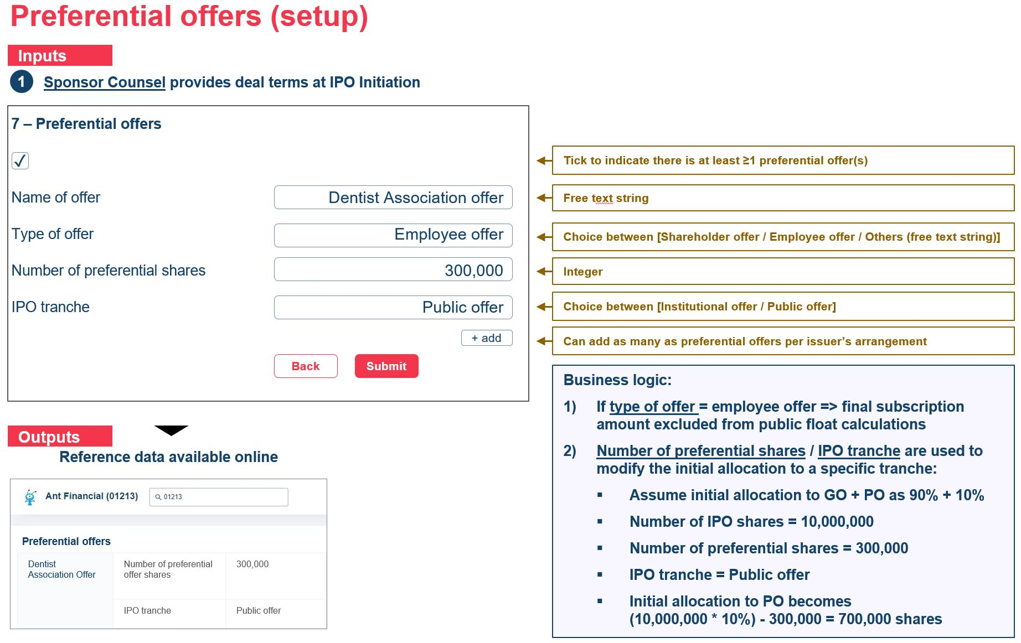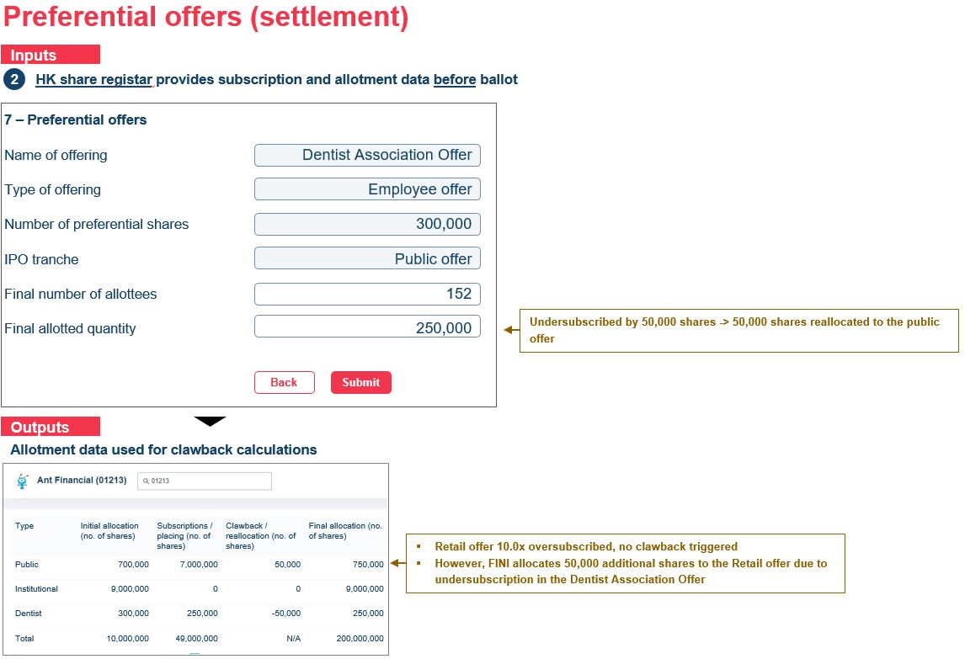



**Upsizing the Public Offer**

If an IPO has an upsize option, i.e. IPO initiation Field #35 >0.00%, the sponsor counsel (with the Principal Sponsor as checker) is responsible for the inputting the exercised upsized option for the Public Offer.

|  |  |  |  |
| --- | --- | --- | --- |
| # | Field name | Input method | Notes |
| 7 | Upsize option (%) | Integer  [non-editable data field] | Repetition of IPO initiation Field #35 |
| 8 | Public Offer upsize (number of shares) | Integer | * Lower limit: 0 [Default] * Upper limit: Number of offer shares (IPO initiation Field #31) * Upsize option (%) (IPO initiation Field #35)   The upper limit figure should be rounded down to the nearest board lot.  Sample rounding formula:   |  |  |  | | --- | --- | --- | | # |  |  | | A | Board lot size | 100 | | B | Number of offer shares | 999,999 | | C | Upsize option (%) | 20.00% | | D | Upper limit (raw) | 199,999.8 | | E | Upper limit (rounded)  Step 1): Round down (#D / #A)  Step 2): Result * #A | 199,900 | |

This figure must be inputted before the Public offer book close (IPO initiation Field #52). If there is no input, the system should automatically fill in Field #8 as 0.



### IPO closing and reporting

The following tables summarise the list of required downloadable reports within the FINI system. Unless specified otherwise, each report should be:

* Downloadable as an .csv file
* Feature two versions:
  1. User-specific version for the applicable user
  2. Consolidated version for HKEX / SFC
* Reflect real-time, latest version inputs
* Reported on a per IPO basis

|  |  |  |  |  |
| --- | --- | --- | --- | --- |
| **#** | **Report #** | **Report** | **User** | **User interface** |
| 1 | CPBR-A1 | EIPO Application list | Clearing Participant(s), Share registrar(s) | EIPO Application List |
| 2 | CPBR-A2 | EIPO Input activities | Clearing Participant(s), Share registrar(s) | EIPO Application List |
| 3 | CPBR-A3 | Allotment results | Clearing Participant(s), Share registrar(s) | Allotment result |
| 4 | CPBR-A4 | Lapsed IPO results | Clearing Participant(s), Share registrar(s) | Allotment result |
| 5 | CPBR-A5 | EIPO Confirmation list | Clearing Participant(s), Share registrar(s) | EIPO Application List |
| 6 | HKEX-A1 | Allotment validation results | HKSCC, IPO Vetting, SFC | IPO workstation |
| 7 | HKEX-A2 | Confirmation validation results | HKSCC, IPO Vetting, SFC | IPO workstation |
| 8 | DIST-A1 | Placee list | Lead broker(s), distributor(s) | Placee list |
| 9 | DIST-A2 | Placee input activities | Lead broker(s), distributor(s) | Placee list |
| 10 | DIST-A3 | IPO reference data | Sponsor(s), sponsor counsel, HKSCC, IPO Vetting, SFC | IPO workstation |
| 11 | DIST-A4 | Concentration analysis | Sponsor(s), sponsor counsel, HKSCC, IPO Vetting, SFC | Concentration analysis |
| 12 | DIST-A5 | Master IPO list | IPO Vetting, SFC | IPO workstation |
| 13 | HKEX-A4 | Billing Request summary | HKSCC | IPO workstation |
| 14 | HKEX-A5 | Deal charges request report | HKSCC | IPO workstation |

**DIST-A1**

Comprehensive list of individual and corporate placees, with additional fields indicating (1) name of broker that submitted the placee list (column A) and (2) type of placee – individual or corporate placee (column B).

“N/A” for the following fields:

* Individual placee – contact person (column N) and beneficial owner(s) (columns S to V)
* Corporate placee – name of placee’s employer (column P)



**DIST-A2**

**DIST-A3**

Multiple sheets of IPO reference data:

* An IPO reference data sheet **(‘IPO reference data’)** – listing out IPO reference data extracted from IPO Initiation and the final results of the Global Offering
* A preferential offering sheet **(‘Preferential offering’)** – listing out details of the preferential offering(s)
* A lock up sheet **(‘Lock-up’)** – listing out the shareholders and number of shares that are subject to lock-up after listing



**DIST-A4**

Multiple sheets reflecting the shareholding concentration and board lot concentration with:

* A concentration analysis sheet **(‘Concentration analysis’) –** lists of the top 25 placees, top 25 PO shareholders and top 25 shareholders
* A board lot concentration sheet **(‘Board lot concentration’)** – comprehensive list of the number of allottees for each board lot shares under the PO

Concentration analysis

* C15 to C39: names of top 25 placees of the institutional tranche
* D15 to D39: placing shares allocated to the top 25 placees
* C46 to C70: names of top 25 PO shareholders of the PO tranche
* D46 to D70: PO shares allocated to the top 25 PO shareholders
* C77 to C101, D77 to D101 and E77 to E101: to be extracted from the ‘Top shareholders list’ (item 2 of the regulatory submissions), B2 to B26, C2 to C26 and D2 to D26, respectively
* Descending sort based on shares allocated/shares held (i.e. D15 to D39, D45 to D70 and E77 to E101), and if same values found, second layer of sorting based on shareholders name (i.e. C15 to C39, C45 to C70 and C77 to C101) in alphabetical order

Board lot concentration

* List of number of shares should follow the denomination table uploaded [IPO reference data #39] (column A)
* Number of allottees – count the number of PO shareholders allotted with the corresponding number of shares in column A (column B)
* Total of column B should equal the number of PO shareholders



**DIST-A5**

Multiple sheets reflecting the final retail allotment list + placing allocations, with:

* A summary sheet **(‘summary’)** – a simplified list of allotted retail applicants and placees
* An EIPO allotment results sheet **(‘EIPO allotment’)** – comprehensive list of the final retail allotment
* An individual placing sheet **(‘Individual placing’)** – comprehensive list of individual placees
* A corporate placing sheet **(‘Corporate placing’)** – comprehensive list of corporate placees



## Core processing engine – Public offer

### EIPO application

The purpose of this module is to manage public offer subscription, allotment and statistics between the book open and book close dates (as defined during IPO creation).

The module should be broken down to three main functions:

**EIPO Application List**

The purpose of the EIPO Application list is for:

* **Clearing Participants / Share Registrars** participants to submit and manage their own public offer subscriptions, which must be complete and validated upon entry. **[IIP]**
* **Principal Sponsor / Sponsor(s) / Sponsor’s Counsel / Issuer’s Counsel / Principal Lead Broker / Distributor(s)** participants to have a summary of public offer demand and statistical breakdowns
* **HKSCC / Regulator (HKEX) / Regulator (SFC)** participants to have a detailed view of public offer demand and statistical breakdowns

**Maker-checker workflows**

All Group (1) participants must submit entries via maker-checker flows, per the attached .pptx / screenshot below. A valid public offer subscription is defined as an authorised, non-duplicate entry. **[IIP]**

A function should also be provided to makers and checker to submit entries by multi-selection or all entries within a list.



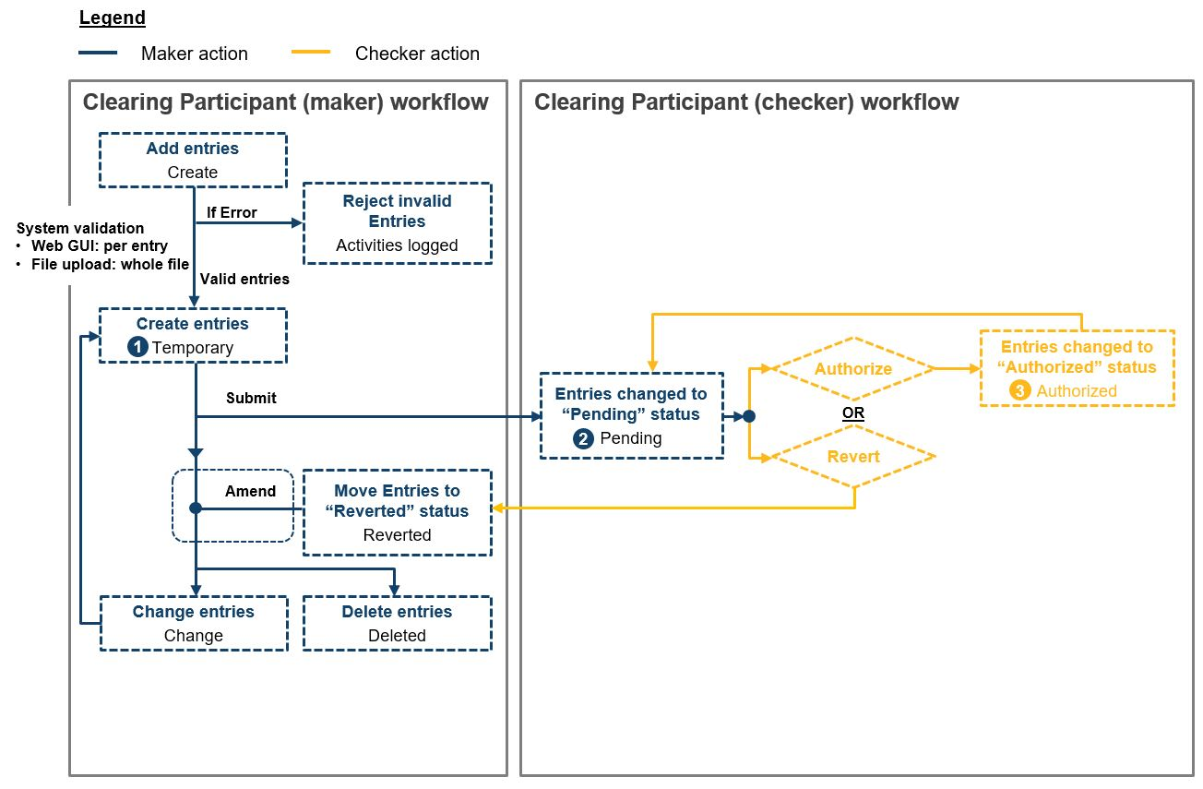

**Interface functions**

Separate interfaces should be maintained for entries in temporary, pending and authorised statuses. Each interface should maintain functions for:

* Searching and filtering within each interface **[IIP]**
* Progressing entries within the workflow **[IIP]**
* Amending entries
* Deleting entries
* Group selecting entries (either within the viewable list or covering every single entry within the interface) for performing the actions listed above

**Creating public offer subscription entries**

Entries can be created (i.e. progressed to temporary status) through:

* **Online entry;**
* **Fixed-length txt file upload; or**
* **API (see** **2.3.1.2 API Gateway****)**

A complete public offer applicant entry:

* Must contain the following mandatory fields:
  + Name of beneficial owner **[IIP]**
  + ID type (HKID / National Identification Document / Passport for individuals, COI / HK BR / LEI number for corporates)
  + ID number **[IIP]**
  + Application quantity (must match denomination table) **[IIP]**
* May contain the following optional fields:
  + Firm ID (Could be any firm ID)
  + Joint Account #2 ID type
  + Joint Account #2 Name (Mandatory if Joint Account #2 ID type is non-blank) **[IIP]**
  + Joint Account #2 ID (Mandatory if Joint Account #2 ID type is non-blank) **[IIP]**
  + Joint Account #3 ID type
  + Joint Account #3 Name (Mandatory if Joint Account #3 ID type is non-blank) **[IIP]**
  + Joint Account #3 ID (Mandatory if Joint Account #3 ID type is non-blank) **[IIP]**
  + Joint Account #4 ID type
  + Joint Account #4 Name (Mandatory if Joint Account #4 ID type is non-blank) **[IIP]**
  + Joint Account #4 ID (Mandatory if Joint Account #4 ID type is non-blank) **[IIP]**
  + Remark **[IIP]**

**Online entry**

An online interface should be provided to create new public offer subscription entries, which are to be validated during entry.

The interface should also include dropdown menus for:

* ID type:
  + HKID
  + National Identification Document
  + Passport
  + COI
  + HK BR
  + LEI
* Application quantity: **[IIP]**
  + [Reflecting the denomination table from IPO initiation]

The online entry function should also permit the amendment of any entries (created via online entry, fixed-length txt file upload or API) in temporary status.

**Fixed-length txt file upload**

An online interface should be provided for the uploading of fixed-length txt files, accessible by Clearing Participants and Share Registrars only**.**

Each txt file should contain:

* Only one header record **[IIP]**
* At least one detailed record; and **[IIP]**
* Only one control record **[IIP]**

Each field within the txt file should be based on the following definitions:

|  |  |
| --- | --- |
| **Field format** | **Field Format** |
| X(1) | X = alphanumeric characters  1 = field length must be 1 |
| 9(1) | 9 = must be a number between 0-9  1 = field length must be 1 |
| 9(2)v9(2) | 9 = must be a number between 0-9  2 = field length must be 2  v = decimal point  The left field should be right justified, and the right field should be left justified.  e.g. 1.2 should be reflected as 0120 |
| Right justified | Even if the actual field value has fewer numbers or characters than the required field length, zeroes or blank spaces must be inputted before the actual field value to match the field length.  e.g. inputting 1234 for a 9(5), right justified field should be “01234” |

The format of the header record should be as follows:

|  |  |  |
| --- | --- | --- |
| **Field Name** | **Field Format** | **Description** |
| Record Type **[IIP]** | X(1) | Should always be 0 for header record |
| File indicator **[IIP]** | 9(4) | Must be a unique number per batch upload within an IPO |
| Participant ID **[IIP]** | X(6) | Must reflect the Clearing Participant or Share Registrar’s participant ID, taken from the Participant Master (Field #2) or Registrar Master (Field #2) |
| Sender BIC **[IIP]** | X(8) | Must reflect the Clearing Participant or Share Registrar’s BIC code (if any), taken from the Participant Master (Field #5) or Registrar Master files (Field #3) |
| Stock code **[IIP]** | X(5), right justified | IPO stock code (from IPO initiation Field #10) |
| ISIN **[IIP]** | X(12) | IPO ISIN code (from IPO initiation Field #12) |
| Stock Price **[IIP]** | 9(7)v9(5) | Max offer price of the IPO (from IPO initiation Field #26) |
| Part Own File Reference **[IIP]** | X(15) | Free text field for the Clearing Participant or Share Registrar’s own reference |
| Batch Transmission Date **[IIP]** | X(8) | Should reflect the date of upload in YYYYMMDD format (GMT +8) |
| File Name **[IIP]** | X(15) | Constant as “IPO UPL FILE” |

The format of each detailed record should be as follows:

|  |  |  |
| --- | --- | --- |
| **Field Name** | **Field Format** | **Description** |
| Record Type **[IIP]** | X(1) | Should always be 1 for detailed record |
| Application quantity **[IIP]** | 9(11), right justified | The number of shares for which the applicant is applying |
| Firm ID | 9(5) | Optional field  Must be a valid firm ID from the Participant Master file (Field #4). Registrar codes should be treated as invalid. |
| Beneficiary Owner **[IIP]** | X(80) | Full name of the applicant |
| ID type | X(4) | HKID = for HKID numbers  NIDD = for National Identification Document numbers  PASS = for any other passport numbers  COIN = for Certificate of Incorporation numbers  HKBR = for Hong Kong Business Registration numbers  LEIN = Legal Entity Identity numbers |
| BO ID / BR# **[IIP]** | X(20) | ID number of the applicant |
| Joint Account #2 Name | X(80) | Full name of the second joint account applicant (if any). |
| Joint Account #2 ID type | X(4) | HKID / NIDD / PASS / COIN / HKBR / LEIN |
| Joint Account #2 ID **[IIP]** | X(20) | ID number of the second joint account applicant. |
| Joint Account #3 Name | X(80) | Full name of the third joint account applicant (if any). |
| Joint Account #3 ID type | X(4) | HKID / NIDD / PASS / COIN / HKBR / LEIN |
| Joint Account #3 ID **[IIP]** | X(20) | ID number of the third joint account applicant. |
| Joint Account #4 Name | X(80) | Full name of the fourth joint account applicant (if any). |
| Joint Account #4 ID type | X(4) | HKID / NIDD / PASS / COIN / HKBR / LEIN |
| Joint Account #4 ID **[IIP]** | X(20) | ID number of the fourth joint account applicant. |
| Remark **[IIP]** | X(32) | Free text field for the Clearing Participant or Share Registrar’s own reference |

The format of the control record should be as follows:

|  |  |  |
| --- | --- | --- |
| **Field Name** | **Field Format** | **Description** |
| Record Type **[IIP]** | X(1) | Should always be 9 for trailer record |
| Total number of detailed records **[IIP]** | 9(9) | The total number of detailed records within the fixed-length txt file. |
| Total application quantity **[IIP]** | 9(18) | The total application quantity |

**Allotment result**

The purpose of the Allotment result is for:

* **Clearing Participants / Share Registrars** participants to manage and monitor the funding and allotment of their public offer subscriptions **[IIP]**
* **HKSCC / Regulator (HKEX) / Regulator (SFC)**  participants to monitor the funding and allotment of the whole public offer

**Interfaces**

Separate interfaces should be maintained for:

* **Pre-funding** (captured after allotment, showing the funding requirements of each allotted application)
* **Allotment** (captured after payment, showing the payment results for each allotted application)
* **Refund** (captured after IPO pricing, showing the refunding amounts based on the IPO price differential)

Each interface should include basic functions:

* Searching and filtering entries **[IIP]**
* Viewing entries in detail **[IIP]**

**EIPO statistics**

The purpose of EIPO statistics is to provide participants a high level overview of public offer subscription on a per deal basis.

The interface should include:

* Statistics breaking down between different public offer subscription channels (by number of applicants and valid application quantity) **[IIP]**
* Statistics breaking down between different the public offer subscription information across different Clearing Participants (by number of applicants and valid application quantity) **[IIP]**

**Summary**

The accessibility for each participant in respect of each functional module is summarised within the following table:

|  |  |  |  |
| --- | --- | --- | --- |
| **Participant type** | **EIPO Application List** | **Allotment result** | **EIPO statistics** |
| Clearing Participants (maker) | Per own entries: **[IIP]**   * Temporary * Pending * Authorised | X | X |
| Clearing Participants (checker) | Per own entries: **[IIP]**   * Pending * Authorised | Own funding details: **[IIP]**   * Pre-funding * Allotment * Refund | X |
| Share Registrar (maker) | Per own entries: **[IIP]**   * Temporary * Pending * Authorised | X | X |
| Share Registrar (checker) | Per own entries: **[IIP]**   * Pending * Authorised | Own funding details: **[IIP]**   * Pre-funding * Allotment * Refund | X |
| Principal sponsor | X | X | Per own deal statistics:   * EIPO statistics * Broker channel statistics |
| Sponsor(s) | X | X | Per own deal statistics:   * EIPO statistics * Broker channel statistics |
| Sponsor’s counsel | X | X | Per own deal statistics:   * EIPO statistics * Broker channel statistics |
| Issuer’s counsel | X | X | Per own deal statistics:   * EIPO statistics * Broker channel statistics |
| HKSCC | All entries:   * Authorised | Whole deal funding details: **[IIP]**   * Pre-funding * Allotment * Refund | All deal statistics: **[IIP]**   * EIPO statistics * Broker channel statistics |
| SEHK Listing Department | All entries:   * Authorised | Whole deal funding details: **[IIP]**   * Pre-funding * Allotment * Refund | All deal statistics: **[IIP]**   * EIPO statistics * Broker channel statistics |
| SFC | All entries:   * Authorised | Whole deal funding details: **[IIP]**   * Pre-funding * Allotment * Refund | All deal statistics: **[IIP]**   * EIPO statistics * Broker channel statistics |

### Application data management: real-time check and statistics

Deduplication of public offer subscription entries should be on a real-time basis. Duplicate applications are defined as those with an exact matching ID number (regardless of the ID number’s positioning within a joint account). There should be deduplications on three different levels:

|  |  |  |
| --- | --- | --- |
| **#** | **Check** | **Handling** |
| 1 | Own application list duplication **[IIP]** | The duplication should be flagged in real-time during creation and should not be able to reach “temporary” status **[IIP]** |
| 2 | Cross public offer application list duplication **[IIP]** | The duplication should be flagged to the relevant participants after authorization.  If the deduplication is not resolved by the public offer close, then both applications should be invalidated. (See **2.4.3 Application data management: cleansing and verification**) **[IIP]** |
| 3 | Cross public offer application v. institutional offer placing duplication **[IIP]** | Since institutional offer allocations may only be authorised after clawback, the relevant public offer application (regardless of allotment) takes precedence over the institutional offer allocation. |

All duplicate applications should not be counted towards valid applications and applied quantity statistics.

### Application data management: cleansing and verification

The system should perform a final cleansing and verification check after the public offer book close to detect any outstanding duplicate applications and invalidate them from the EIPO Application List.

### Application data management: consolidation and allotment

The HK share registrar is responsible for balloting the public offer. After the final cleansing and verification checks, the system should send a consolidated EIPO application List file (per IPO) via EMFT to the Share Registrar for balloting.

The Share Registrar is responsible for sending an EIPO allotment file (per IPO) via EMFT to the system for generating payment instructions.

The size of the public offer after clawback should be calculated as:

|  |  |  |  |  |  |  |
| --- | --- | --- | --- | --- | --- | --- |
| Initial allocation to PO | + | Clawback shares | + | Preferential offer reallocation (if any) | + | Upsize option to PO |

Please see the 2.3.4 Data Exchange with SR for file specifications.

### EIPO funding calculator

Within a standard IPO flow, there should two funding calculations:

1. Pre-funding of the Public offer, after the **EIPO allotment file step (see** 2.3.4 Data Exchange with SR**)** is successful
2. Refunding of the Public offer, after the **commencement of trading step** is successful

All calculations should only apply to broker channel applicants.

**Pre-funding**

Each individual applicant’s pre-funding requirements should be based on the EIPO Allotment file (SR -> FINI), and should comprise of five components:

|  |  |  |  |
| --- | --- | --- | --- |
| **#** | **Component** | **Formula** | **Rounding** |
| 1 | **Application money** | |  |  |  | | --- | --- | --- | | Successful quantity | x | Max offer price | | [EIPO Allotment file detailed record] |  | [IPO initiation Field #26] | |  |  |  | | 2 decimal points |
| 2 | **Brokerage** | |  |  |  | | --- | --- | --- | | Application money | x | Brokerage | | [EIPO pre-funding Field #1] |  | [IPO initiation Field #64] | |  |  |  | | 2 decimal points |
| 3 | **SFC Transaction Levy** | |  |  |  | | --- | --- | --- | | Application money | x | SFC Transaction Levy | | [EIPO pre-funding Field #1] |  | [IPO initiation Field #65] | |  |  |  | | 2 decimal points |
| 4 | **SEHK Trading Fee** | |  |  |  | | --- | --- | --- | | Application money | x | SEHK Trading Fee | | [EIPO pre-funding Field #1] |  | [IPO initiation Field #66] | |  |  |  | | 2 decimal points |
| 5 | **Investor Compensation Levy** | |  |  |  | | --- | --- | --- | | Application money | x | Investor Compensation Levy | | [EIPO pre-funding Field #1] |  | [IPO initiation Field #67] | |  |  |  | | 2 decimal points |

Worked example:

* Successful quantity: 2,000
* Max offer price: $4.56
* Brokerage: 1.0000%
* SFC Transaction Levy: 0.0027%
* SEHK Trading Fee: 0.0050%
* Investor Compensation levy: 0.0000%

|  |  |  |  |
| --- | --- | --- | --- |
| **#** | **Component** | **Calculation** | **Output (rounded)** |
| **1** | **Application money** | 2,000 x 4.56 = 9,120 (unrounded) | **9,120.00** |
| **2** | **Brokerage** | 9,120 x 1.0000% = 91.2 (unrounded) | **91.20** |
| **3** | **SFC Transaction Levy** | 9,120 x 0.0027% = 0.2462 (unrounded) | **0.25** |
| **4** | **SEHK Trading Fee** | 9,120 x 0.0050% = 0.4560 (unrounded) | **0.46** |
| **5** | **Investor Compensation Levy** | 9,120 x 0.0000% = 0.0000 (unrounded) | **0.00** |
|  | **Total** |  | **9,211.91** |

**Refunding**

The calculations should be based on the individual applicant’s definitive funding requirements based on the final offer price (using the same components), minus the applicant’s pre-funding requirements.

Using the previous example, where the IPO priced at **$4.50**:

* Successful quantity: 2000
* Max offer price: $4.56
* **Final offer price: $4.50**
* Brokerage: 1.0000%
* SFC Transaction Levy: 0.0027%
* SEHK Trading Fee: 0.0050%
* Investor Compensation levy: 0.0000%

Definitive funding requirements:

|  |  |  |  |
| --- | --- | --- | --- |
| **#** | **Component** | **Calculation** | **Output (rounded)** |
| **1** | **Application money** | 2,000 x 4.50 = 9,000 (unrounded) | **9,000.00** |
| **2** | **Brokerage** | 9,000 x 1.0000% = 90 (unrounded) | **90.00** |
| **3** | **SFC Transaction Levy** | 9,000 x 0.0027% = 0.2430 (unrounded) | **0.24** |
| **4** | **SEHK Trading Fee** | 9,000 x 0.0050% = 0.4500 (unrounded) | **0.45** |
| **5** | **Investor Compensation Levy** | 9,000 x 0.0000% = 0.0000 (unrounded) | **0.00** |
|  | **Total** |  | **9,090.69** |

Refunding calculation:

|  |  |  |  |  |
| --- | --- | --- | --- | --- |
| Pre-funding requirements | - | Investor Compensation Levy | = | Refund |
| 9,211.91 | - | 9,090.69 | = | **121.22** |

### Payment instruction

All payment instructions for the Public offer should be based on the EIPO funding calculator, grouped by Clearing Participant and IPO. For example, if three hundred Clearing Participants have EIPO applications for 2 IPOs that close on the same date, 600 payment instructions should be issued day.

FINI will not issue any payment instructions for Share Registrar channel applications, and those applications are always assumed to be fully funded.

**Pre-funding**

**Step 1: Calculating each applicant’s pre-funding requirements**

Assume Alibaba (09988)’s IPO with the following terms:

* Max offer price: $188
* Brokerage: 1.0000%
* SFC Transaction Levy: 0.0027%
* SEHK Trading Fee: 0.0050%
* Investor Compensation levy: 0.0000%

Raw file (see EIPO Allotment file specifications):

|  |
| --- |
| 0EIPO ALLOTMENT0998820200612134555  10134517753270400000000000000000001000100000000100  10134544548471600000000000000000001000100000000100  1013453430209720000000010000000000100 00000000200  1013458098038510000000010000000000100 00000000200  1013458814435490000000010000000000100 00000000200  1011306836129340000000010000000000200 00000000300  1011308286359300000000010000000000200 00000000300  1011306932614570000000010000000000200 00000000300  1011308637247380000000010000000000300 00000000400  1011307266860110000000020000000000400 00000000600  91027009001800 |

Processed data tables (see EIPO Allotment file specifications):

|  |  |  |  |  |  |
| --- | --- | --- | --- | --- | --- |
| **Firm ID** | **Application instruction #** | **Successful quantity** | **Unsuccessful quantity** | **Unsuccessful Reason Code** | **Application Quantity** |
| 1345 | 177532704 | 0 | 100 | 01 – NOT ALLOTTED | 100 |
| 1345 | 445484716 | 0 | 100 | 01 – NOT ALLOTTED | 100 |
| 1345 | 343020972 | 100 | 100 |  | 200 |
| 1345 | 809803851 | 100 | 100 |  | 200 |
| 1345 | 881443549 | 100 | 100 |  | 200 |
| 1130 | 683612934 | 100 | 200 |  | 300 |
| 1130 | 828635930 | 100 | 200 |  | 300 |
| 1130 | 693261457 | 100 | 200 |  | 300 |
| 1130 | 863724738 | 100 | 300 |  | 400 |
| 1130 | 726686011 | 200 | 400 |  | 600 |

Calculate each applicant’s funding requirements:

|  |  |  |  |  |  |  |  |  |  |
| --- | --- | --- | --- | --- | --- | --- | --- | --- | --- |
| **#** | **Firm ID** | **App. Inst. #** | **Success Qty** | **App. money** | **Brokerage** | **SFC Transaction levy** | **SEHK trading fee** | **Investor Comp. Levy** | **Total** |
| **1** | **1345** | 177532704 | 0 | 0 x 188  = **188.00** | 0 x 1.0000%  = **0.00** | 0 x 0.0027%  = **0.00** | 0 x 0.0500%  = **0.00** | 0 x 0.0000%  = **0.00** | **0.00** |
| **2** | **1345** | 445484716 | 0 | 0 x 188  = **188.00** | 0 x 1.0000%  = **0.00** | 0 x 0.0027%  = **0.00** | 0 x 0.0500%  = **0.00** | 0 x 0.0000%  = **0.00** | **0.00** |
| **3** | **1345** | 343020972 | 100 | 100 x 188  = **18,800.00** | 18,800 x 1.0000%  = **188.00** | 18,800 x 0.0027%  = **0.51** | 18,800 x 0.0500%  = **9.40** | 18,800 x 0.0000%  = **0.00** | **18,997.91** |
| **4** | **1345** | 809803851 | 100 | 100 x 188  = **18,800.00** | 18,800 x 1.0000%  = **188.00** | 18,800 x 0.0027%  = **0.51** | 18,800 x 0.0500%  = **9.40** | 18,800 x 0.0000%  = **0.00** | **18,997.91** |
| **5** | **1345** | 881443549 | 100 | 100 x 188  = **18,800.00** | 18,800 x 1.0000%  = **188.00** | 18,800 x 0.0027%  = **0.51** | 18,800 x 0.0500%  = **9.40** | 18,800 x 0.0000%  = **0.00** | **18,997.91** |
| **6** | **1345** | 683612934 | 100 | 100 x 188  = **18,800.00** | 18,800 x 1.0000%  = **188.00** | 18,800 x 0.0027%  = **0.51** | 18,800 x 0.0500%  = **9.40** | 18,800 x 0.0000%  = **0.00** | **18,997.91** |
| **7** | **1130** | 828635930 | 100 | 100 x 188  = **18,800.00** | 18,800 x 1.0000%  = **188.00** | 18,800 x 0.0027%  = **0.51** | 18,800 x 0.0500%  = **9.40** | 18,800 x 0.0000%  = **0.00** | **18,997.91** |
| **8** | **1130** | 693261457 | 100 | 100 x 188  = **18,800.00** | 18,800 x 1.0000%  = **188.00** | 18,800 x 0.0027%  = **0.51** | 18,800 x 0.0500%  = **9.40** | 18,800 x 0.0000%  = **0.00** | **18,997.91** |
| **9** | **1130** | 863724738 | 100 | 100 x 188  = **18,800.00** | 18,800 x 1.0000%  = **188.00** | 18,800 x 0.0027%  = **0.51** | 18,800 x 0.0500%  = **9.40** | 18,800 x 0.0000%  = **0.00** | **18,997.91** |
| **10** | **1130** | 726686011 | 200 | 200 x 188  = **37,600.00** | 37,600 x 1.0000%  = **376.00** | 37,600 x 0.0027%  = **1.02** | 37,600 x 0.0500%  = **18.80** | 37,600 x 0.0000%  = **0.00** | **37,995.82** |

**Step 2 – Group funding requirements by Clearing Participant**

Note: Clearing Participants might not use their own firm ID in their EIPO applications. The grouping of payment instructions should be based on the application instruction number and its related Clearing Participant ID.

|  |  |  |  |  |  |  |
| --- | --- | --- | --- | --- | --- | --- |
| **App. Inst. #** | **Funding requirement** | **Clearing Participant ID** |  | **Clearing Participant ID** | **Clearing Participant** | **Funding requirement** |
| 177532704 | **0.00** | B01345 | ▶ | B01345 | Phillip Securities | **56,993.73** |
| 445484716 | **0.00** | B01345 | B01130 | BOCI Securities | **113,987.46** |
| 343020972 | **18,997.91** | B01345 |  |  |  |
| 809803851 | **18,997.91** | B01345 |  |  |  |
| 881443549 | **18,997.91** | B01345 |  |  |  |
| 683612934 | **18,997.91** | B01130 |  |  |  |
| 828635930 | **18,997.91** | B01130 |  |  |  |
| 693261457 | **18,997.91** | B01130 |  |  |  |
| 863724738 | **18,997.91** | B01130 |  |  |  |
| 726686011 | **37,995.82** | B01130 |  |  |  |

**Step 3 – Generate payment instructions (in this example: MT101)**

Phillip Securities’ (B01345) funding requirements for Alibaba (09988) (See MT101 payment specifications):

|  |
| --- |
| {1:F01HKSCHKHHAIPO0000000000}{2:I101BKCHHKHHXXXN2020}{4:  :20:09988B01345PAI01  :28D:1/1  :50C:HKSCHKHHIPO  :30:200612  :21:09988B01345PAI01  :32B:HKD56993,73  :50G:/HK000-000-00000000  BKCHHKHHXXX  :57A:HSBCHKHHXXX  :59F:/HK999-999-99999999  1/ALIBABA GROUP HOLDING LIMITED  2/26F TOWER ONE TIMES SQUARE  2/1 MATHESON ROAD CAUSEWAY BAY  3/HKSAR CHINA  :71A:SHA} |

BOCI Securities’ (B01130) funding requirements for Alibaba (09988) (See MT101 payment specifications):

|  |
| --- |
| {1:F01HKSCHKHHAIPO0000000000}{2:I101BKCHHKHHXXXN2020}{4:  :20:09988B01130PAI01  :28D:1/1  :50C:HKSCHKHHIPO  :30:200612  :21:09988B01130PAI01  :32B:HKD113987,46  :50G:/HK111-111-11111111  BKCHHKHHXXX  :57A:HSBCHKHHXXX  :59F:/HK999-999-99999999  1/ALIBABA GROUP HOLDING LIMITED  2/26F TOWER ONE TIMES SQUARE  2/1 MATHESON ROAD CAUSEWAY BAY  3/HKSAR CHINA  :71A:SHA} |

**Refunding**

Assume Alibaba (09988)’s IPO (same as pre-funding example) with the following terms:

* Final offer price: $176
* Brokerage: 1.0000%
* SFC Transaction Levy: 0.0027%
* SEHK Trading Fee: 0.0050%
* Investor Compensation levy: 0.0000%

|  |  |  |  |  |  |  |  |  |
| --- | --- | --- | --- | --- | --- | --- | --- | --- |
| **App. Inst. #** | **Pre-funding requirement** | **Definitive funding requirement** | **Pre-funding – Definitive = refund** | **Clearing Participant ID** |  | **Clearing Participant ID** | **Clearing Participant** | **Refunding requirement** |
| 177532704 | **0.00** | **0.00** | **0.00** | B01345 | ▶ | B01345 | Phillip Securities | **3,637.89** |
| 445484716 | **0.00** | **0.00** | **0.00** | B01345 | B01130 | BOCI Securities | **7,275.79** |
| 343020972 | **18,997.91** | **17,785.28** | **1,212.63** | B01345 |  |  |  |
| 809803851 | **18,997.91** | **17,785.28** | **1,212.63** | B01345 |  |  |  |
| 881443549 | **18,997.91** | **17,785.28** | **1,212.63** | B01345 |  |  |  |
| 683612934 | **18,997.91** | **17,785.28** | **1,212.63** | B01130 |  |  |  |
| 828635930 | **18,997.91** | **17,785.28** | **1,212.63** | B01130 |  |  |  |
| 693261457 | **18,997.91** | **17,785.28** | **1,212.63** | B01130 |  |  |  |
| 863724738 | **18,997.91** | **17,785.28** | **1,212.63** | B01130 |  |  |  |
| 726686011 | **37,995.82** | **35,570.55** | **2,425.27** | B01130 |  |  |  |

Phillip Securities’ (B01345) refunding instruction for Alibaba (09988) (See MT101 refund specifications):

|  |
| --- |
| {1:F01HKSCHKHHAIPO0000000000}{2:I101HSBCHKHHXXXN2020}{4:  :20:09988B01345REF01  :28D:1/1  :50C:HKSCHKHHIPO  :30:200613  :21:09988B01345REF01  :32B:HKD3637,89  :50G:/HK999-999-99999999  HSBCHKHHXXX  :57A:BKCHHKHHXXX  :59F:/HK000-000-00000000  1/PHILLIP SECURITIES (HONG KONG) LTD  2/11/F UNITED CENTRE  2/95 QUEENSWAY  3/HONG KONG  :71A:SHA} |

BOCI Securities’ (B01130) refunding instruction for Alibaba (09988) (See MT101 refund specifications):

|  |
| --- |
| {1:F01HKSCHKHHAIPO0000000000}{2:I101HSBCHKHHXXXN2020}{4:  :20:09988B01130REF01  :28D:1/1  :50C:HKSCHKHHIPO  :30:200613  :21:09988B01130REF01  :32B:HKD7275,79  :50G:/HK999-999-99999999  HSBCHKHHXXX  :57A:BKCHHKHHXXX  :59F:/HK111-111-11111111  1/BOCI SECURITIES LIMITED  2/22/F GRAND MILLENNIUM PLAZA  2/181 QUEEN’S ROAD CENTRAL  3/HONG KONG  :71A:SHA} |

### Share posting

For each IPO that successfully prices before the deadline, FINI should generate a share posting file for all broker channel allotments (excluding unsuccessful applications) based on the EIPO final allocation file.

Please see the share posting file specifications in 2.8.1 Data Exchange with CCASS.

## Core processing engine – Institutional offer

### IPO pricing

**Permissions**

* Sponsor counsel (maker)
  + Inputs the final IPO price
* Principal sponsor (checker)
  + Approves the sponsor counsel’s data entry
* Regulator (HKEX) / Regulator (SFC) / HKSCC / Principal lead broker / Sponsors / Distributors
  + View only (in IPO reference data)

**Data input**

The IPO pricing function should be available after the public offer book open, with a single input field and the following system validations:

* The upper bound = max offer price [IPO initiation Field #26]
* The lower bound = min offer price [IPO initiation Field #26] – (min offer price [IPO initiation Field #26] * price flexibility [IPO initiation Field #25])

Examples:

|  |  |  |  |  |  |
| --- | --- | --- | --- | --- | --- |
| **Example** | **Min offer price** | **Max offer price** | **Price flexibility** | **Upper bound** | **Lower bound** |
| Case 1 | 40.500 | 45.000 | 10% | 45.000 | 36.450 |
| Case 2 | 16.200 | 21.000 | 8% | 21.000 | 14.904 |
| Case 3 | 1.230 | 1.500 | 10% | 1.500 | 1.107 |

As the Sponsor counsel inputs and the Principal sponsor confirms the final IPO price, the following message boxes should be prompted for user confirmation:

|  |  |
| --- | --- |
| **Condition** | **Message prompt [for both sponsor counsel / principal sponsor]** |
| If final IPO price ≥ min offer price | “Please confirm the final offer price of [IPO initiation Field #2] to be [IPO initiation Field #23][Final IPO price].” |
| If final IPO price < min offer price | “Please confirm the final offer price of [IPO initiation Field #2] to be [IPO initiation Field #23][Final IPO price], with a downward price adjustment.” |

### Sub-placing arrangement

The sub-placing arrangement function, which should become available after the IPO price has been finalised, is for principal lead brokers and distributors to manage institutional offer allocations after finalising clawback and IPO pricing.

**Permissions**

* **Principal lead broker**
  + Confirms the final size of the institutional offer
  + Maintains an overall view and editing rights of the placing network/structure
  + Sub-place shares or edit the number of shares sub-placed to any distributor (on-boarded during IPO initiation or added thereafter)
* **Distributor(s)**
  + View the placing network/structure related to it (i.e. one level up and down)
  + Sub-place or edit the number of shares sub-placed to other distributors (but never to distributors on the preceding level(s)
* **Regulators (HKEX and SFC)**
  + Maintain an overall view but no editing rights of the placing network/structure

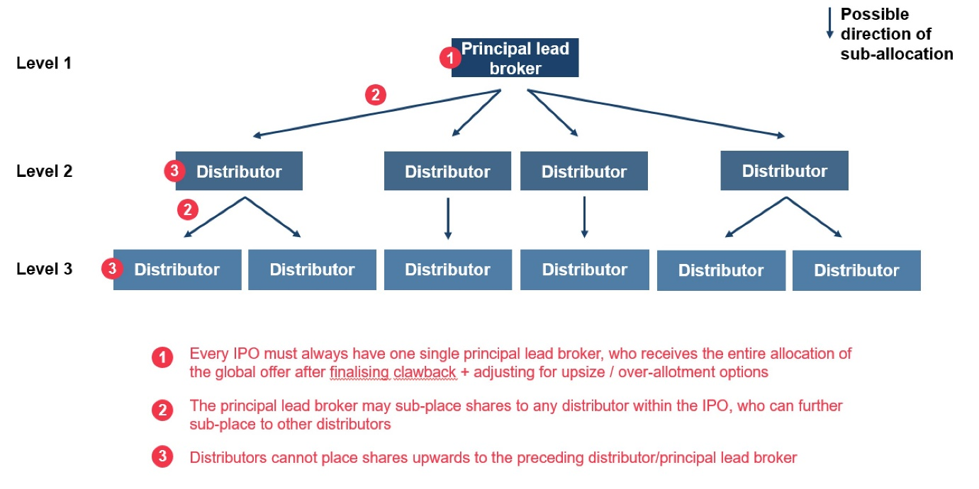

**Confirming the final size of the institutional offer (before 2 p.m. (T-day)**

After IPO pricing (10 a.m. (T-day)), the principal lead broker should confirm (with maker/checker mechanisms) the final final size of the institutional offer, which is based on three variables:

|  |  |  |  |
| --- | --- | --- | --- |
| # | Field name | Input method | Notes |
| 1 | Number of institutional offer shares (if any) | Integer  [Non-editable data field] | System-calculated based on the clawback. |
| 2 | Exercised public offer upsize option (number of shares) | Integer  [Non-editable data field] | Repetition of Public Offer upsize (number of shares) (Upsizing the public offer Field #8) |
| 3 | Institutional offer upsize (number of shares) | Integer | Human input:   * Lower limit: 0 [DEFAULT] * Upper limit: Number of offer shares (IPO Initiation Field #31) * Upsize option (%) (IPO initiation Field #35), rounded down to the nearest board lot minus exercised public offer upsize Option (Field #2) |
| 4 | Total exercised upsize option (number of shares) | Integer  [Non-editable data field] | Field #2 + #3 |
| 5 | Over-allocation (number of shares) | Integer | Human input:   * Lower limit: 0 [DEFAULT] * Upper limit (rounded down to the nearest board lot): IF IPO initiation Field #36 = “Inclusive”, then:  |  |  |  |  |  |  |  | | --- | --- | --- | --- | --- | --- | --- | | ( | Number of offer shares | + | Total exercised upsize option) | ) | * | Over-allotment option | |  | [IPO initiation Field #31] |  | [Sub-placing arrangement Field #4] |  |  | [IPO initiation Field #37] |  * IF IPO initiation Field #36 = “Exclusive”, then :  |  |  |  | | --- | --- | --- | | Number of offer shares | * | Over-allotment option | | [IPO initiation Field #31] |  | [IPO initiation Field #37] | |
| 6 | Final size of the institutional offer | Integer  [Non-editable data field] | Field #1 + #3 + #5. |
| 7 | Total issued share capital upon listing | Integer | Human input:  Must be <= Number of existing shares (IPO initiation Field #30) + Number of offer shares (IPO initiation Field #31) + Field #4 |

Detailed examples for these calculations can be seen in attached .pptx and screenshot below.

At 2 p.m. (T-day), the placee cut-off time (see 2.6.3 Placee allocation), the institutional offer size should become non-editable.



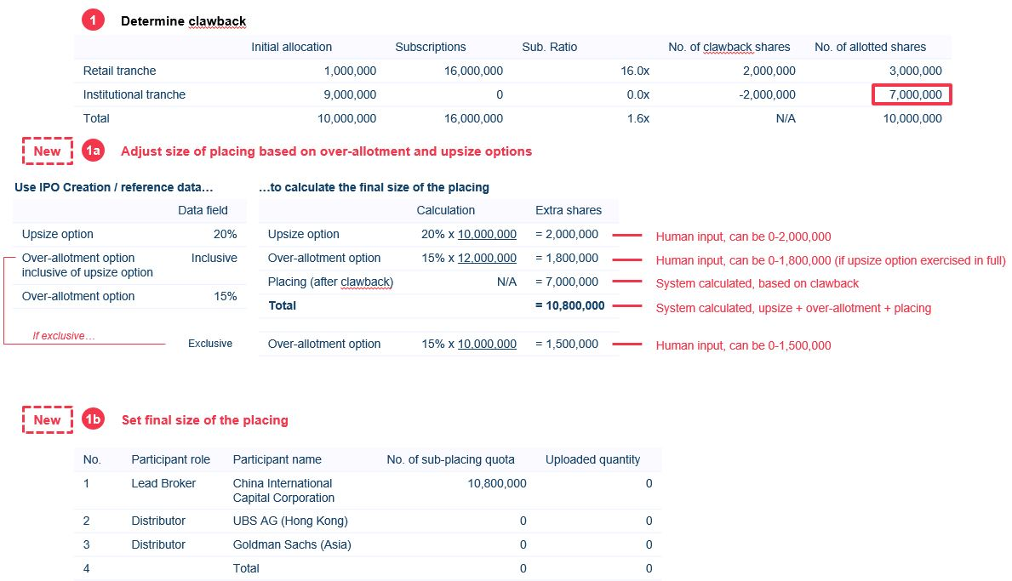

**Amending the final size of the institutional offer**

After the principal lead broker confirms the final size of the institutional offer, a function should be provided to allow for further amendment (with maker/checker mechanisms) within the permissible ranges **(before Placee cut-off)**:

* If the size of the institutional offer is increased, the “extra” shares are allocated to the principal lead broker
* If the size of the institutional offer is decreased, the entire sub-placing arrangement should be reset with all shares “reallocated” to the principal lead broker
  + Any authorised placee entries should also be reverted to temporary status

The principal lead broker may also reset the entire sub-placing arrangement and move all placee entries across distributors to temporary status.

Regulators may return editing rights to the principal lead broker after the Placee cut-off.

**Allocating the placing shares (before Placee cut-off)**

The principal lead broker may allocate shares to distributors, and distributors can further allocate shares downstream to other distributors by amending the control list to reflect the share allocation at each level.

**Amending the distribution of shares/control list (before Placee cut-off)**

To re-allocate/amend the distribution of shares, distributors must communicate with the distributor from the preceding level to amend the control list and shares allocation (i.e. perform a redistribution of shares). The submission of placee entries and amendment of the control list can be done concurrently.

The sub-placing distributor cannot reduce the sub-placing amount without the principal lead broker resetting the entire sub-placing arrangement.

When the control list is amended such that the number of shares allocated to a distributor is more than the number of shares per placee list submitted, the submitted placee list is still valid. The Distributor (Maker) will need to further submit placee entries to “fill in the gap” until the entire placee list total matches the shares allocated to that distributor.

**Interface functions**

The sub-placing interface should maintain functions for:

* Amending sub-placing amounts to different distributors (with maker-checker workflows) **[IIP]**
* A data table showing the latest sub-placing relationship across distributors (example below)

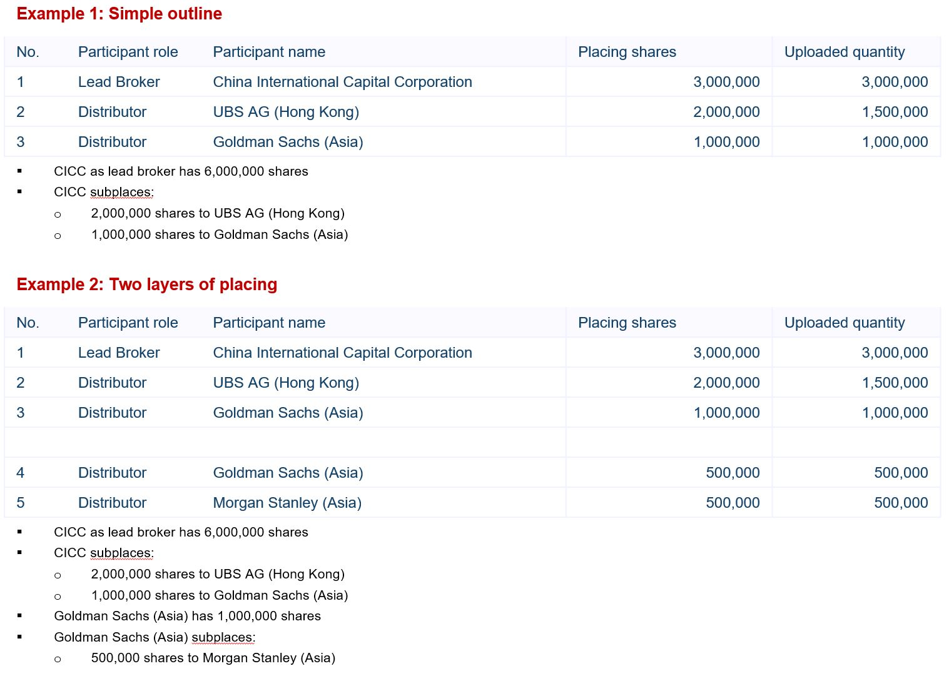

### Placee allocation

The purpose of this module is to manage each lead broker / distributor’s own institutional offer allocations between IPO pricing and book listing approval. Access to the module is divided into two main categories:

* **Principal lead broker / distributors** who submit and manage their own placing allocations, which must be complete and validated upon entry **[IIP]**
* **Regulators** who monitor authorised entries in real-time and approve placees for regulatory purposes



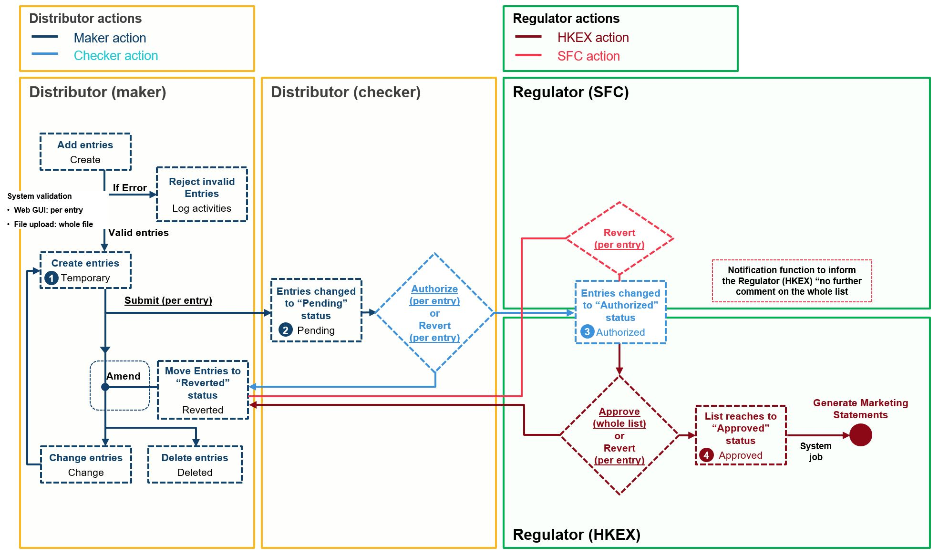

**Placee list**

The principal lead broker / distributors must submit entries via maker-checker flows, per the attached .pptx / screenshot below.

**Approval workflow**

To create a placee entry (temporary status), a Distributor (Maker) must ensure:

1. All fields must be complete (please refer to the section titled “Creating placee entries”)
2. There are no duplicating entries based on ID number (within own placee list / v. EIPO application list)
3. Supporting documents are uploaded, unless “N” is selected for “supporting document requirement”

To submit a placee entry for regulatory approval (pending -> authorised status), a Distributor (Checker) must ensure that the number of placing shares to be allocated does not exceed the distributor’s subplacing quota.

**Interface functions**

Separate interfaces should be maintained for entries in temporary, pending, authorised and approved statuses. Each interface should maintain functions for:

* Searching and filtering within each interface **[IIP]**
* Progressing entries within the workflow **[IIP]**
* Amending entries **[IIP]**
* Deleting entries **[IIP]**
* Group selecting entries (either within the viewable list or covering every single entry within the interface) for performing the actions listed above **[IIP]**

**Creating placee entries**

Entries can be created (i.e. progressed to temporary status) through:

* **Online entry; or**
* **.xls / .xlsx file upload**

A complete **individual placee** entry must contain the following mandatory fields:

* HKID / NID / Passport no. **[IIP]**
* ID type **[IIP]**
  + HKID
  + National Identification Document
  + Passport
* Full name (English or Chinese) **[IIP]**
* Residential address **[IIP]**
* Telephone area code
* Telephone number **[IIP]**
* No. of shares allotted (must be whole number) **[IIP]**
* Name of placee’s employer **[IIP]**
* Placee category
  + N/A
  + Category 1: Cornerstone investor
  + Category 2: Existing or past employee of the issuer
  + Category 1+2
* Supporting document requirement
  + N
  + Category 3: Connected client
  + Category 4: Existing shareholder/director and their close associate
  + Category 3 + 4

A complete **corporate placee** entry must contain the following mandatory fields:

* COI / HK BR / LEI no.
* ID type **[IIP]**
  + HK BR
  + COI
  + LEI
* Full company name (English or Chinese) **[IIP]**
* Placee address **[IIP]**
* Telephone area code
* Telephone number **[IIP]**
* Contact person **[IIP]**
* No. of shares allotted (must be whole number) **[IIP]**
* Placee category:
  + N/A
  + Category 1: Cornerstone investor
  + Category 2: Discretionary managed portfolio
  + Category 3: Discretionary trust
  + Category 1+2
  + Category 1+3
  + Category 2+3
  + Category 1+2+3
* **Note: “Details of beneficial ownership” fields will not be required if “Category 3: Discretionary trust”, “Category 1+3”, “Category 2+3” or “Category 1+2+3” are selected**
* Supporting document requirement
  + N
  + Category 4: Connected client
  + Category 5: Existing shareholder and their close associate
  + Category 6: SFC-authorised fund
  + Category 4+5
  + Category 4+6
  + Category 5+6
  + Category 4+5+6
* Details of beneficial ownership:
  + HKID / NID / Passport no. **[IIP]**
  + ID type (HKID / National Identification Document / Passport)
  + Full name (English or Chinese) **[IIP]**

**Online entry**

An online interface should be provided to create new institutional offer allocation entries, which are to be validated during entry to prevent errors.

The interface should also include dropdown menus for individual or corporate entries:

* ID type (for individuals) **[IIP]**:
  + HKID
  + National Identification Document
  + Passport
* ID type (for corporates) **[IIP]**:
  + COI
  + HK BR
  + LEI

The online entry function should also permit the amendment of any entries (created via online entry, fixed-length txt file upload or API) in temporary status.

**.xls / .xlsx file upload**

An online interface should be provided for the uploading of .xls / .xlsx files, accessible by the principal lead broker and distributors only**.**



**Cut-off times**

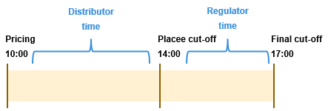

|  |  |  |  |
| --- | --- | --- | --- |
| **Action** | **User** | **Start** | **End (Cut-off)** |
| Create / edit entries  **( -> Temporary)** | Distributor (Maker) | Public Offer book open | “Final cut-off” |
| Submit for checker approval  **(Temporary -> Pending)** | Distributor (Maker) | Public Offer book open | “Final cut-off” |
| Revert for maker amendment  **(Pending -> Temporary)** | Distributor (Checker) | Public Offer book open | “Final cut-off” |
| Submit for regulatory approval  **(Pending -> Authorised)** | Distributor (Checker) | IPO Pricing | “Placee cut-off”  (available if there is at least one regulatory follow up) |
| Regulatory follow up  **(Authorised -> Temporary)** | Regulator (SFC) **or**  Regulator (HKEX) | Public Offer book open | “Final cut-off”  (**no** exceptions) |
| Regulatory approval  **(Authorised -> Approved)** | Regulator (HKEX) | Public Offer book open | “Final cut-off”  (**no** exceptions) |

Once Distributor (Maker) initiates the first temporary entry, the system should display the following warning statement:

* **Header:** “WARNING”
* **Message:** “No amendments to the placee list can be made after 14:00 [Listing date -1] except for addressing regulators’ comments”

**Commenting on placee lists**

Regulators can comment on multiple entries of individual placee lists and/or the consolidated placee list at any time before approving the placee list. The system should prompt the same number of message boxes as the number of entries selected by Regulators, one after another. Once Regulators submit comments, the comments should be consolidated and sent to that particular distributor. Each distributor may only view comments relating to its placees. All Regulators users may make comments concurrently.

Distributors should have no permissions seeing which Regulator user issued comments.

**Placee cut-off**

At Placee cut-off (i.e. 2 p.m. on T-day), FINI should perform a system validation on whether (1) the placee lists match the control list in terms of number of shares and (2) the completeness of placee lists submitted. Failing the system check, FINI should suspend all downstream system jobs.

Two options should be made available to resolve this exception:

* Sponsor counsel / sponsor amend the IPO timetable to push back the placee cut-off time (see Dynamic IPO – exceptions handling)
* Regulators set a new deadline within the same day (must be before 5 p.m.)

**Final cut-off**

The Distributor (Maker) receiving comments from Regulators during Regulator time will be given editing rights to amend the relevant placee entries only. Distributor (Maker) can (1) amend and resubmit, (2) delete and/or (3) create and submit new placee entries. FINI should validate the amended placee entries (see “Maker-checker workflows” section above) and ensure that the Distributor’s amended placee list meets completion conditions (see “Completion conditions” section below) prior to submission to Distributor (Checker).

At Final cut-off, if the consolidated placee list has not been approved by a Regulator (HKEX), FINI should perform a system validation based on the **Completion conditions**:

* **A successful check** = placee list approved, documents generated and proceed with share-posting etc
* **An unsuccessful check** = all downstream jobs, including generation of documents and share-posting, should be suspended. The only option for resolving this exception should be sponsor counsel / sponsor amending the IPO timetable to push back the cut-off times.

**Completion conditions**

In order for the placing allocations stage of the workflow to complete for Regulator (HKEX) to proceed with “No further comments” (with a confirmation box saying “Confirm no further comments on [number of placees] placees allocated [final size of the institutional offer] shares?”):

1. The placee list of principal lead broker and each distributor must:
   * Correspond exactly to the participant’s number of sub-placing shares
2. The consolidated placee list across the entire institutional offer must:
   * Correspond exactly to the final size of the institutional offer
   * Have ≥100 placees
   * Shares placed to existing or past employees of the issuer must not exceed 10% of the total placing shares
3. The following documents have been submitted to Regulators (see 2.6.7 Regulatory Submissions)
   * Item-1: Sponsor confirmation form
   * Item-2: Top shareholders list

**Placee statistics**

The purpose of Placee statistics is to provide Regulators a high level overview of institutional offer allocations on a per deal basis.

The interface should include:

* High level statistics relating to the final size of the institutional offer **[IIP]**
* Statistics breaking down institutional offer allocations across different lead broker and distributors (by number of placees and valid uploaded quantity) **[IIP]**

**Viewing permissions**

The accessibility for each participant in respect of each functional module is summarised within the following table:

|  |  |  |
| --- | --- | --- |
| **Participant type** | **Placee list** | **Placee statistics** |
| Principal lead broker (maker) | Per own entries: **[IIP]**   * Temporary * Pending * Authorised | X |
| Principal lead broker (checker) | Per own entries: **[IIP]**   * Pending * Authorised * Approved | X |
| Distributor (maker) | Per own entries: **[IIP]**   * Temporary * Pending * Authorised | X |
| Distributor (checker) | Per own entries: **[IIP]**   * Pending * Authorised * Approved | X |
| Sponsor | X | Per own deal statistics |
| Sponsor’s counsel | X | Per own deal statistics |
| Issuer’s counsel | X | Per own deal statistics |
| HKSCC | X | All deal statistics **[IIP]** |
| Regulator (HKEX) | All entries:   * Authorised * Approved | All deal statistics **[IIP]** |
| Regulator (SFC) | All entries:   * Authorised * Approved | All deal statistics |

### Application data management: real-time check and statistics

The system should provide Regulators a series of special checks on individual placees and the composition of the placee list.

**Invalid entries**

|  |  |  |
| --- | --- | --- |
| **#** | **Check** | **Handling** |
| 1 | ID numbers within own placee list **[IIP]** | The duplication should be flagged in real-time during creation and should not be able to reach “temporary” status **[IIP]** |
| 2 | Cross public offer application v. institutional offer placing duplication **[IIP]** | Since institutional offer allocations may only be authorised after clawback, the relevant placee should be flagged to the submitting distributor. The duplication should be flagged in real-time when attempted to submit and should not be able to reach “temporary” status |

The following results of the checks should be displayed in the Authorised tab, and viewable only by Regulators.

**Duplicate entries (flagged yellow)**

|  |  |  |
| --- | --- | --- |
| **#** | **Check** | **Handling** |
| 1 | ID numbers across placee lists of different distributors | The duplication should be flagged to the relevant participants after authorisation.  **However**, the duplicates should not be invalidated. Once approved by Regulators, the duplicates should be shown separately on the consolidated placee list, but calculated as a single placee in the concentration analysis. |

**Modified / deleted entries (flagged blue)**

|  |  |  |
| --- | --- | --- |
| **#** | **Check** | **Handling** |
| 1 | Amendment to any data field | User interface should display an audit log comparing the data field changes between latest and previous versions. |

**Flagged entries (“Authorised tab”) (flagged red)**

|  |  |  |
| --- | --- | --- |
| **#** | **Check** | **Business logic** |
| 1 | Duplicating / similar fields (other than ID numbers) | Applies to:   1. Full names 2. Addresses 3. Employers |
| 2 | New substantial shareholder | Placees that have been allocated shares, in aggregate with any existing shares held by that placee, amounting to ≥10% or more of the listing applicant’s issued share capital (before over-allotment option). This should not count towards the public float. |
| 3 | Name of employer v. names of distributors | Flag all placees whose employers are one of the distributors (i.e. employee of a distributor). |
| 4 | Name of placee v. names of distributors | Flag all placees who are one of the distributors (i.e. part of the syndicate). |

**Prioritisation of colour coding**

Entries that reach approved status should have their colour codes removed.

If a placee matches one or more system checks, the order of prioritisation should be as follows:

1. Yellow (Duplicate)
2. Red (Flagged)
3. Blue (Modified)

### Application data management: cleansing and verification

The system should remove all invalid entries after performing cleansing and verification checks at:

* Placee cut-off;
* Final cut-off; and
* Regulator (HKEX) approving the placee list

### Application data management: consolidation

All authorised placee entries should be consolidated in real-time for the Regulator’s view and added to any institutional offer statistics, including the concentration analysis.

### Regulatory submission

Every IPO has a required list of submissions that must be made to the Regulators ahead of listing approval. In some cases, HKSCC is also a recipient for notifications purposes.

Each submission will have a pre-determined:

* Workflow – e.g. maker, checker, submitter, reviewer
* Format – e.g. online e-form, excel upload, system-generated
* Viewers – who can view it
* Start time – when should this item be open for submission
* End time – submission deadline

|  |  |  |  |
| --- | --- | --- | --- |
| **#** | **Item** | **Submitter** | **Recipient** |
| 1 | Sponsor confirmation form | Principal Sponsor | Regulator (HKEX) / Regulator (SFC) |
| 2 | Top shareholders list | Principal Sponsor |
| 2 | Letters of independence | Lead broker (checker) / distributors (checker) |
| 3 | Marketing Statement | Lead broker (checker) / distributors (checker) |
| 4 | Sponsor’s Declaration | Principal Sponsor |
| 5 | Issuer’s Declaration | Issuer’s counsel |
| 6 | Transaction levy form | Principal Sponsor |
| 8 | Allotment results announcement | Sponsor counsel |

**Item-1: Sponsor confirmation form (Main Board and GEM)**

|  |  |
| --- | --- |
| **Workflow** | Principal Sponsor -> Regulators |
| **Format** | Online e-form |
| **Viewers** | Sponsor counsel, Principal Sponsor, Sponsor(s), Regulators |
| **Start time** | Public offer open |
| **End time** | Listing approval |

The purpose of this form is to capture any data fields requiring human input for the generation of:

* Allotment results announcement

|  |  |  |
| --- | --- | --- |
| **#** | **Data field** | **Input logic** |
| 1 | Number of public float shares | Input box, must be integer ( |

**Item-2: Top shareholders list**

The top shareholders list should be submitted with the placee lists, containing a shareholding list of the company’s top 25 shareholders, representing at least 50% of the Company’s issued share capital, after the completion of the IPO, at a minimum.

|  |  |
| --- | --- |
| **Workflow** | Principal Sponsor -> Regulators |
| **Format** | User Excel-upload |
| **Viewers** | Principal Sponsor, Sponsor Counsel, Regulators |
| **Start time** | Public offer book open |
| **End time** | Placee list approval |

An online interface should be provided for the downloading and uploading of the top shareholders list, which is used to calculate the public float of the issuer, based on the attached template (.xls / .xlsx).

Max file size: 50mb

Validation rules:

* Only validate ‘Top Shareholders’ sheet, starting from row 2
* Limited to Columns A to G
* For each data entry row, all columns must be non-blank
* Minimum = 25 entries, maximum = unlimited entries
* Column C:
  + Must be integer ≥0
* Column D:
  + Must be integer >0
  + Total of column D must be ≥ 50% * (number of shares held by existing shareholders + number of offer shares + final upsize)
* Column F:
  + Must be integer ≥0
  + Must be ≤ column D
* Column G:
  + Must be Y or N



Failing any validation rules, the entire upload should be rejected. Any new upload should completely replace the previous one.

**Item** **3: Letters of independence (Main Board and GEM)**

|  |  |
| --- | --- |
| **Workflow** | Generated after the regulators approve the placee list -> to all brokers to confirm accuracy of the information in the auto-generated Letter of Independence -> must submit before commencement of trading |
| **Format** | System-generated PDF |
| **Viewers** | Relevant Principal Lead Broker / Distributor, Regulators |
| **Start time** | After placing allocations have been finalised |
| **End time** | N/A |

Based on each distributor’s placee list, FINI should automatically generate the Letter of Independence together with the Marketing Statements and Allotment Results Table which is tailored based on the following fields:

* **Company name** – Company name (English full) [IPO initiation Field #2]
* **Exception** – If the distributor’s placee list has at least one “connected client” (individual or corporate), “Existing shareholder/director and their close associate” (individual) or “Existing shareholder and their close associate” (corporate), to include *“except for those disclosed in the Prospectus and those to be disclosed in the Company’s allotment result announcement”*
* **Name of broker** – Firm name of Distributor [IPO initiation Field #46 / 47]
* **Title of broker** – User name of Distributor (Checker) [IPO initiation Field #46 / 47]
* **Rule reference** – Use “paragraph 13 of Appendix 6 to the Main Board Rules” (for Main board) with “Note 2 of the GEM Rule 10.12(4) (for GEM).

Each Distributor (Checker) will need to sign off (by clicking the submit button) the Letter of Independence. The prompt message will be “*I hereby confirm the information in this letter is accurate and not misleading in any material respect”.*

The output should reference to the template below:

|  |
| --- |
| For Main Board and GEM    **Note:** If it is a GEM applicant,replace “paragraph 13 of Appendix 6 to the Main Board Rules” with “Note 2 of the GEM Rule 10.12(4) (see above bullet point). |

**Item-4: Marketing Statement (Main Board and GEM)**

After placing allocations have been finalised, each lead broker and distributor must submit a marketing statement to reflect a summary of its subplacing relationships and placee information.

|  |  |
| --- | --- |
| **Workflow** | Generated after the Regulators approve the placee list-> to all brokers to confirm the accuracy of the information in the auto-generated marketing statement -> must submit before commencement of trading |
| **Format** | System-generated PDF |
| **Viewers** | Relevant Principal Lead Broker / Distributor, Regulators |
| **Start time** | After placing allocations have been finalised |
| **End time** | Before commencement of trading |

The output of the system-generated marketing statement should take reference from the PDF attachment.

|  |  |
| --- | --- |
| Main Board: | GEM: |

Note: The required information differs between lead brokers and distributors.

Required data fields for **lead broker(s)**:

|  |  |  |
| --- | --- | --- |
| **#** | **Data field** | **Input logic** |
| 1 | Name of issuer/vendor | Company name (English full)  [IPO initiation Field #2] |
| 2 | Description of security | Securities to be listed  [IPO initiation Field #17] |
| 3 | Total amount or number of securities being placed | Final size of the institutional tranche (after adjusting for over-allotment and upsize options) |
| 4 | Total amount of number of securities being placed by the undersigned | Final placing size for the lead broker, inclusive of any subplacing to other distributors |
| 5 | Net price to the issuer/vendor | Final IPO price |
| 6 | Name of lead broker | Company name of the lead broker  [IPO initiation Field #46] |
| 7 | Name(s) of distributor(s) (if appropriate) | A list of the lead broker’s sub-placing distributors |
| 8 | Name(s) of the persons(s) or firm(s) from whom the undersigned obtained the securities to be placed by the undersigned | [leave as blank] |
| 9 | Summary of distribution | The number of placing shares subplaced to each of the lead broker’s sub-placing distributors |
| 10 | Analysis of distribution | **Clients** – any independent clients under placee list (individual + corporate)  **Existing or past employees of the issuer** – flagged under placee list (individual)  **Discretionary managed portfolios** – flagged under placee list (corporate)  **Other Exchange Participants\*** – subplaced to other distributors  **Retained by the undersigned** – if the company name (corporate placee) = the name of the lead broker |
| 11 | By the lead broker to the general public | [leave as blank] |
| 12 | By the undersigned to other Exchange Participants | A detailed list of each distributor to whom the lead broker has subplaced and number of shares subplaced and the sub-total percentage (should equal to the % in 10 in the data field of Other Exchange Participants). |
| 13 (1) | Distribution of placees | Number of placees with 1 board lot and up to 10 board lots, and more than 10 [from results of placing allocations]  % of placee to total [from results of placing allocations] |
| 13(2) | Concentration of placing shares | Number of shares held by Top, Top 5, Top 10, and Top 25 placees [from results of placing allocations]  % of placing to total [from results of placing allocations] |
|  | Signed  (After the placing allocation is completed, the marketing statement will be generated, and FINI will notify the relevant brokers to sign off the marketing statement, ) | To prompt message box where it says “*I hereby confirm the information filled in this form is accurate and not misleading in any material respect.*” |

For the declaration statement, If the distributor’s placee list has at **no** “connected client” (individual or corporate), “Existing shareholder/director and their close associate” (individual) or “Existing shareholder and their close associate” (corporate) (the “**Relevant Checkbox**”) ticked in the place, use the following statement:

“*I hereby certify that to the best of my knowledge and belief, none of the securities placed by me have been placed with the directors or any existing shareholders of the issuer or their close associates or any nominee of any of the foregoing*.

**Otherwise**, use the following statement:

“*I hereby certify that to the best of my knowledge and belief, save as disclosed in the prospectus or the allotment results announcement, none of the securities placed by me have been placed with the directors or any existing shareholders of the issuer or their close associates or any nominee of any of the foregoing.”*

Required data fields for **distributors**:

|  |  |  |
| --- | --- | --- |
| **#** | **Data field** | **Input logic** |
| 1 | Name of issuer/vendor | Company name (English full)  [IPO initiation Field #2] |
| 2 | Description of security | Securities to be listed  [IPO initiation Field #17] |
| 3 | Total amount or number of securities being placed | Final size of the institutional tranche (after adjusting for over-allotment and upsize options) |
| 4 | Total amount of number of securities being placed by the undersigned | Final placing size for the distributor, inclusive of any subplacing to other distributors |
| 5 | Net price to the issuer/vendor | [leave as blank] |
| 6 | Name of lead broker | [leave as blank] |
| 7 | Name(s) of distributor(s) (if appropriate) | [leave as blank] |
| 8 | Name(s) of the persons(s) or firm(s) from whom the undersigned obtained the securities to be placed by the undersigned | [leave as blank] |
| 9 | Summary of distribution | [leave as blank] |
| 10 | Analysis of distribution | **Clients** – any independent clients under placee list (individual + corporate)  **Existing or past employees of the issuer** – flagged under placee list (individual)  **Discretionary managed portfolios** – flagged under placee list (corporate)  **Other Exchange Participants\*** – subplaced to other distributors  **Retained by the undersigned** – if the company name (corporate placee) = the name of the distributor |
| 11 | By the lead broker to the general public | [leave as blank] |
| 12 | By the undersigned to other Exchange Participants | A detailed list of each distributor to whom the distributor has subplaced and number of shares subplaced and the sub-total percentage (should equal to the % in 10 in the data field of Other Exchange Participants). |
| 13(1) | Distribution of placees | Leave blank (for lead broker only) |
| 13(2) | Concentration of placing shares | Leave blank (for lead broker only) |
|  | Signed  (After the placing allocation is completed, the marketing statement will be generated, and FINI will notify the relevant brokers to sign off the marketing statement, ) | To prompt message box where it says “*I hereby confirm the information filled in this form is accurate and not misleading in any material respect.*” |

For the declaration statement, If the distributor’s placee list has at **no** “connected client” (individual or corporate), “Existing shareholder/director and their close associate” (individual) or “Existing shareholder and their close associate” (corporate) (the “**Relevant Checkbox**”) ticked in the place, use the following statement:

“*I hereby certify that to the best of my knowledge and belief, none of the securities placed by me have been placed with the directors or any existing shareholders of the issuer or their close associates or any nominee of any of the foregoing*.

*The number of holders should be based on number of placees under the subplaced distributors, not number of subplaced distributors. For example:

* **Goldman Sachs (Asia)** subplaces to 2 distributors (China International Capital Corporation, UBS AG (HK))
* **China International Capital Corporation** places to 25 clients
* **UBS AG (HK)** places to 20 clients

The number of holders would be should be 45, not 2. Applies at immediate level, e.g. if UBS AG (HK) sub-placed further to CLSA (with 15 clients), the number of holders should still be 45.

Each Distributor (Checker) will need to sign off (by clicking the submit button) the marketing statement.

**Item 5: Sponsor’s Declaration (Main Board and GEM)**

|  |  |
| --- | --- |
| **Workflow** | Generated after the Regulators approve the placee list -> Sponsor to confirm the accuracy of the auto-generated form before trading commence |
| **Format** | System-generated PDF |
| **Viewers** | Principal sponsor, Regulators |
| **Start time** | After placing allocations have been finalised |
| **End time** | N/A |

The output of the system-generated Sponsor declaration should take reference from the word doc attachment.

|  |  |
| --- | --- |
| Main Board: | GEM: |

Note: The sponsor declaration form should be sent back to the sponsors, and confirm by them by clicking a button which says “*I hereby confirm (1) I have obtained all the necessary information and supporting documents to make this confirmation; and (2) the information filled in this form is accurate and not misleading in any material respect”*.

Required data field:

|  |  |  |  |
| --- | --- | --- | --- |
| **Points/ Paragraph** | **Data field** | **Input logic** | **Timing** |
|  | Case Number | Case ID  [IPO initiation Field #1] | Auto-gen when IPO initiated |
|  | Date | Date  [Date of Regulators approving the placee list] | Auto-gen when IPO initiated |
|  | Name of issuer | Company name (English full)  [IPO initiation Field #2] | Auto-gen when IPO initiated |
|  | Name of sponsor(s) | Sponsor names (English full)  [IPO initiation Fields #40 + #41] | Auto-gen when IPO initiated |
| 1 | Number of shareholders in retail tranche | Number of allotted retail tranche investors [from EIPO allotment list] | After Retail Tranche balloting ends |
| 2 | Number of placees | Number of placees  [from consolidated placee list] | After Placing allocation finalized |
| 2 | Total amount or number of securities being placed | Number of securities being placed  [final size of the institutional offer + public offer] | After Placing allocation finalized |
|  | Name of Principal Sponsor | User name of Principal Sponsor  [IPO initiation Field #40] | Auto-gen when IPO initiated |
|  | Title of Principal Sponsor | Firm name of Principal Sponsor  [IPO initiation Field #40] | Auto-gen when IPO initiated |
|  | Signed  (After the placing allocation is completed, the Sponsor Declaration will be generated, and FINI will notify the principal sponsor to sign off) | To prompt message box where it says “*I hereby confirm (1) I have obtained all the necessary information and supporting documents to make this confirmation; and (2) the information filled in this form is accurate and not misleading in any material respect.*” | To be generated when the regulators approve the “placee list”. FINI will notify the principal sponsor and to confirm by it before trading commence. |

**Item 6: Issuer’s Declaration (Main Board and GEM)**

After price determined, listing applicant must submit an issuer’s declaration form (or known as Form FFD004M). This form requires the listing applicant’s representatives (i.e. a director and a company secretary) to confirm matters relating to the listing applicants IPO such as the listing documents, the number and type of shares to be issued, and whether the conditions relating to the listing approval have been satisfied.

|  |  |
| --- | --- |
| **Workflow** | Company counsel download a pre-filled template -> amend the issuer’s declaration form -> upload the signed issuer’s declaration onto FINI |
| **Format** | User-uploaded PDF |
| **Viewers** | Company counsel of that particular IPO |
| **Start time** | Public offer book open |
| **End time** | Listing approval |

The output of the system-generated issuer’s declaration should take reference from the word doc attachment.

|  |  |
| --- | --- |
| Main Board: | GEM: |

As there are too many data fields which require manual input, the issuer’s declaration form will be available for download by the issuer’s counsel to fill in. The issuer declaration will be pre-filled with two data field: (1) Case number; and (2) name of the listing applicant. After the company counsel completed the company declaration form, it will be uploaded onto FINI.

Note: Only 1 company declaration form is required for a listing applicant.

The data field in the above word doc is to be pre-filled as below:

|  |  |  |  |
| --- | --- | --- | --- |
| **Paragraph number** |  | **Data field** | **Input logic** |
| N/A |  | Case Number | Case ID  [IPO initiation Field #1] |
| First paragraph |  | Name of issuer | Company name (English full)  [IPO initiation Field #2] |

**Item-7: Transaction levy form (Main Board: M402; GEM: G402)**

After the placing allocation has been finalized, the transaction levy form will be submitted by the listing applicant to specify the number of shares in placing and retail tranches that were allotted, the offer price to calculate the amount of trading fees and transaction levy, as well as brokerage.

|  |  |
| --- | --- |
| **Workflow** | Principal Sponsor -> Regulators (Approve / revert) |
| **Format** | System-generated PDF |
| **Viewers** | Principal Sponsor, Sponsor Counsel, Regulators |
| **Start time** | After placing allocation has been finalized |
| **End time** | Listing approval |

The output of the system-generated Transaction levy form should take reference from the word doc attachment.

|  |
| --- |
| For Main Board and GEM:    Note 1: If it is a GEM, cross out all “Main Board” in the template, and remove the phrase “Appendix 8 of the Main Board Listing Rules”, and “M402”  Note 2: If it is a Main Board, cross out all “GEM” in the template, and remove the phrase “Appendix 9 of the GEM Listing Rules”, and “G402”. |

|  |  |  |
| --- | --- | --- |
| **Paragraph number** | **Data field** | **Input logic** |
|  | Date | Date  [System generation date] |
|  | Listing applicant | Company name  [IPO initiation Field #2] |
|  | Case Number | Case ID  [IPO initiation Field #1] |
|  | Transaction type | Primary or Secondary listing  [IPO initiation Field #19] |
|  | Name of issuer | Company name (English full)  [IPO initiation Field #2] |
| Placing (Trading fee and Transaction levy) | Number of placing shares | Number of placing shares (including upsize option and over-allocation)  [from consolidated placee list] |
| Placing (Trading fee and Transaction levy) | Offer price | Final offer price  [from system after price determined] |
| Placing (Trading fee and Transaction levy) | Dollar Amount | Number of placing shares x offer price  [formula] |
| Payment method | Electronic transfer | Electronictransfer only, no select option. |
|  | Sponsor name | Name of Principal Sponsor user  [IPO initiation Field #38] |
|  | Sponsor title | Name of submitting Principal Sponsor user  [IPO initiation Field #38] |
|  | Signed  (After the placing allocation is completed, the Transaction Levy Form M402 or G402) will be generated, and FINI will notify the principal sponsor to sign off) | To prompt message box where it says “*I hereby confirm (1) I have obtained all the necessary information and supporting documents to make this confirmation; and (2) the information filled in this form is accurate and not misleading in any material respect.*” |

### Document services

Every IPO has a required list of submissions that must be made to HKSCC in respect of settlement of the institutional offer.

Each submission will have a pre-determined:

* Workflow – e.g. maker, checker, submitter, reviewer
* Format – e.g. online e-form, excel upload, system-generated
* Viewers – who can view it
* Start time – when should this item be open for submission
* End time – submission deadline

|  |  |  |
| --- | --- | --- |
| **#** | **Item** | **Recipient** |
| 1 | Placement form / Pre-deposit form | Input: HKSCC  Output: HKSCC, Sponsor counsel, Principal Sponsor, Sponsor(s), Principal Lead Broker, Share Registrar |
| 2 | Formal admission letter | HKSCC, Sponsor counsel, Principal Sponsor, Sponsor(s), Principal Lead Broker, Share Registrar |

**Placement form / Pre-deposit form**

|  |  |
| --- | --- |
| **Workflow** | Sponsor counsel -> HKSCC (approve / revert) |
| **Format** | Input: online e-form, output: system-generated PDF |
| **Viewers** | Principal Sponsor, Sponsor Counsel, HKSCC, Principal Lead Broker, Share Registrar |
| **Start time** | Public offer book open; submit only after placing allocations have been finalised |
| **End time** | Commencement of trading |

The purpose of this online e-form is to specify the settlement arrangements of the institutional offer.

The first section should specify the type of securities being settled into CCASS:

|  |  |  |
| --- | --- | --- |
| **#** | **Data field** | **Input logic** |
| 1 | Securities to be admitted into CCASS | [Non-editable data field]  Securities to be listed [IPO initiation Field #17] |
| 2 | Transfer from overseas share registrar to Hong Kong share registrar | Tick box [Default unticked] |
| 3 | Supporting documents – share certificate specimen | Optional single file upload function:  Max file size per upload: 50mb  Formats: PDF / JPEG / PNG |
| 4 | Supporting documents – others | Optional multiple file upload function for other file uploads, such as board resolutions.  Max file size per upload: 50mb  Formats: PDF / JPEG / PNG |
| 5 | Name of Depositary | Appears only if IPO Initiation Field #17 = **“Depositary Receipts”**  Free text string |
| 6 | Name of Trustee-Manager | Appears only if IPO Initiation Field #17 = **“Share Stapled Units”**  Free text string |

The second section should allow the submitter to select up to five CCASS participant accounts into which the institutional offer shares should be deposited on the listing date:

|  |  |  |
| --- | --- | --- |
| **#** | **Data field** | **Input logic** |
| 7 | Number of securities | Integer (no decimals)  The total amount across all data fields should not exceed the final size of the institutional offer. |
| 8 | New / borrowed / sale | Dropdown menu:   * New * Borrowed * Sale * Others (Please fill in) [prompt free text] |
| 9 | Name of shareholder | If #8 = New:   * “HKSCC Nominees Limited” [Non-editable]   If #8 = Borrowed / Sale / Others:   * Free text input |
| 10 | CCASS Participant ID | Search / dropdown menu, must be valid CCASS Participant ID from Participant Master (See 2.8.2 Data exchange with CCASS)  After selection, the data field should also reflect the name of the CCASS Participant. |

HKSCC should have a function to comment and revert the submission.

Should the sponsor counsel make a new submission due to HKSCC reverting the original submission, the user interface should display an audit log comparing the data field changes between latest and previous versions, inclusive of any new upload for fields #2 / #3.

After HKSCC approval, the system should generate a PDF based on the following template below:



|  |  |  |
| --- | --- | --- |
| **#** | **Data field** | **Output logic** |
| 1 | Placement form / Pre-deposit form | If:   * Offering type [IPO initiation Field #16] = **“By introduction”**; **OR** * Securities to be listed [IPO initiation Field #17] = **“Ordinary shares (conversion from B to H shares)”** **OR** **“Depositary Receipts”**   Then = “Pre-deposit form”  Else:   * “Placement form” |
| 2 | Type of Securities | * Securities to be listed [IPO initiation Field #17] |
| 3 | Name of issuer | * Company name (English full) [IPO initiation Field #2] |
| 4 | Registrar | * Name of HK share registrar [IPO initiation Field #48] |
| 5 | Sponsor | * Names of Principal sponsor and sponsor(s) [IPO initiation Field #40 + 41] |
| 6 | Total Quantity | * Sum of “Number of securities” [Placement form / Pre-deposit form Field #7] |
| 7 | Board lot | * Board lot size [IPO initiation Field #24] |
| 8 | Settlement arrangements | * Data table summarizing data fields #7 - #10 from Placement form / pre-deposit form [Placement form / pre-deposit form Field #7-10] |
| 9 | Settlement Instructions (SI) Input Date | * Settlement Instructions (SI) Input Date [IPO initiation Field #56] |
| 10 | Certificates Delivery Date | * Placing shares delivery date [IPO initiation Field #57] |
| 11 | Declaration undertaking | Refer to attachment templates and conditions below. All disclosures are non-mutually exclusive, i.e. can have all three undertakings combined.  New shares only   * If ≥ 1 entry under Placement form / Pre-deposit form Field #8 is **“New”**   Has sale or borrowed shares   * If ≥ 1 entry under Placement form / Pre-deposit form Field #8 is not **“New”**   Transfer from overseas share registrar to Hong Kong share registrar   * If Placement form / Pre-deposit form Field #2 is **“Ticked”** |
| 12 | Sponsor Counsel name | * Firm name of Sponsor Counsel [IPO initiation Field #42] |
| 13 | Title of Sponsor Counsel | * Full name of submitting Sponsor Counsel user [IPO initiation Field #42] |
| 14 | Name of Depositary | Appears only if Placement form / pre-deposit form Field #5 is non-blank |
| 15 | Name of Trustee-manager | Appears only if Placement form / pre-deposit form Field #6 is non-blank |
| 16 | Share certificate specimen | Copy of share certificate specimen upload (if any) appended to the final page of the output form |

**Formal admission letter**

|  |  |
| --- | --- |
| **Workflow** | After Regulator (HKEX) approves placee allocations |
| **Format** | System-generated PDF |
| **Viewers** | Principal Sponsor, Sponsor Counsel, HKSCC, Principal Lead Broker, Share Registrar |
| **Start time** | N/A |
| **End time** | N/A |

The output of the letter to Sponsor should take reference from following attachment:



|  |  |  |
| --- | --- | --- |
| **#** | **Data field** | **Output logic** |
| 1 | Reference number | * Case number [IPO initiation Field #1] |
| 2 | Approval date | * Approval date of the Placement form / Pre-deposit form |
| 3 | Stock name | * Company name (English full) [IPO initiation Field #2] |
| 4 | Sponsor name | * Firm name of Principal Sponsor [IPO initiation Field #40] |
| 5 | Type of Securities | * “Securities to be listed”   [IPO initiation Field #17] |
| 6 | Name of Issuer | * Company name (English full) [IPO initiation Field #2] |
| 7 | Listing date | * Commence of trading date [IPO initiation Field #57] |

## Controls & monitoring

### Exceptions handling for dynamic IPOs

This section covers all functional exceptions handling for an IPO’s end-to-end workflow, which are divided into three sections:

* Change in IPO reference data
* Lapse in IPO
* Extreme weather

All functional exceptions should be managed through the “IPO reference data” section of the IPO.

#### Change in IPO reference data

**Overall workflow**

The workflow for amending an IPO’s reference data after the public offer book open is similar to IPO initiation, with two two added data fields :

* Two new data fields under the 8. Documents section

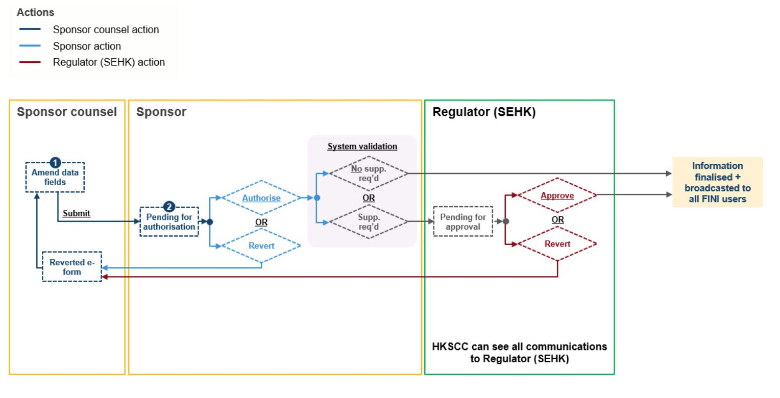

|  |  |  |  |
| --- | --- | --- | --- |
| **#** | **Field name** | **Input method** | **Notes** |
| 62a | Supplemental announcement | File upload | Optional field   * Up to ten file uploads * PDF only * No preview required * Size limitation per file: 40mb |
| 62b | Supplemental prospectus | File uload | Optional field   * Up to ten file uploads * PDF only * No preview required * Size limitation per file: 40mb |

**Lapse in IPO**

**Extreme weather**

### Contingency planning

This section all non-functional exceptions to an IPO’s the .

covers the policies and measures should any dependent component of FINI fails.

|  |  |  |  |
| --- | --- | --- | --- |
|  | **Component** | **Consequence** | **Contingency** |
| Data exchange / connectivity | FINI <-> EMFT | Following data exchanges mechanism would fail:   * Participant reference data (CCASS -> FINI) * Data exchange with SR (FINI <-> SR) | **FINI -> CCASS communications:**  HKSCC to download data file from FINI and send to SRs via secured email.  **CCASS -> FINI communications:**  SRs to send to HKSCC via secured email, and HKEX ITD to run data patches |
|  | Data exchanges with SR would be suspended:   * Autopay brokerage file * EIPO application file * EIPO allotment file * EIPO final allocation file * EIPO confirmed file * EIPO unconfirmed file | **FINI -> SR communications:**  HKSCC to download data file from FINI and send to SRs via secured email.  **SR -> FINI communications:**  SRs to send to HKSCC via secured email, and HKEX ITD to run data patches |
| FINI <-> SWIFT SAA |  |  |
| FINI <-> Mulesoft |  |  |
| FINI <-> ForgeRock |  |  |
|  |  |  |  |
|  |  |  |  |

### Data access rights

[Victor]

### Audit log (internal & external)

[List of actions, table matrix]

## Internal integration layer & HKEX existing systems

### Data exchange with CCASS

**CCASS reference data (CCASS ▶ FINI)**

* **Purpose:** Maintain latest records (e.g. IDs, bank account details) of Clearing Participants and Share Registrars for EIPO validation and payments
* **Frequency:** 08:00 (daily)
* **Format:** .txt

The reference data is separated into four different interface files, per the specifications in the attached .xlsx file below.



The table below includes samples of each interface file:

|  |  |
| --- | --- |
| **File** | **Sample attachment** |
| Participant Master |  |
| Registrar Master |  |
| Designated Bank Account Master |  |
| Bank Indicator Master |  |
| Non-Clearing Participant Master |  |
| Non-Clearing Participant Bank Account Master |  |
| Calendar Master |  |
| ICL Member Information File |  |
| Stock Master |  |

**Share posting (FINI ▶ CCASS)**

* **Purpose:** Deposit allotted EIPO shares into CCASS for trading next day
* **Frequency:** 14:30 (daily), if ≥1 IPO(s) that has been priced
* **Format:** .txt

The specifications are outlined in the table below.



**Header record:**

|  |  |  |
| --- | --- | --- |
| **Field Name** | **Field Format** | **Description** |
| Record type | X(1) | Should always be 0 for header record |
| Registrar code | X(6) | HK share registrar [IPO initiation Field #48] |
| Stock ID | X(15) | Stock code [IPO initiation Field #10], left justified.  e.g. 9988 should be expressed as ‘9988 ‘ |
| Processing date | X(8) | File processing / share posting date, in YYYYMMDD format |
| File name | X(15) | Always ‘SHARE ALLOTMENT’ |
| Filler | X(255) | Always blank |

**Detailed record:**

|  |  |  |
| --- | --- | --- |
| **Field Name** | **Field Format** | **Description** |
| Record Type | X(1) | Should always be 1 for detailed record |
| Participant ID | X(6) | The applicant’s Clearing Participant |
| Application number | X(20) | Application instruction #, left justified.  e.g. ‘766745300 ‘ |
| Applicant name 1 | X(40) | Beneficiary Owner field from EIPO application |
| Applicant name 2 | X(40) | Joint Account #2 Name field from EIPO application |
| Applicant name 3 | X(40) | Joint Account #3 Name field from EIPO application |
| Applicant name 4 | X(40) | Joint Account #4 Name field from EIPO application |
| ID number | X(20) | BO ID / BR# field from EIPO application |
| Beneficial owner | X(40) | Beneficiary Owner field from EIPO application |
| No. of shares applied | 9(11) | The applicant’s applied quantity from EIPO application |
| No. of shares allotted | 9(11) | The applicant’s allotted quantity from EIPO allotment file |
| No. of shares rejected | 9(11) | The applicant’s unsuccessful quantity from EIPO allotment file |
| Broker number | 9(5) | Always ‘09388’ |
| Filler | X(15) | Always blank |

**Control record:**

|  |  |  |
| --- | --- | --- |
| **Field Name** | **Field Format** | **Description** |
| Record Type | X(1) | Should always be 9 for control record |
| Total number of detailed records | 9(5) | Total number of applications in the broker channel |
| Total number of shares applied | 9(15) | Total application quantity in the broker channel |
| Total number of shares allotted | 9(15) | Total allotment in the broker channel |
| Filler | X(263) | Always blank |

**Weekly EIPO fee invoice (Fini ▶ CCASS)**

* **Purpose:** Deposit allotted EIPO shares into CCASS for trading next day
* **Frequency:** [09:00, first trading day (weekly)]
* **Format:** [.txt]

The specifications are outlined in the attached [x] file below.

[Specifications file]

### FINI -> Electronic Case Management (ECM)

At the end of an IPO (reached “Commencement of trading” or “lapsed”), FINI should perform export all documents and reports related to the International Offer, including:

|  |  |  |
| --- | --- | --- |
| **File** | **Section** | **Format** |
| DIST-A1: Placee list | IPO closing and reporting | .xlsx |
| DIST-A2: Placee input activities | IPO closing and reporting | .xlsx |
| DIST-A3: IPO reference data | IPO closing and reporting | .xlsx |
| DIST-A4: Concentration analysis | IPO closing and reporting | .xlsx |
| DIST-A5: Control list | IPO closing and reporting | .xlsx |
| DIST-A6: Master IPO list | IPO closing and reporting | .xlsx |
| Form Ds: Marketing Statements | Regulatory submission | .pdf |
| Form E: Sponsor’s Declaration | Regulatory submission | .pdf |
| Form F: Issuer’s Declaration | Regulatory submission | .pdf |
| Transaction levy form | Regulatory submission | .pdf |
| Allotment results announcement | Regulatory submission | .pdf |
| Letters of independence | Placee allocation | .pdf |
| Placee supporting document(s) | Placee allocation | .pdf |

### FINI -> Sanctum

[Input]